Newsletter January 2022

A warm welcome back to school after the Christmas break.

Staff News
Mr Sean Sly and his partner, Laura, welcomed a son, Sebastian William Sly, weighing in at 7lb 15oz. Mum and son are both doing well. Mr Sly is loving being a Dad however isn’t enjoying the sleepless nights.

Isolating Changes Due to Covid
If you have covid symptoms you must book a PCR. LFT’s should be used to identify asymptomatic cases.

You will have heard the news that from Monday 17th January 2022 isolation rules have changed to 6 days. People self-isolating with COVID-19 will have the option to reduce their isolation period after 5 full days if they test negative on both day 5 and day 6 and do not have a temperature. Individuals who are still positive on their rapid lateral flow tests must stay in isolation until they have had 2 consecutive negative tests taken on separate days. Tests must be taken 24 hours apart. If this applies to your child, please inform school by calling the office whether you have had a negative or positive result on these days.

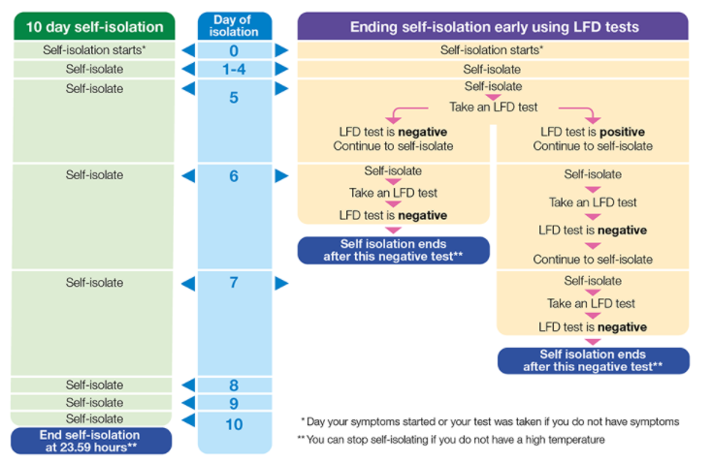

School will inform you when we have hit a trigger and have an outbreak. We will also let you know when the classes can rejoin the rest of school. This is 10 days after the last confirmed case.

Please complete the lateral flows first thing in the morning so that after two tests your children can return to school as soon as possible.

Parking
The containers that were on site at Royd have now been removed from the car park. This should hopefully ease some of the parking pressures on the neighbouring streets. If you are a parent/carer with a child at the afterschool club at Deepcar Pre school please do not use Royd staff car park to park your car whilst you collect your child. You will need to park on the road and walk down the path to collect your child.

I have continued to witness inappropriate parking. I have been in contact again with Sheffield City Council about asking for the wardens to return. In the coming weeks children at school are also going to go out on patrol and leave yellow tickets on any car that has been parked irresponsibly. Please return these tickets to the school office. Please think about the safety of our children on both sites.

Information Sessions for Parents/Carer
Staff are organising some virtual sessions for parents to attend. Please look out for these invites in the coming days.
Fundraising
Many thanks to everyone for supporting our recent charity collections and school fundraising.
We have raised the following amounts. We have such wonderful supportive parents at school. thankyou

Event | Royd NI | St John’s Junior
Wacky Hair Day | 105.70 | 70.00
Christmas Donations | 541.90 | 135.00
Christmas Jumper Day |  | 134.50

Young Voices
We have received a new provisional date of Friday 13th May 2022 for Young Voices for children that were due to attend from the KS2 choir.

Residentials

We have booked the following dates for residentials this year.

Year Group | Dates | Destination
Y2 | 15th - 17th June 2022 (1night stay) | Whirlow Hall Farm
Y3 | Details to follow
Y4 | 27th - 29th April 2022 (2 night stay) | The Oakes
Y5 | 15th- 17th June 2022 (2 night stay) | Kingswood
Y6 | 18th -19th May 2022 (1 night stay) | London

I will write to you with any new updates in the coming weeks. It has been a very busy and positive start to the year. Please do not hesitate to contact the school offices if you do have any queries.

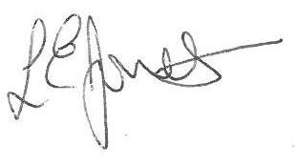
Yours sincerely,

Louise Jones, Executive Head

Deepcar St John’s

January 2022
27 - Sleeping Beauty Pantomime PM

February 2022
11- Wear red day – Valentine Day
14 - new playground equipment being fitted
21 - No School - training day

March 2022
- Parents evening
3- World Book Day
3 - Y5 CS/TR parents evening
18 - Red Nose Day
Royd Nursery Infant

January 2022
27- Sleeping Beauty Pantomime AM

February 2022
3 Parents Evening - All School
9 Parents Evening – FS1 only
10 Parents Evening (not FS1)
11- Wear Red Day - Valentine day
21- No School - training day
25- Rock Steady lessons begin

March 2022
3 - World Book Day
18- Red Nose Day

