

















**+**

**This document can be laminated & used at your reception for supply staff & visiting professionals, to help them to identify your safeguarding team quickly & enable them to share information easily**

**The Designated Safeguarding Lead**

Name: **Sean Sly**

Location: Head Teachers Office

**The Designated Safeguarding Deputy**

Name: **Louise Jones**

Location: Head Teachers Office

**Safeguarding Children Policy Front Sheet**

**Royd Nursery Infant School**

**Academic year: 2020 - 2021**

**Academic year: 2014-15**

**Any allegation or disclosure involving someone who works with children in a paid or voluntary capacity** **must** be reported directly to the Head Teacher, Principal or Senior Manager, unless it involves them and then it should be reported directly to the Chair of the Governing Body or Management Committee.

We all have a statutory duty to “safeguard and promote the welfare of children”.

If you have any concerns about the health and safety of a child at this education setting or feel that something may be troubling them, you should share this information with an appropriate member of staff straight away.

Some issues e.g. a child’s appearance, hygiene, general behaviour, can be shared with any teacher or member of support staff in this setting. Do not worry that you may be reporting small matters – we would rather that you tell us things which turn out to be small than miss a worrying situation.

**However, if you think the matter is very serious and may be related to a child protection concern, where the child has been harmed or is at risk of harm e.g. physical, sexual, emotional abuse or neglect, you must talk to one of the people below immediately. If you are unable to contact them you can ask the school office staff to find them and ask them to speak to you straight away about a confidential and urgent matter.**

The people you should talk to at this setting are:

**September 2020 www.safeguardingsheffieldchildren.org.uk**

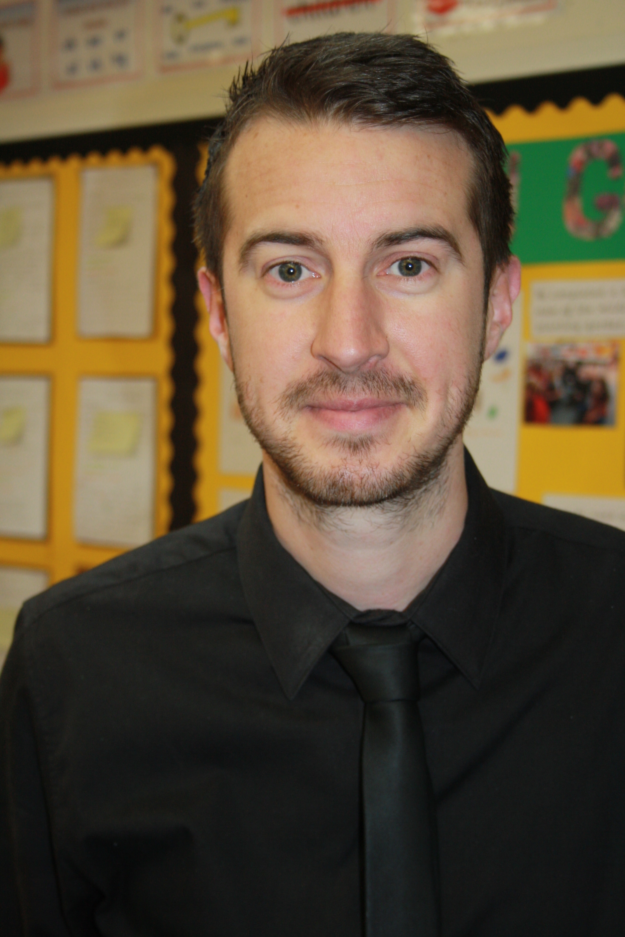t photo here

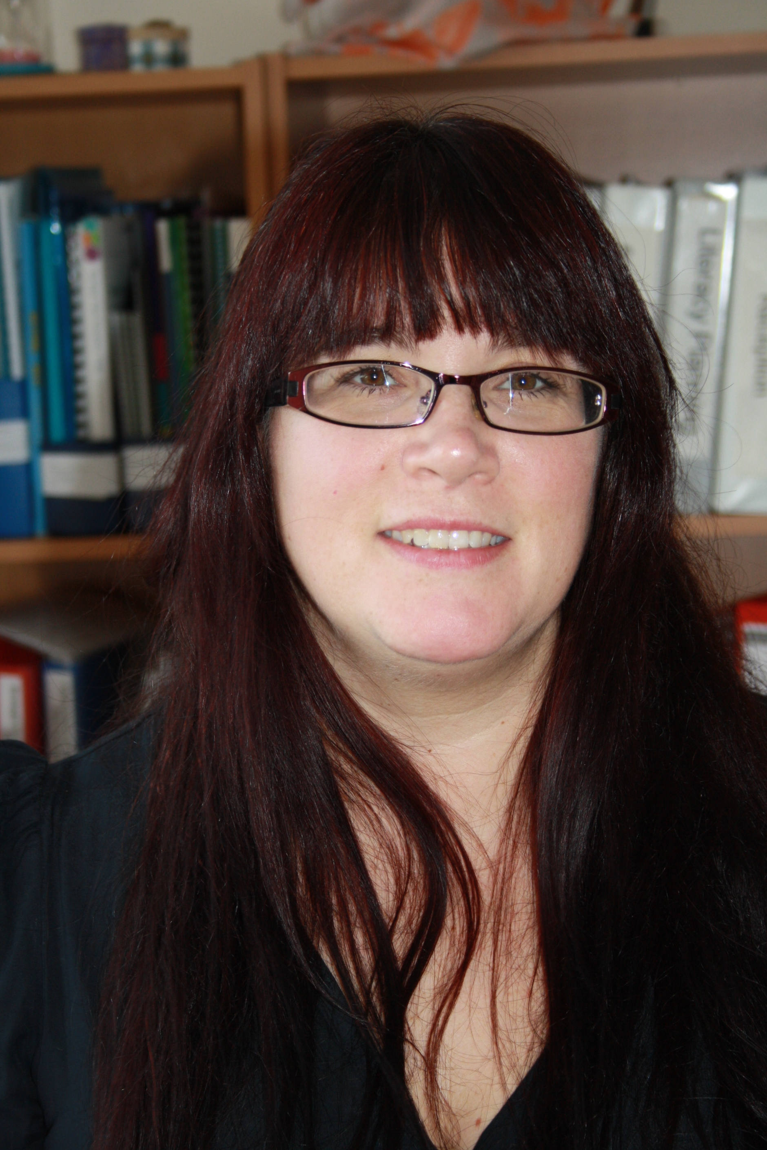 here

































**The Safeguarding Children Team in your setting includes:**

**Head Teacher/Senior Manager:** responsible for implementing policies & procedures, allocating resources to the safeguarding team & addressing staff safeguarding concerns.

Name**: Louise Jones** (Executive Head Teacher)

**Child Protection Liaison Teacher of Officer (CPLT/O):** a senior member of the leadership team, responsible for dealing with safeguarding issues, providing advice and support to other staff, liaising with the local authority, and working with other agencies.

Name: **Sean Sly** (Deputy Head Teacher)

**Deputy Child Protection Liaison Teacher or Officer (CPLT/O):** a member of theteaching, support or pastoral staff, in a post which requires assessment of children, with sufficient status & authority to effectively deputise for the CPLT/O role above. Cannot be an administrative or finance worker.

Name: **Louise Jones** (Executive Head Teacher)

**Special Educational Needs Coordinator (SENCo):** staff member who providesadvice, liaison & support for school staff and other agencies working with pupils with special education needs and their parents or carers.

Name: **Joanne Swales**

**Online Safety Coordinator:** to develop and maintain an e-safe culture within a school.

Name: **Sean Sly** (Deputy Head Teacher)

**Your Safeguarding Children Team also links in with the:**

**Safeguarding/Child Protection Governor:** ensures there are appropriate safeguarding children policies and procedures in place, monitors whether they are followed and, together with the rest of the governing body, remedies deficiencies and weaknesses that are identified.

Name: **Jania Brookes**

**Chair of Governors:** takes the lead in dealing with allegations of abuse made against the Head Teacher (and other members of staff when the Head Teacher is not available), in liaison with the Local Authority; and on safe recruitment practices with the Head Teacher

Name: **Scott Mell**

**September 2020 www.safeguardingsheffieldchildren.org.uk**