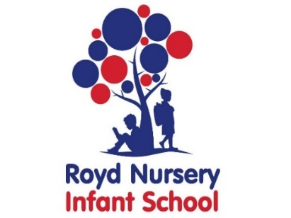

Royd Nursery Infant School

Carr Road, Deepcar

Sheffield, S36 2PR

Tel 0114 288 2594

Email [enquiries@royd.sheffield.sch.uk](mailto:enquiries@royd.sheffield.sch.uk)

[www.roydnurseryinfants.co.uk](http://www.roydnurseryinfants.co.uk)

Headteacher: Louise Jones

6 December 2021

Dear Parents/Carers of

For children in FS2, Y1 and Y2 we are running several afterschool clubs during the first Spring term. The letter for Y1 and Y2 football is attached and Choir has finished until Easter.

There is a new activity Boxercise. Sessions typically involve hitting focus pads but no class involves hitting an opponent. It is a fun, challenging and safe workout that also teaches self discipline.

If you would like your child to attend please return the form below by Monday 13 December 2021. Payment for clubs will be requested once places are confirmed. (This does not apply to football club where payment is required up front). Thank you.

Yours sincerely,

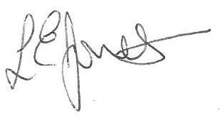

Louise Jones Sean Sly

Executive Head Acting Deputy Head

-------------------------------------------------------------------------------------------------------------------  
**After School Clubs Spring 1 2022**

Child’s Name : Class :

|  |  |  |  |  |  |  |
| --- | --- | --- | --- | --- | --- | --- |
| **Day** | **Activity** | **Time** | **Teacher** | **Cost** | **Dates** | **Y/N** |
| **Mon** | **Multi Skills** | **3.20 pm – 4.20 pm** | **Links** | **£15** | **10 Jan – 7 Feb**  **5 sessions** |  |
| **Tues** | **Dance** | **3.20 pm – 4.20 pm** | **Links** | **£18** | **4 Jan – 8 Feb**  **6 sessions** |  |
| **Fri** | **Boxercise** | **3.20 pm – 4.20 pm** | **Rachel Howard** | **£18** | **7 Jan – 11 Feb**  **6 Sessions** |  |

Signed ____________________________________________________ Parent/carer

December 2021

Dear Parents/Carers of

At Little Messys we aim to develop children's confidence, social skills and football skills through highly engaging games and challenges. We promote teamwork and sportsmanship in our sessions which reflect on their school life too.

We are now taking bookings for the Spring 1 term. This programme is open to Y1 and Y2 girls and boys of any ability. The block of sessions will commence on Wednesday 5 and Thursday 6 January for 5 weeks (last sessions Wednesday 9 and 10 February). There are a maximum of 12 places for each session which will be allocated on a first come first served basis. We will be playing on the school field next door or in the school hall so please bring appropriate clothing for indoor & outdoor PE (+ shinpads, Tracksuit bottoms, jumper, trainers and a water bottle).

If you wish your child to participate please fill in the registration form below indicating which session/sessions are preferred, and return it to the School Office.

An upfront CASH payment of £17.50 (£3.50 x 5 sessions or £35 for both days) will secure your child’s place for this block of sessions. ***Payment must be with the consent slip for a place to be reserved.***

For more information about Little Messys visit our website www.littlemessys.co.uk. Or check out our Facebook page Little Messys Sheffield .

Liam Ward, Little Messys. [Sheffield@littlemessys.co.uk](mailto:Sheffield@littlemessys.co.uk)

**IMPORTANT**

**Make sure whoever is picking up your child knows the PASSWORD you’ve set with school. Due to the schools safeguarding policy, we are not able to let children go until we get the password.**

--------------------------------------------------------------------------------------------------------------------------

**CHILD’S NAME**: **CLASS**:

PARENT NAME:________________________SIGNED:________________________

CONTACT NUMBER:_________________ Photo Consent (tick box for permission) [ ]

Preference : Wednesday Thursday Both days

MEDICAL OR ANY OTHER NEEDS WE SHOULD BE AWARE OF

:______________________________________________________________________

PLEASE ENCLOSE THIS TERMS PAYMENT OF £17.50 CASH (£35 if child is doing both days) WITH THIS RETURN SLIP TO THE SCHOOL RECEPTION TO SECURE YOUR CHILD’S PLACE.