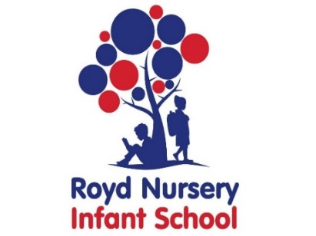

Royd Nursery Infant School

Carr Road, Deepcar

Sheffield, S36 2PR

Tel 0114 288 2594

Email [enquiries@royd.sheffield.sch.uk](mailto:enquiries@royd.sheffield.sch.uk)

[www.roydnurseryinfants.co.uk](http://www.roydnurseryinfants.co.uk)

Headteacher: Louise Jones

7 February 2022

Dear Parents/Carers

For children in FS2, Y1 and Y2 we are running several afterschool clubs during the next half term. Football for Y1/Y2 is yet to be confirmed.

If you would like your child to attend please return the form as soon as possible or email pstuart@royd.sheffield.sch.uk. Payment for clubs will be requested after the half term holiday. Thank you.

Yours sincerely,

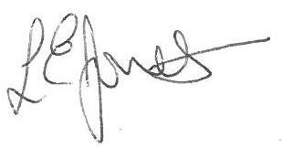

Louise Jones Sean Sly

Executive Head Acting Deputy Head

-------------------------------------------------------------------------------------------------------------------  
**After School Clubs Spring 2 2022**

Child’s Name : Class :

|  |  |  |  |  |  |  |
| --- | --- | --- | --- | --- | --- | --- |
| **Day** | **Activity** | **Time** | **Teacher** | **Cost** | **Dates** | **Y/N** |
| **Mon** | **Multi Skills** | **3.20 pm – 4.20 pm** | **Links** | **£15** | **28 Feb – 28 Mar**  **5 sessions** |  |
| **Mon** | **Purple Mash** | **3.20 pm – 4.20 pm** | **Mrs Staniland** | **£15** | **28 Feb – 28 Mar**  **5 sessions** |  |
| **Tues** | **Dance** | **3.20 pm – 4.20 pm** | **Links** | **£18** | **22 Feb – 29 Mar**  **6 sessions** |  |
| **Tues** | **Love of Reading** | **3.20 pm – 4.20 pm** | **Mrs Dobbs** | **£18** | **22 Feb – 29 Mar**  **6 sessions** |  |
| **Fri** | **Boxercise** | **3.20 pm – 4.20 pm** | **Rachel Howard** | **£18** | **25 Feb – 1 Apr**  **6 Sessions** |  |

Signed ____________________________________________________ Parent/carer