

Royd Nursery Infant School

Carr Road, Deepcar

Sheffield, S36 2PR

Tel 0114 288 2594

Email [enquiries@royd.sheffield.sch.uk](mailto:enquiries@royd.sheffield.sch.uk)

[www.roydnurseryinfants.co.uk](http://www.roydnurseryinfants.co.uk)

Headteacher: Louise Jones

12 March 2020

Dear Parent/Carers,

Due to the continuing success of the aerobics sessions we have booked a further session. The dates are as follows;

* Reception Thursday 19 March
* Year 1 Wednesday 25 March
* Year 2 Thursday 26 March

We would love it for parent/carers to come and join in with your child. Parent/Carers need to arrive at 2.30 pm wearing suitable clothing and footwear. The session will take place on the big yard whatever the weather and will finish at 3pm.

If you would like to join us please complete and return the slip below or email Mrs Stuart on [pstuart@royd.sheffield.sch.uk](mailto:pstuart@royd.sheffield.sch.uk). We look forward to seeing you all.

Yours sincerely,

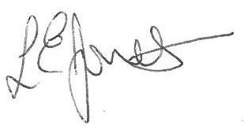



Louise Jones Sean Sly

Executive Head Acting Deputy Head

_____________________________________________________________________

**Aerobics Spring 2 2020**

Name of child: _Edgar Martins_______________________________ Class: 6

YES I/We would love to attend and will arrive for 2.30pm.

NO I/We will not be attending.

Signed ____________________________________________________ Parent/carer



