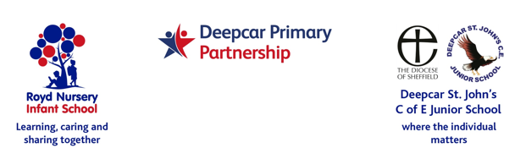

4th November 2021

Anti- Bullying Week

Dear Parents and Carers,

Monday 15th November 2021 it is the start of Anti Bullying week in schools. The theme this year is ‘One Kind Word’.

Kindness is more important today than it has ever been. The isolation of the last year has underlined how little acts of consideration can break down barriers and brighten the lives of the people around us.

This is one of the reasons that ‘One Kind Word’ was chosen as this year’s theme and will also be the theme for assemblies over the week.

We will start the week off by holding an odd socks day on Monday 15th November 2021.

I hope the children enjoy choosing their odd socks and we look forward to seeing them next week.

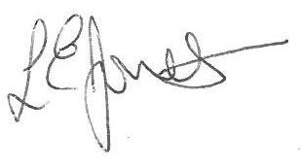
Yours sincerely,

Louise Jones
Executive Head

