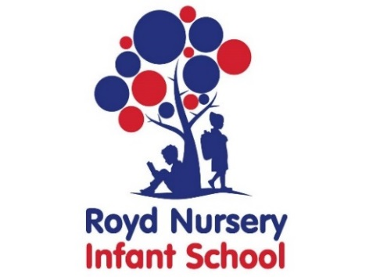
Royd Nursery Infant School
Carr Road, Deepcar
Sheffield, S36 2PR
Tel 0114 288 2594
Email enquiries@royd.sheffield.sch.uk
Executive Headteacher: Louise Jones

APPLICATION FORM FOR ROYD NURSERY

Please fill in and return to the School Office or email enquiries@royd.sheffield.sch.uk.

Name of child ………………………………………………………………………………….

Date of birth ……………………………………

Address ………………………………………………………………………………………...

Post Code ………………………………….

Name of Parent/Guardian ……………………………………………………………………

Email Address …………………………………………………………………………………

Telephone number ……………………………………………………………………………

Is there any information you think we need to know about your child, for instance, health problems, allergies, family problems?

……………………………………………………..……………………………………………

Which school do you expect your child to attend after nursery? ………………………...

N.B. Admission to a nursery school or class does not guarantee a place in school when your child reaches the normal age of admission and applications must be made in accordance with the Authority’s Policy.

N.B. Admission to a nursery school or class does not guarantee a place in school when
your child reaches the normal age of admission and applications must be made in
accordance with the Authority’s Policy.

Please contact the School if you need any more information.

Signed ……………………………………………………… Date …………………………..

N.B. Admission to a nursery school or class does not guarantee a place in school when your child reaches the normal age of admission and applications must be made in accordance with the Authority’s Policy.

N.B. Admission to a nursery school or class does not guarantee a place in school when your child reaches the normal age of admission and applications must be made in accordance with the Authority’s Policy.

N.B. Admission to a nursery school or class does not guarantee a place in school when your child reaches the normal age of admission and applications must be made in accordance with the Authority’s Policy.

