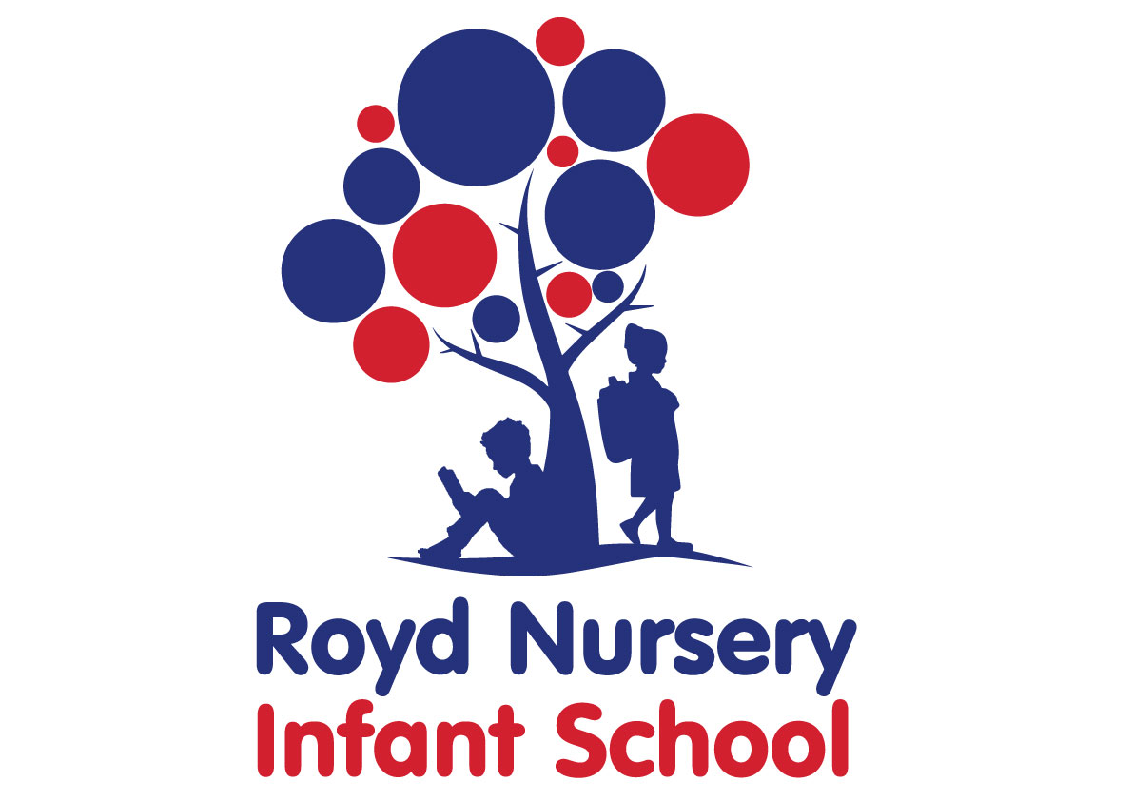
Policy: Art

Adopted by Governing Body on | September 2020
Headteacher | L Jones
Date of Review | September 2021

Contents:

Statement of intent
- Legal framework
- Roles and responsibilities
- The curriculum
- Cross-curricular links
- Teaching and learning
- Planning
- Assessment and reporting
- Resources and equipment
- Health and safety
- Homework
- Equal opportunities
- Monitoring and review

Statement of intent
Royd Nursery Infant School understands that art helps to engage, inspire and challenge pupils, equipping them with the knowledge and skills to experiment, invent and create their own works of art. Our school is committed to encouraging pupils’ curiosity and creativity, allowing them to think critically and develop a thorough understanding of art and its place in the world, including how it reflects our history and contributes to the culture, creativity and wealth of our nation.
By teaching art, we aim to ensure pupils:
- Produce creative work, exploring their ideas and recording their experiences.
- Become proficient in drawing and painting, sculpture and other art techniques.
- Can evaluate and analyse creative works using the language of art.
- Know about great artists and understand the historical and cultural development of their art forms.
- Enjoy an active involvement in art.
- Have the confidence and skills to communicate their ideas through their artwork.
- Have opportunities to experience a broad and balanced range of art activities and show progression within these.
- Become visually literate and able to identify and apply the key elements of art.
- Are given equal access to the experience of art, regardless of their gender, race or disability.

Legal framework
  - This policy has due regard to all relevant legislation and statutory guidance including, but not limited to, the following:
- DfE (2013) ‘Art and design programmes of study: key stages 1 and 2’
- DfE (2017) ‘Statutory framework for the early years foundation stage’
- Equality Act 2010
  - This policy operates in conjunction with the following school policies:
- Equal Opportunities Policy
- Assessment Policy
- SEND Policy

Roles and responsibilities
  - The Art subject leader and curriculum team is responsible for:
- Preparing policy documents, curriculum plans and schemes of work for art.
- Reviewing changes to the national curriculum and advising teachers on the implementation of these.
- Monitoring the learning and teaching of art, providing support for staff where necessary.
- Ensuring the continuity and progression from year group to year group.
- Helping to develop colleagues’ expertise in art.
- Organising the deployment of resources and carrying out an annual audit of all related resources.
- Liaising with teachers across all phases.
- Liaising with the SENCO about support for pupils with SEND.
- Communicating developments in the teaching of art to all teaching staff and the SLT as appropriate.
- Leading staff meetings and providing staff members with the appropriate training.
- Organising, providing and monitoring CPD opportunities in art.
- Ensuring common standards are met for recording and assessing pupil performance.
- Advising on the contribution of art to other curriculum areas, including cross-curricular links and extra-curricular activities.
- Collating assessment data and setting new priorities for the development of art in subsequent years.
  - The classroom teacher is responsible for:
- Acting in accordance with this policy.
- Ensuring the progression of pupils’ art skills, with due regard to the national curriculum.
- Planning lessons effectively, ensuring a range of teaching methods are used to cover the content of the national curriculum.
- Displaying pupils’ artwork in a way that enhances the learning environment and promotes a variety of ideas and designs.
- Liaising with the Art subject leader and curriculum team about key topics, resources and support for individual pupils.
- Monitoring the progress of the pupils in their class and reporting this to parents on an annual basis.
- Reporting any concerns regarding the teaching of the subjects to the Art subject leader and curriculum team or a member of the SLT.
- Undertaking any training that is necessary to effectively teach art.
- Evaluating schemes of work and maintaining the resources required to deliver lessons.
  - The SENCO is responsible for:
- Liaising with the Art subject leader and curriculum team to implement and develop specialist art-based learning throughout the school.
- Organising and providing training for staff regarding the curriculum for pupils with SEND.
- Advising staff on how best to support pupils’ needs.
- Advising staff on the inclusion of art in pupils’ individual education plans (IEPs).
- Advising staff on the use of TAs to meet pupils’ needs.

The curriculum
  - The school aims to assist pupils in achieving attainment targets set out in the national curriculum. By the end of each key stage, pupils are expected to know, apply and understand the matters, skills, and processes specified in the national curriculum. Pupils will learn a broad range of subject knowledge and draw on disciplines such as maths, science, computing and art.

EYFS
  - All pupils in the EYFS are taught art as an integral part of the topic work covered during the academic year.
  - All art objectives within the EYFS are underpinned by the following three prime areas outlined in the ‘Statutory framework for the early years foundation stage’:
- Communication and language
- Physical development
- Personal, social and emotional development
  - There are four specific areas through which the three prime areas are strengthened and applied:
- Literacy
- Mathematics
- Understanding the world
- Expressive arts and design
  - The art curriculum in the EYFS focusses on the specific areas of understanding the world and expressive arts and design.
  - Pupils will be taught to:
- Safely use and explore a variety of materials, tools and techniques, experimenting with colour, design and texture, form and function.
- Represent their own feelings through art, as well as music, dance, role play, storytelling and D&T.

KS1
  - Pupils will be taught:
- To use a range of materials creatively to design and make products
- To use drawing, painting and sculpture to develop and share their ideas, experiences and imagination.
- To develop a wide range of art techniques in using colour, pattern, texture, line, shape, form and space.
- About the work of a range of artists, describing the differences and similarities between different practices and disciplines and making links to their own work.

Cross-curricular links

English
  - Art enhances the teaching of English by encouraging pupils to ask and answer questions about the starting points for their work.
  - Pupils can compare ideas, methods and approaches in their work, comparing and sharing ideas with their peers.
  - Pupils can use art when creating and drawing images and designs in their English work, e.g. when creating stories with pictures.

Maths
  - Art contributes to the teaching of maths by enhancing pupils’ understanding of shape, space and measurement.

PSHE
  - Art is used to encourage pupils to discuss their feelings about their own work, as well as their peers’ work, and explain their work methods and approaches.

Spiritual, moral, social and cultural (SMSC) development
  - Teaching art offers opportunities to support the social development of pupils through the way they are expected to work with each other in lessons.
  - Art helps pupils to develop respect for other pupils’ abilities. Working in groups encourages collaboration and gives pupils the opportunity to learn from each other and share ideas and feelings.
  - Pupils develop an understanding and appreciation of different times, cultures and religions through their work on famous artists.

Computing
  - Pupils explore shape, colour and pattern in their work, and can collect visual information to help them develop their ideas.
  - Pupils can record their observations and manipulate them through editing or painting software to create their own designs.
  - Pupils can use the internet to explore famous artists and designers.

Teaching and learning
  - Art lessons are delivered through continuous provision for pupils in the EYFS. KS1 children receive a block of art lessons during topic lessons depending on whether art is a focus for that half term.
  - The school uses a variety of teaching and learning styles in art lessons that are matched to the activity and ability of pupils. The main aim of these lessons is to develop pupils’ knowledge, skills and understanding.
  - Teaching and learning styles are adapted to support pupils with SEND to ensure these pupils continue to have their confidence and self-esteem raised.
  - Teachers ensure pupils apply their knowledge and understanding when developing ideas, planning and producing artwork, and evaluating these.
  - Pupils will be taught to describe key characteristics and associated processes in common language, as well as understand and use technical terminology and specialist vocabulary.
  - The school uses a mixture of whole-class teaching, group work and individual activities. Pupils are given the opportunity to work on their own and collaborate with others, listening to their peers’ ideas and treating these with respect.
  - Principles for effective teaching include:
- Setting tasks in the context of pupils’ prior knowledge.
- Promoting active learning.
- Inspiring, exciting and motivating pupils to know more.
  - Strategies for effective teaching include:
- Ensuring the teaching methods used suit the purpose and needs of the pupils.
- Providing a meaningful context and clear purpose when assigning tasks.
- Using focussed practical tasks to help pupils develop and evaluate artwork.
- Ensuring tasks are built on skills and understanding.
  - The classroom teacher will work with the Art subject leader and curriculum team to ensure that the needs of all pupils are met by:
- Setting tasks which can have a variety of responses.
- Providing resources of differing complexity, according to the ability of the pupils.
- Setting tasks of varying difficulty, depending on the ability group.
- Utilising TAs to ensure that pupils are effectively supported.
  - As part of art, pupils are provided with topic books, which they are required to present their work in. The topic book is used to evidence pupils’ responses to a variety of information, through mark making, colour mixing, pattern work and other techniques.
  - Topic books are used for:
- Practising certain skills and features and gathering information to use on larger pieces of work in class.
- Practising drawing techniques, such as shading, colouring, perspective and drawing from different viewpoints.
- Recording details about drawings.
- Developing ideas for future studies.
- Gathering information to give specific knowledge of how things are made or work.
- Photographs
- Pictures from magazines, comics, cards, calendars, stamps, etc.
- Samples of textures, fabrics and other materials
- Colour strips from colour mixing
- Evaluations by pupils of their own work and the work of other artists
  - Topic books are an essential record of individual pupils’ experiences and ideas throughout a year, and will be seen as evidence for assessment and reporting purposes.
  - Displays of artwork on topic displays are used to celebrate achievement and support teaching and learning.
  - The school promotes displays of artwork on topic displays in classrooms to influence how pupils feel about their environment, convey standards and promote high expectations.
  - Displays are used to communicate ideas, stimulate interest, celebrate pupils’ work, reflect the ethos of the school and respond to pupils’ interests.

Planning
  - All relevant staff members are briefed on the school’s planning procedures as part of staff training.
  - Throughout school, art is taught as a discrete lesson and as part of cross-curricular themes when appropriate.
  - Teachers will use the key learning content in the DfE’s ‘Art and design programmes of study: key stages 1 and 2’ and the national curriculum as a starting point for their planning.
  - Issues of health and safety are addressed in the planning and delivery of the art curriculum.
  - Lesson plans will demonstrate a balance of interactive and independent elements used in teaching, ensuring that all pupils engage with their learning.
  - Lesson plans will demonstrate the balance of visual, auditory and kinaesthetic elements used in teaching, ensuring that all pupils with different learning styles can access the learning experience.
  - There will be a clear focus on direct, instructional teaching and interactive oral work with the whole class and targeted groups.
  - Planning of the art curriculum is focussed on creating opportunities for pupils to:
- Use a wide range of materials.
- Produce creative work, explore their ideas and record their experiences.
- Appreciate and understand the work of other artists and famous people.
- Record their ideas and plan for larger pieces of work.
- Learn how to gather and evaluate different materials.
- Become proficient in drawing, painting, sculpture and other art techniques.
- Evaluate and analyse their work and that of others using the language of art.
- Discuss ideas and planning with their peers.
- See that their work is valued, celebrated and displayed around the school.
  - The school creates long-term, medium-term and short-term plans for the delivery of the art curriculum – these are as follows:
- Long-term: includes the topics studied in each term during the key stage
- Medium-term: includes the details of work studied each term
- Short-term: includes the details of work studied during each lesson
  - The Art subject leader and curriculum team is responsible for reviewing and updating long-term and medium-term plans, and communicating these to teachers.
  - Teachers are responsible for reviewing and updating short-term plans, building on the medium-term plans, taking into account pupils’ needs and identifying the methods in which topics could be taught.
  - Long-term planning will be used to outline the units to be taught within each year group.
  - Medium-term planning will be used to outline the vocabulary and skills that will be taught in each unit of work, as well as highlight the opportunities for assessment.
  - Medium-term plans will identify learning objectives, main learning activities and differentiation.
  - Medium-term plans will be shared with the Art subject leader and curriculum team to ensure there is progression between years.
  - Short-term planning will be used flexibly to reflect the objectives of the lesson, the success criteria and the aims of the next lesson.
  - All lessons will have clear learning objectives, which are shared and reviewed with pupils.

Assessment and reporting
  - Pupils will be assessed, and their progression recorded, in line with the school’s Assessment Policy.
  - By the end of each key stage, pupils are expected to know, apply and understand the matters, skills and processes specified in the relevant programme of study.
  - An EYFS profile will be completed for each pupil in the final term of the year in which they reach age five.
  - The progress and development of pupils within the EYFS is assessed against the early learning goals outlined in the ‘Statutory framework for the early years foundation stage’.
  - The progress and development of pupils within KS1 is assessed against the descriptors outlined in the national curriculum.
  - Throughout the year, teachers will plan on-going creative assessment opportunities in order to gauge whether pupils have achieved the key learning objectives.
  - Assessment will be undertaken in various forms, including the following:
- Talking to pupils and asking questions
- Discussing pupils’ work with them
- Marking work against the learning objectives
- Pupils’ self-evaluation of their work
- Classroom tests and formal exams
  - Teachers will also assess pupils’:
- Knowledge of tools, materials and equipment.
- Ability to record and communicate their design ideas in a clear manner.
- Personal qualities and attitudes towards their work.
- Ability to explain what they have created and how.
- Ability to use tools and materials safely and effectively.
- Ability to evaluate their work and the work of others.
  - Teachers will record pupils’ ability and progression through two types of assessment – formative and summative.
  - Formative assessment, which is carried out informally throughout the year, will be used to identify pupils’ understanding of subjects and inform their immediate lesson planning.
  - In terms of summative assessments, the results of end-of-year assessments will be passed to relevant members of staff, such as pupils’ future teachers, in order to demonstrate where pupils are at a given point in time.
  - Summative assessments are also used at the end of a unit of work. Teachers will make a judgement about the work of each pupil in relation to the national curriculum.
  - Parents will be provided with a written report about their child’s progress during the Summer term every year. This will include information on pupils’ attitudes towards art, understanding of methods, investigatory skills and the knowledge levels they have achieved.
  - Verbal reports will be provided at parents’ evenings during the Autumn and Spring terms.
  - The progress of pupils with SEND will be monitored by the SENCO.

Resources and equipment
  - The school has a selection of centrally stored materials, tools and equipment to ensure that all pupils have access to the necessary resources.
  - The school library contains resources and topic books to support pupils’ research. The school receive books form Sheffield City Council Library on the topic focus for each half term. Books are displayed in the classroom linked to the half termly topic.
  - The art budget covers the cost of materials and replacement tools. Class teachers are required to maintain the tools and equipment in their classrooms.
  - Pupils may occasionally be asked to bring materials from home if they can; however, to provide all pupils with the same opportunities, the school will provide for pupils who are unable to do this.
  - Display walls are utilised and updated on a half termly basis, in accordance with the area of art being taught at the time.
  - At the start of each school year, the Art subject leader and curriculum team will work with the head teacher to assess the school’s art tools, materials and equipment to ensure there is sufficient equipment for pupils, allowing for funds to be allocated where necessary.

Health and safety
  - Staff members will act in accordance with the school’s Health and Safety Policy at all times.
  - Accidents and near-misses will be reported following the procedure outlined in the school’s Accident Reporting Procedure Policy.
  - All staff members will be shown how to correctly use equipment as part of their induction training.
  - Any ‘new’ activities which a teacher has not used in the classroom before will be trialled prior to being performed with pupils.
  - Pupils are allowed full access to a wide range of materials in art, to maximise their learning experience; however, health and safety concerns are inherent with this subject, including storing materials and tools, and the use of equipment.
  - PPE, such as gloves and eye protection, is made available to all pupils and teachers where required.
  - The risks of each task and the tools required will be assessed by the classroom teacher and Art subject leader and curriculum team before lessons, and relevant PPE will be compulsory based on their decisions.
  - All tools and equipment will be checked before the start of every lesson by the classroom teacher.
  - Pupils will be taught to use tools and equipment properly by the classroom teacher before use. They will also be fully briefed on the importance of how to correctly use tools and equipment.
  - All tools and equipment are stored in the store cupboard at the end of each day. Art equipment, such as paint, is stored on an art trolley or an art cupboard in each classroom. Classrooms are not accessed during lunch and break times by children to prevent unsupervised access to potentially harmful tools or equipment.

Homework
  - Homework will be set on a weekly basis and will follow and build upon curriculum content. The content of the homework will be decided by the class teacher and monitored by SLT. Throughout the academic year there will be a range of homework provided linked to differing subjects.
  - Parents will receive a weekly newsletter informing them about the main topics and units of work that will be covered.
  - Parents will be encouraged to discuss the homework that is set with their child. If they have any queries or other comments about the homework, parents should make an appointment to see their child’s class teacher.

Equal opportunities
  - We are an inclusive school that ensures all pupils are provided with equal learning opportunities, regardless of social class, gender, culture, race, disability or learning difficulties. Our Equal Opportunities Policy ensures all pupils are able to achieve their potential in all areas of the curriculum.
  - In order to ensure pupils with SEND achieve to the best of their ability, outcomes are adapted, and the delivery of the art curriculum is differentiated for these pupils, in line with the school’s SEND Policy.
  - The planning and organising of teaching strategies for art will be reviewed on an annual basis by the Art subject leader and curriculum team to ensure that no pupil is at a disadvantage.
  - The school aims to maximise the use and benefits of art as one of many resources to enable all pupils to achieve their full potential.

Monitoring and review
  - This policy will be reviewed on an annual basis by the Art subject leader and curriculum team and head teacher.
  - Any changes made to this policy will be communicated to all members of staff and the governing board.
  - All members of staff directly involved with teaching art are required to familiarise themselves with this policy.

