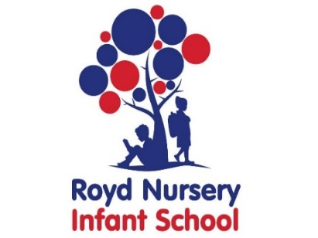

Royd Nursery Infant School

Carr Road, Deepcar

Sheffield, S36 2PR

Tel 0114 288 2594

Email [enquiries@royd.sheffield.sch.uk](mailto:enquiries@royd.sheffield.sch.uk)

[www.roydnurseryinfants.co.uk](http://www.roydnurseryinfants.co.uk)

Headteacher: Louise Jones

10 September 2021

Dear Parent/Carers of Year 1 and Year 2 children,

Mrs Musgrave, Class 8, will be leading the School Choir. Practice will be on Wednesday’s after school beginning next Wednesday 15 September 2021 ending Wednesday 8 December 2021. The practice will finish at 4.00 pm.

The choir may perform at local Christmas Fayres and letters with dates will follow in due course. School is also hoping that the Christmas play will be able to take place this year, unless Government guidance is changed, and practising for the songs needs to begin. For any child that is in the school choir this will be their role in the Christmas play.

If your child would like to join the choir, please complete the consent slip below and return it to the School Office as soon as possible or email Mrs Stuart in the office on pstuart@royd.sheffield.sch.uk. Thank you.

Yours sincerely,

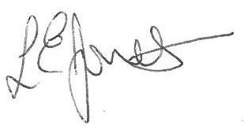

Louise Jones Sean Sly

Executive Head Acting Deputy Head

----------------------------------------------------------------------------------------------------------------

**Royd School Choir Autumn 2021**

Name of Child: Class:

I agree to my child joining the School Choir and attending practise sessions on Wednesday’s after school.

Signature : ______________________________________________ Parent / Carer



