18th March 2020
Dear Parents / Carers,
Further to the information sent out yesterday.
There may be the possibility in the near future that Deepcar St John’s and Royd Nursery Infant will be operating partial openings due to reduced staffing. We are currently operating with nearly a full staff compliment so this may be some time in the future but I am wanting to prepare for any eventuality.
If this occurs we will prioritise Year 2 and Year 6 pupils, pupils whose parent/carers work for the NHS, emergency services, social care or work in another school and pupils entitled to free school meals.
We will be sending a message out today to inform the parent/carers that their child has free school meals and is therefore a priority. If you do not receive a text this means that you are not in this category.
We are aware of some parent/carers that work for the NHS, emergency services, school staff from other schools and social care but not all. Can you please ring the school or email the office today to confirm that this is your profession so we know how many children we need to support at school.
Afterschool clubs
We are running the majority of afterschool clubs and you will have had notifcation if it has been cancelled. We are aiming to keep these going until the end of next week. Hopefully this will support parent/carers with childcare. If this changes we will contact you as soon as possible.
Many thanks for your support

Yours sincerely
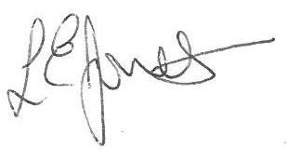
Louise Jones
Executive Head Teacher

