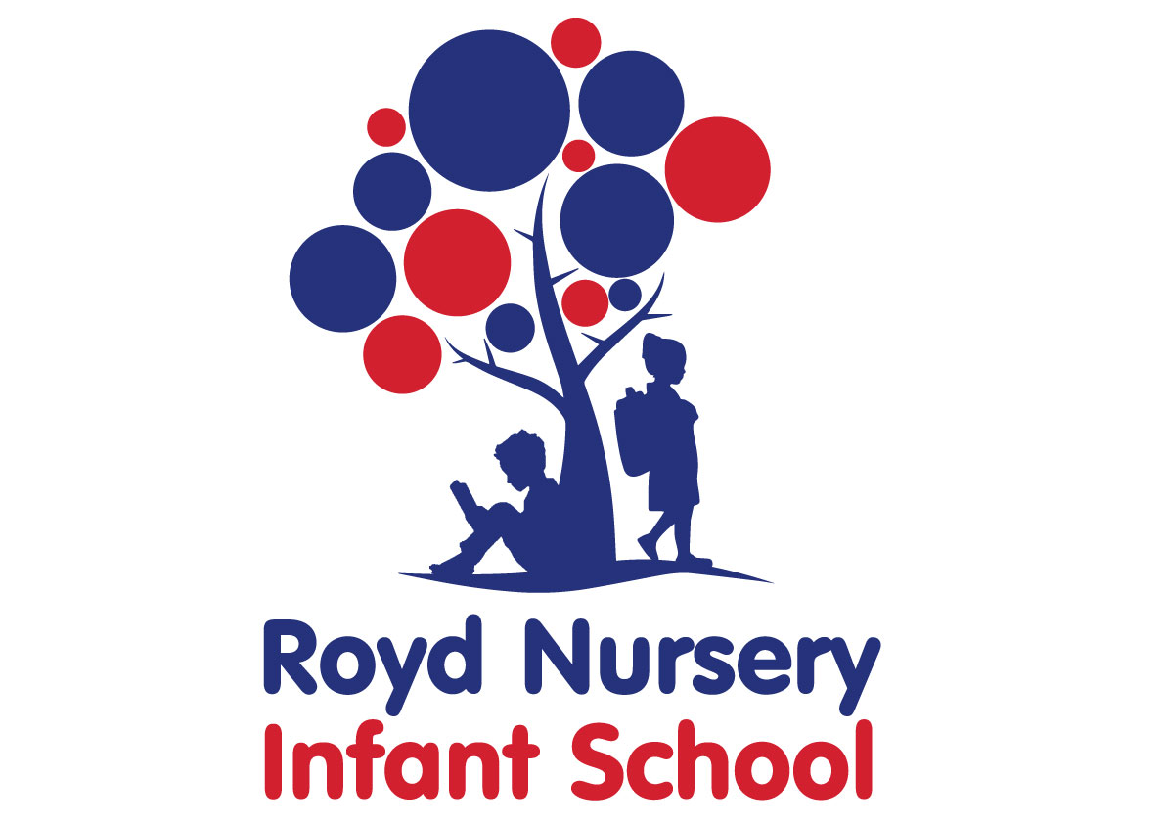

Policy: Curriculum Policy

Adopted by Governing Body on | September 2020
Headteacher | LJones
Date of Review | September 2021

Introduction
At Royd Nursery infant School we believe that the curriculum is a powerful tool that promotes a love of learning and willingness to explore and the time to have fun. We enrich the curriculum our curriculum based on the whole school ethos on mutual respect, equality and a sense of wonder at the world we live in. We are completely committed to developing the whole child. Our children will have the opportunity to be creative, physically active and to be academically challenged.
The curriculum is currently evolving at Royd Nursery infant school using the ‘Cornerstones’ programme. This makes link to the national curriculum (introduced in 2014) for Key Stage 1. Pupils in foundation stage follow the Early Years Foundation Stage Curriculum.

Values
We value the way in which all children are unique, and our curriculum promotes respect for the views of each individual child, as well as for people of all cultures. We value the spiritual and moral development of each person, as well as their intellectual and physical growth.
We value the importance of each person in our community. We organise our curriculum so that we promote cooperation and understanding between members of our community.
We value the rights enjoyed by each person in our society. We respect each child in our school for who they are, and we treat them with fairness and honesty. We aim to enable each person to be successful, and we provide equal opportunities for all the children in our school.
We value our environment, and we aim, through our curriculum, to teach respect for our world, and how we should care for it for future generations, as well as our own.
We values parents and work in partnership with them to enrich the curriculum. Parents are informed about the curriculum through newsletters, homework, curriculum workshops and invited to join in with their child during sessions. They are positively encouraged to become involved.
Aims and objectives
- To enable all children to understand that they are all successful learners
- To enable children to develop their own interests
- Promote a positive attitude towards learning, so that children enjoy coming to school, and acquire a solid basis for lifelong learning
- To teach the basic skills in English, maths , ICT and Science
- To enable children to be creative through art, dance, music, drama and DT
- To teach children to become healthy individuals who enjoy sports and appreciate the importance of a healthy life style
- To enable children to be positive citizens in society and to feel that they can make a difference
- To understand and respect other cultures
- To fulfil all the requirements for the national and new curriculum and the locally agreed syllabus for RE
- To teach children to have an awareness of their own spiritual development, and to understand right from wrong
- To help children understand the importance of truth and fairness, so that they grow up committed to equal opportunities for all
- To teach pupils to have respect for themselves and high self esteem, and to be able to live and work co-operatively with others
- To enable children to be active and take responsibility for their own health
- To develop their own thinking
- To enable pupils to take risks and ask questions
- To enable pupils to develop their own intellect including their emotional development

Organisation and Planning
We plan our curriculum in three stages
We agree a long term plan for each key stage. This indicates what topics are to be taught in each term.
Medium term plans give clear guidance on the objectives and teaching strategies that we use when teaching each topic. Key Stage 1 pupils are taught using the national curriculum (introduced in 2014). Short term plans are those that our teachers write on a weekly basis.

Special to Royd
- Foundation Stage children attend four sessions of Forest Schools activities
- Children in Y1 and Y2 make animations each term
- In Y2 all children contribute to making a film: Live action and animation. Many films are shortlisted for national and international competitions.

Foundation Stage
The curriculum we teach in the Foundation Stage base is the Early Years foundation Stage and we follow the Development Matters document. Our curriculum planning focuses on the three prime areas of
- communication and Language
- Physical development
- Personal, social and emotional development

and four specific areas of
- Literacy
- Mathematics
- Understanding the world
- Expressive arts and design
Our school fully supports the principle that young children learn through play and by engaging in well-planned structured activities. During the first few weeks the teacher begins to assesss each child. We are aware that all children need the support of parents and teachers to make good progress in school. We strive to build positive links with the parents of each child . This relationship is nurtured throughout their time in Foundation Stage and onto Key Stage 1.
Children with Special Educational Needs
The curriculum is designed to provide access and opportunity for all children who attend the school. If necessary the curriculum is adapted to meet the needs of individual children, then we do so only after the parents of the child have been consulted.
If a child has a special need, our school does all it can to meet their individual need. We comply with the requirements in the SEN code of practice in providing for children with SEND. If a child is displaying signs of having special needs, his/her teacher makes an assessment of their needs. In most instances the teacher is able to provide resources and educational opportunities which meet the child’s needs within the normal class room organisation. If a child’s needs is more severe they are referred to the appropriate external agency for further assessment.

Extra curricular activities
We are committed to developing the whole child. We extend the curriculum by offering extra curricular activities, including dance, gymnastics, football, keep fit clubs, Purple Mash, art, choir, recorders, gardening, imagination gaming. Most club are offered for half a term and then changed. A few clubs run all year eg choir.
Curriculum teams
The role of the curriculum team
- Provide a strategic lead and direction for the subject
- Support and offered advice to colleagues on issues related to the subject
- Monitor pupil progress in the subject area
- Provide efficient resource management for the subject area
It is the role of the curriculum team to keep up to date with developments in their subject both at national and local level. They review the way the subject is taught in school and plan for improvement. Development planning links to curriculum plans for each subject
Monitoring
Our governing body will be responsible for monitoring the school curriculum and its implementation. Governors liaise with curriculum team and class teachers.
The headteacher is responsible for the day to day organisation of the curriculum through planning, classroom observations, liaising with curriculum teams and SLT.
Review
This policy will be reviewed annually.

