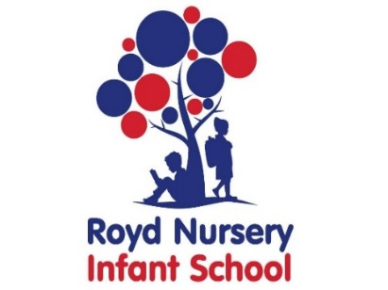

Royd Nursery Infant School

Carr Road, Deepcar

Sheffield, S36 2PR

Tel 0114 288 2594

Email [enquiries@royd.sheffield.sch.uk](mailto:enquiries@royd.sheffield.sch.uk)

[www.roydnurseryinfants.co.uk](http://www.roydnurseryinfants.co.uk)

Headteacher: Louise Jones

4 February 2022

Dear Parents/Carers

On Wednesday 23 February 2022 at 5.30 pm there will be an information session for FS1 and FS2 parents/carers on the new Early Years Foundation Stage (EYFS) Statutory Framework curriculum. It will be very informal and staff will provide information on

* What the new expectations in each area of learning will be
* What each child will be expected to do
* Ideas on how you can help your child

The meeting should last approximately 1 hour. We would encourage all parents/carers to attend to find out how to help their child learn and develop.

If you would like to attend please complete and return the slip below or email Ms Stuart [pstuart@royd.sheffield.sch.uk](mailto:pstuart@royd.sheffield.sch.uk) by by Monday 21 February 2022. A link will be sent out on Tuesday 22 February 2022 via parentmail.

Yours sincerely,

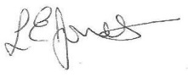

Louise Jones Sean Sly

Executive Head Acting Deputy Head

----------------------------------------------------------------------------------------------------

**FS1/2 Curriculum Information Session 23 February 2022**

Name of Child : Class :

I / we will be attending the curriculum session 5.30 pm.

I/we will not be attending the curriculum session.

Signed __________________________________________ Parent/Carer



