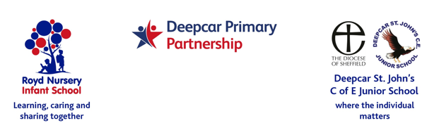**Harvey Begbie**

Dear Parent/Carers,

The Christmas Concerts for the Foundation children (Nursery and Reception) will be on Wednesday 8 December 2021 at 10 am and 2pm plus Wednesday 15 December 2021 at 10 am and 2 pm. Younger siblings are welcome to attend but please be aware they will sit on your knee and not have a separate seat. Should siblings begin to make a noise or become disruptive, please take them down to the School Office so children in the play are not distracted. Thank you.

Entry to the shows are free and we would really appreciate your support by purchasing raffle tickets on the day to help raise money for the School. These will be sold outside while people are queuing. If you have any items that you would like to donate for the raffle prizes it would be greatly appreciated. Please leave them in the School Office. Thank you.

Families are limited to two tickets per child and allocated on a first come first served basis. In the event that extra tickets are available please indicate on the slip overleaf or email Paula in the office on [pstuart@royd.sheffield.sch.uk](mailto:pstuart@royd.sheffield.sch.uk).

School has had low numbers of Covid cases in school due to the safety measures in place and there are two additional performances this year to ensure spacing between seats. We are asking all attendees to please complete a lateral flow test and wear masks to the event.

To reduce the time in school

* raffle tickets will be sold outside with winners announce via Parentmail after the event
* Photographs are not allowed during the event. Individual photographs will be taken during dress rehearsal and sent home to parents/carers.
* Windows and doors will be open to increase ventilation. Please wear layers as it could be cold.
* You will be asked to hand sanitise on entry.

Please be aware that children will be singing. Parents/carers are to make their own decision about attending and risk assess against mixing with and the possibility of it affecting them. If we have an outbreak in school concerts may be cancelled. This would be under advice from Public Health.

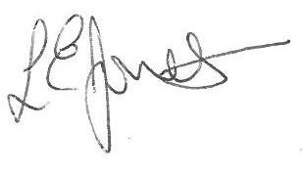Yours sincerely,



Louise Jones Sean Sly

Executive Head Acting Deputy Head

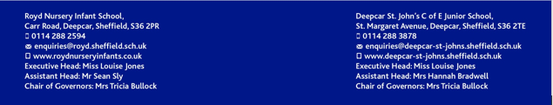



**Foundation Stage Christmas Concert 2021**

Child’s Name : Harvey Begbie Class : R1

**Please remember a total of only two seats per family**.

Wednesday 8 December 2 pm

10 am - State number of tickets required – (maximum of two.)

2 pm - State number of tickets required – (maximum of two.)

Wednesday 15 December 2 pm

10 am - State number of tickets required – (maximum of two.)

2 pm - State number of tickets required – (maximum of two

Yes I/we would like extra tickets, should they be available