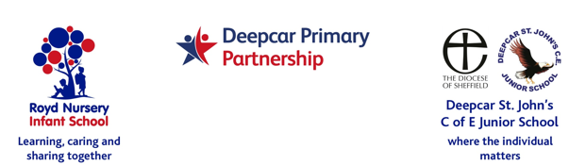
14th January 2022

Dear Parents/Carers

Several years ago Royd Nursery Infant School hosted paediatric first aid training by a training company for Parents/Carers and it was well attended. I am trying to gauge interest in hosting a similar course in the coming months.

The course would be all day and, although not certified, it would cover everything Parents/Carers need to know. School would subsidise the cost, which will depend on the level of interest however, as a guideline, it would be around £10 per person.

If you are interested in attending, please complete the slip below and return to school by Friday 28th January 2022 stating the days that are best for you. After this date I will organise the best day(s) to suit as many as possible and confirm the course details. Thank you.

Yours sincerely,
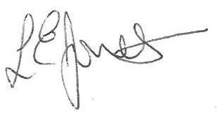
Louise Jones
Head Teacher
-------------------------------------------------------------------------------------------------------------
Parent / Carer First Aid Course 2022

Name of Child: Class :

Name of parent: ________________________________________________

Days of the week that best suit me are (please tick boxes)

Mon Tues Wed Thurs Frid

