ROYD & ST. JOHNS

WANT TO HELP YOUR CHILD WITH LEARNING AND GIVE THEM A POSITIVE MINDSET?
IF YOU BELIEVE YOU CAN, YOU WILL!
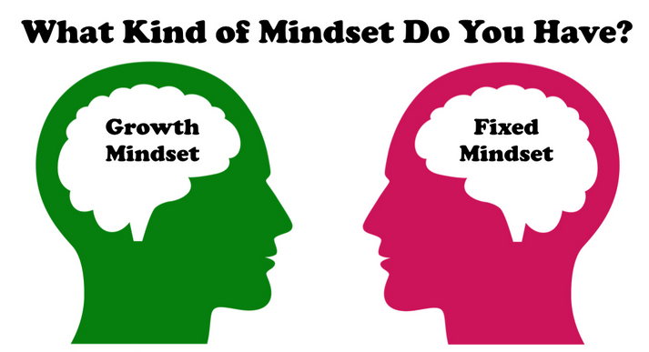

Come and find out!
A must do Workshop for all parents
ONLINE ONLY
KEEP POSITIVE
Sign up for either of these dates:-
PREPARE THEM FOR LIFE!
Monday 28th February 10 – 11 am
Tuesday 8th March 1 – 2 pm
(You will receive a Zoom Link)

