8th February 2022
Dear Parents / Carers,
I am really pleased to inform you that we have managed to organise some family learning sessions with the team from Sheffield.
You may have heard of the term ‘Growth Mindset’. Come and find out more at one of the sessions – details on attached flyer.
Do you have trouble with your child saying ‘I can’t do it’ or giving up before they have tried. Do they need to develop their resilience when they find things difficult in life?
The focus of the session is Growth Mindset. As schools we try and improve children’s mindset as having this attitude will increase success for children as they become adults.
The sessions will take place on Monday 28th February between 10am-11am and Tuesday 8th March between 1pm and 2 pm. You only need to attend one session.
We are expecting to have a large amount of interest in these sessions and places are limited. The sessions are virtual and we will need you to complete an enrolment form.
Please fill in the details below and return by Wednesday 23rd February 2022.
Yours sincerely,
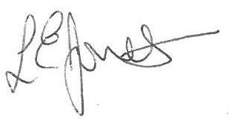

Louise Jones
Executive Headteacher
- - - - - - - - - - - - - - - - - - - - - - - - - - - - - - - - - - - - - - - - - - - - - - - - - - - - - - - - - - - - - - - - -
Growth Mindset Parent/Carer Session

Name of Pupil : ______________________________ Year Group ____

Name of parent attending :______________________________________

Email address :_______________________________________________

I/We wish to attend

Monday 28th February 10am - 11am

Or

Tuesday 8th March 1pm - 2pm

