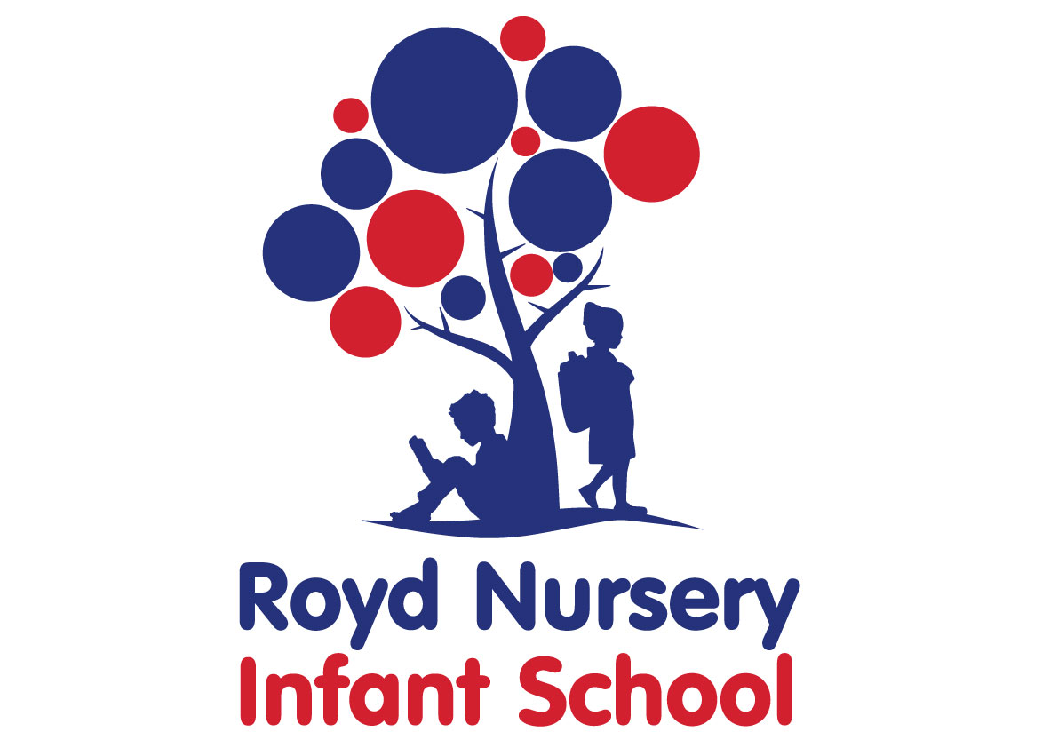
Policy: History

Adopted by Governing Body on | September 2020
Headteacher | L Jones
Date of Review | September 2021

Contents:
Statement of intent
- Legal framework
- Roles and responsibilities
- The curriculum
- Cross-curricular links
- Teaching and learning
- Planning
- Assessment and reporting
- Resources and equipment
- Health and safety
- Homework
- Equal opportunities
- Monitoring and review

Statement of intent

At Royd Nursery Infant School we believe that, through the study of history, children make sense of their world and enrich their understanding of it.
This policy sets out the framework in which the history curriculum will be taught.
Through this curriculum, children will understand the similarities and differences between societies and cultures, and the impact of changes on people and place.

Legal framework
  - This policy has due regard to statutory guidance, including, but not limited to, the following:
- DfE (2013) ‘History programmes of study: key stages 1 and 2.
- DfE (2017) ‘Statutory framework for the early years foundation stage’

Roles and responsibilities
  - The History subject leader and curriculum team is responsible for:
- Preparing policy documents, curriculum plans and schemes of work for history.
- Reviewing changes to the national curriculum and advising teachers on their implementation.
- Monitoring the learning and teaching of history, providing support for staff where necessary.
- Ensuring the continuity and progression from year group to year group.
- Encouraging staff to provide effective learning opportunities for pupils.
- Helping to develop colleagues’ expertise in the subject.
- Organising the deployment of resources and carrying out an annual audit of all history-related resources.
- Liaising with teachers across all phases.
- Communicating developments in the teaching of history to all teaching staff and the SLT, as appropriate.
- Leading staff meetings and providing staff members with the appropriate training.
- Organising, providing and monitoring CPD opportunities in the subject.
- Ensuring common standards are met for recording and assessing pupil performance.
- Advising on the contribution of history to other curriculum areas, including cross-curricular and extra-curricular activities.
- Collating assessment data and setting new priorities for the development of history in subsequent years.
  - The classroom teacher(s) is/are responsible for:
- Acting in accordance with this policy.
- Ensuring progression of pupils’ historical skills, with due regard to the national curriculum.
- Planning lessons effectively, ensuring a range of teaching methods are used to cover the content of the national curriculum.
- Liaising with the History subject leader and curriculum team about key topics, resources and support for individual pupils.
- Monitoring the progress of pupils in their class and reporting this on an annual basis to parents.
- Reporting any concerns regarding the teaching of the subject to the History subject leader and curriculum team or a member of the SLT.
- Undertaking any training that is necessary in order to effectively teach the subject.
  - The special educational needs coordinator (SENCO) is responsible for:
- Liaising with the History subject leader and curriculum team in order to implement and develop specialist history based learning throughout the school.
- Organising and providing training for staff regarding the history curriculum for pupils with special educational needs and disabilities (SEND).
- Advising staff how best to support pupils’ needs.
- Advising staff on the inclusion of historical objectives in pupils’ individual education plans.
- Advising staff on the use of teaching assistants in order to meet pupils’ needs.

The curriculum
  - The school aims to assist pupils in achieving attainment targets set out in the national curriculum. By the end of each key stage, pupils are expected to know, apply and understand the matters, skills, and processes specified in the national curriculum. Pupils will learn a broad range of subject knowledge and draw on disciplines such as maths, science, computing and art.

EYFS
  - All pupils in the EYFS are taught history as an integral part of the topic work covered during the academic year.
  - All history objectives within the EYFS are underpinned by the following three prime areas outlined in the ‘Statutory framework for the early years foundation stage’:
- Communication and language
- Physical development
- Personal, social and emotional development
  - There are four specific areas through which the three prime areas are strengthened and applied:
- Literacy
- Mathematics
- Understanding the world
- Expressive arts and design
  - The history curriculum in the EYFS focusses on the specific areas of understanding the world.
  - Pupils will be taught to:
- Talk about past and present events in their own lives and lives of family members.
- Remembers and talks about significant events in their own experiences.
- Recognises and describes special times or events for family or friends

KS1
  - Pupils will be taught about:
- changes within living memory. Where appropriate, these should be used to reveal aspects of change in national life.
- events beyond living memory that are significant nationally or globally [for example, the Great Fire of London, the first aeroplane flight or events commemorated through festivals or anniversaries].
- the lives of significant individuals in the past who have contributed to national and international achievements. Some should be used to compare aspects of life in different periods [for example, Elizabeth I and Queen Victoria, Christopher Columbus and Neil Armstrong, William Caxton and Tim Berners-Lee, Pieter Bruegel the Elder and LS Lowry, Rosa Parks and Emily Davison, Mary Seacole and/or Florence Nightingale and Edith Cavell]
- significant historical events, people and places in their own locality.

Cross-curricular links
  - English
- Pupils write information texts comparing places and are always encouraged to use the aspects of the English National Curriculum in topic writing.

  - Mathematics
- Pupils further develop their mathematical skills by ordering numbers/days/dates on timelines.
  - Computing
- Pupils learn to use technology to research historical events, and enhance their research skills through the internet and CD ROMs.
- Pupils are able to present their work using programs such as Word and PowerPoint.
  - Spiritual, moral, social and cultural development
- Pupils learn to express their feelings.
- Group activities develop pupils’ social skills and help them to cooperate with other people outside of their friendship group.
- Pupils are encouraged to respect other pupils’ views.

Teaching and learning
  - History lessons are delivered through continuous provision for pupils in the EYFS. KS1 children receive a block of history lessons during topic lessons depending on whether history is a focus for that half term.
  - The school uses a variety of teaching and learning styles in history lessons that are matched to the activity and ability of pupils. The main aim of these lessons is to develop pupils’ knowledge, skills and understanding.
  - Teaching and learning styles are adapted to support pupils with SEND to ensure these pupils continue to have their confidence and self-esteem raised.
  - Teachers ensure pupils apply their knowledge and understanding when developing ideas, planning and producing music, and evaluating these.
  - Pupils will be taught to describe key characteristics and associated processes in common language, as well as understand and use technical terminology and specialist vocabulary.
  - The school uses a mixture of whole-class teaching, group work and individual activities. Pupils are given the opportunity to work on their own and collaborate with others, listening to their peers’ ideas and treating these with respect.
  - Principles for effective teaching include:
- Setting tasks in the context of pupils’ prior knowledge.
- Promoting active learning.
- Inspiring, exciting and motivating pupils to know more.
  - Strategies for effective teaching include:
- Ensuring the teaching methods used suit the purpose and needs of the pupils.
- Providing a meaningful context and clear purpose when assigning tasks.
- Using focussed practical tasks to help pupils develop and evaluate history work.
- Ensuring tasks are built on skills and understanding.
  - The classroom teacher will work with the History subject leader and curriculum team to ensure that the needs of all pupils are met by:
- Setting tasks which can have a variety of responses.
- Providing resources of differing complexity, according to the ability of the pupils.
- Setting tasks of varying difficulty, depending on the ability group.
- Utilising TAs to ensure that pupils are effectively supported.
  - As part of history, pupils are provided with topic books, which they are required to present their work in. The topic book is used to evidence pupils’ responses to a variety of information.
  - Topic books are an essential record of individual pupils’ experiences and ideas throughout a year, and will be seen as evidence for assessment and reporting purposes.
  - Displays of history work on topic displays are used to celebrate achievement and support teaching and learning.
  - The school promotes displays of history work on topic displays in classrooms to influence how pupils feel about their environment, convey standards and promote high expectations.
  - Displays are used to communicate ideas, stimulate interest, celebrate pupils’ work, reflect the ethos of the school and respond to pupils’ interests.

Planning
  - All relevant staff members are briefed on the school’s planning procedures as part of staff training.
  - Throughout school, history is taught as a discrete lesson and as part of cross-curricular themes when appropriate.
  - Teachers will use the key learning content in the DfE’s ‘History programmes of study: key stages 1 and 2’ and the national curriculum as a starting point for their planning.
  - Issues of health and safety are addressed in the planning and delivery of the history curriculum.
  - Lesson plans will demonstrate a balance of interactive and independent elements used in teaching, ensuring that all pupils engage with their learning.
  - Lesson plans will demonstrate the balance of visual, auditory and kinaesthetic elements used in teaching, ensuring that all pupils with different learning styles can access the learning experience.
  - There will be a clear focus on direct, instructional teaching and interactive oral work with the whole class and targeted groups.
  - The school creates long-term, medium-term and short-term plans for the delivery of the history curriculum – these are as follows:
- Long-term: includes the topics studied in each term during the key stage
- Medium-term: includes the details of work studied each term
- Short-term: includes the details of work studied during each lesson
  - The History subject leader and curriculum team is responsible for reviewing and updating long-term and medium-term plans, and communicating these to teachers.
  - Teachers are responsible for reviewing and updating short-term plans, building on the medium-term plans, taking into account pupils’ needs and identifying the methods in which topics could be taught.
  - Long-term planning will be used to outline the units to be taught within each year group.
  - Medium-term planning will be used to outline the vocabulary and skills that will be taught in each unit of work, as well as highlight the opportunities for assessment.
  - Medium-term plans will identify learning objectives, main learning activities and differentiation.
  - Medium-term plans will be shared with the History subject leader and curriculum team to ensure there is progression between years.
  - Short-term planning will be used flexibly to reflect the objectives of the lesson, the success criteria and the aims of the next lesson.
  - All lessons will have clear learning objectives, which are shared and reviewed with pupils.

Assessment and reporting
  - Pupils will be assessed, and their progression recorded, in line with the school’s Assessment Policy.
  - By the end of each key stage, pupils are expected to know, apply and understand the matters, skills and processes specified in the relevant programme of study.
  - An EYFS profile will be completed for each pupil in the final term of the year in which they reach age five.
  - The progress and development of pupils within the EYFS is assessed against the early learning goals outlined in the ‘Statutory framework for the early years foundation stage’.
  - The progress and development of pupils within KS1 is assessed against the descriptors outlined in the national curriculum.
  - Throughout the year, teachers will plan on-going creative assessment opportunities in order to gauge whether pupils have achieved the key learning objectives.
  - Assessment will be undertaken in various forms, including the following:
- Talking to pupils and asking questions
- Discussing pupils’ work with them
- Marking work against the learning objectives
- Pupils’ self-evaluation of their work
- Classroom tests and formal exams
  - Teachers will record pupils’ ability and progression through two types of assessment – formative and summative.
  - Formative assessment, which is carried out informally throughout the year, will be used to identify pupils’ understanding of subjects and inform their immediate lesson planning.
  - In terms of summative assessments, the results of end-of-year assessments will be passed to relevant members of staff, such as pupils’ future teachers, in order to demonstrate where pupils are at a given point in time.
  - Summative assessments are also used at the end of a unit of work. Teachers will make a judgement about the work of each pupil in relation to the national curriculum.
  - Parents will be provided with a written report about their child’s progress during the Summer term every year. This will include information on pupils’ attitudes towards art, understanding of methods, investigatory skills and the knowledge levels they have achieved.
  - Verbal reports will be provided at parents’ evenings during the Autumn and Spring terms.
  - The progress of pupils with SEND will be monitored by the SENCO.

Resources and equipment
  - The school has a selection of centrally stored materials, tools and equipment to ensure that all pupils have access to the necessary resources.
  - The school library contains resources and topic books to support pupils’ research. The school receive books form Sheffield City Council Library on the topic focus for each half term. Books are displayed in the classroom linked to the half termly topic.
  - The history budget covers the cost of materials and replacement tools. Class teachers are required to maintain the tools and equipment in their classrooms.
  - Pupils may occasionally be asked to bring materials from home if they can; however, to provide all pupils with the same opportunities, the school will provide for pupils who are unable to do this.
  - Display walls are utilised and updated on a half termly basis, in accordance with the area of history being taught at the time.
  - At the start of each school year, the History subject leader and curriculum team will work with the head teacher to assess the school’s history tools, materials and equipment to ensure there is sufficient equipment for pupils, allowing for funds to be allocated where necessary.

Health and safety
  - Staff members will act in accordance with the school’s Health and Safety Policy at all times.
  - Accidents and near-misses will be reported following the procedure outlined in the school’s Accident Reporting Procedure Policy.
  - All staff members will be shown how to correctly use equipment as part of their induction training.
  - Any ‘new’ activities which a teacher has not used in the classroom before will be trialled prior to being performed with pupils.
  - Pupils are allowed full access to a wide range of materials in history, to maximise their learning experience; however, health and safety concerns are inherent with this subject, including storing materials and tools, and the use of equipment.
  - PPE, such as gloves and eye protection, is made available to all pupils and teachers where required.
  - The risks of each task and the tools required will be assessed by the classroom teacher and History subject leader and curriculum team before lessons, and relevant PPE will be compulsory based on their decisions.
  - All tools and equipment will be checked before the start of every lesson by the classroom teacher.
  - Pupils will be taught to use tools and equipment properly by the classroom teacher before use. They will also be fully briefed on the importance of how to correctly use tools and equipment.
  - All tools and equipment are stored in the resource room at the end of each day (e.g. artefacts). Classrooms are not accessed during lunch and break times by children to prevent unsupervised access to potentially harmful tools or equipment.

Homework
  - Homework will be set on a weekly basis and will follow and build upon curriculum content. The content of the homework will be decided by the class teacher and monitored by SLT. Throughout the academic year there will be a range of homework provided linked to differing subjects.
  - Parents will receive a weekly newsletter informing them about the main topics and units of work that will be covered.
  - Parents will be encouraged to discuss the homework that is set with their child. If they have any queries or other comments about the homework, parents should make an appointment to see their child’s class teacher.

Equal opportunities
  - We are an inclusive school that ensures all pupils are provided with equal learning opportunities, regardless of social class, gender, culture, race, disability or learning difficulties. Our Equal Opportunities Policy ensures all pupils are able to achieve their potential in all areas of the curriculum.
  - In order to ensure pupils with SEND achieve to the best of their ability, outcomes are adapted, and the delivery of the history curriculum is differentiated for these pupils, in line with the school’s SEND Policy.
  - The planning and organising of teaching strategies for history will be reviewed on an annual basis by the History subject leader and curriculum team to ensure that no pupil is at a disadvantage.
  - The school aims to maximise the use and benefits of history as one of many resources to enable all pupils to achieve their full potential.

Monitoring and review
  - This policy will be reviewed on an annual basis by the History subject leader and curriculum team and head teacher.
  - Any changes made to this policy will be communicated to all members of staff and the governing board.
  - All members of staff directly involved with teaching history are required to familiarise themselves with this policy.

