Tuesday 14th September 2021

Dear Parents and Carers,  
  
Next week, is the Great Big Green Week/Recycling Week and on Monday 20 September both schools will be have a ‘green’ day. Children can wear something green to school (children do not need to bring in any monetary donation).

There will be an assembly looking at the effect of climate change and how we can all help to reduce waste and staff at both schools will be running activities linked to recycling in their classroom. Other activities will include litter picks, switching off lights and computers when not in use and ensuring a reduction of waste paper. Also, if you have any used batteries these can be brought into school for recycling.

We are also asking parents/carers to try, wherever possible, to find active ways to travel to school and leave the car parked at home

Hopefully this will be a enjoyable day for all.

Yours sincerely

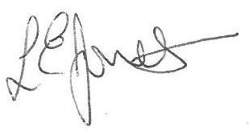

Louise Jones

Executive Head Teacher

 