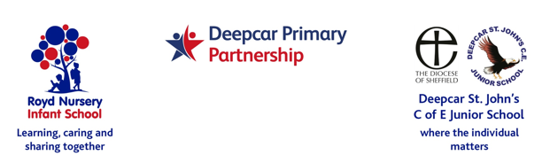

10 December 2021

Dear Parent/Carers,

Our topic in Year 1 and 2 will be ‘Rio di Vida’ and we have arranged for Music Specialists from the Sheffield Music Hub to work with the children on Brazilian music.

The event will be on Friday 7 January 2022 and the cost is £3.80 per child.

If you would like your child to take part please complete and return the slip below. Payment is by Parentmail and is to be received by Thursday 16 December 2021.

Thank you.

Yours sincerely,



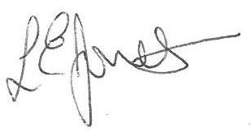

Louise Jones Sean Sly

Executive Head Acting Deputy Head

__________________________________________________________________

**KS1 Music Workshop 7 January 2022**

Name of child: Class:

YES I/We would like my child to attend the Brazilian music sessions on Friday 7 January 2022

Payment of £3.80 has been made by Parentmail

Signed __________________________________________________ Parent/carer

