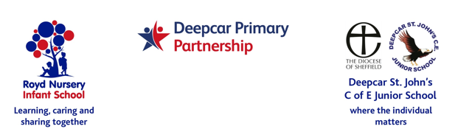

17th January 2022

Dear Parents/Carers,
This academic year Royd Nursery Infant are renewing our Leading Parent Partnership Award and Deepcar St John’s are applying for the award.
I am keen to get some parents/carers involved in the audit, action plan and activities this year. If you are interested in joining the working party please let me know by contacting the relevant school office.
Please see the attached sheet that explains the purpose of the award and get in touch if there is anything you would like to know.

Yours sincerely,
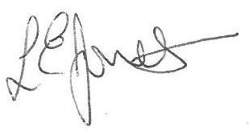
Louise Jones
Head Teacher

