Introducing the
Leading Parent Partnership Award at Royd Nursery Infant school and Deepcar St John’s Junior School

Royd Nursery Infant School is working towards renewing the Leading Parent Partnership Award and St John’s are working towards achieving it for the first time. The LPPA is a nationally recognised award achievable by schools who work very closely with the families of their pupils. The assessment is made by an external advisor.
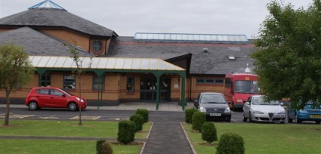
What do you have to do to achieve the award?

Both schools will work towards meeting 9 different objectives before we can achieve the award. These objectives are;

- The school demonstrates a commitment to work towards the Leading Parent Partnership Award.

- The school makes and implements effective plans to achieve and maintain the Leading Parent Partnership Award.

- The school is a welcoming, communicative and friendly place for parents.

- The school promotes the awareness and participation of all groups of parents in supporting their children’s learning and developing their own learning. In addition, the school holds and actively promotes a programme of opportunities and events for joint parent and child participation.

- The school provides a good induction for all new parents.

- The school provides parents with relevant and user-friendly guidance and information to help them support their children’s learning.

- The school produces and implements parent friendly policies to establish effective home-school links and to improve children’s attendance, punctuality, progress and positive participation in school.

- The school provides good support for all parents as their children move through or leave the school.

- The school summarises its achievements against the Leading Parent Partnership Award objectives and outlines its future plans.
What difference will it make to the work we already do with families at
The schools?

It will get even better! By consulting with parents and reviewing our work, we’ll improve our standards and achieve the LPPA!

What can families do to help both school achieve the award?
- Read all newsletters and publicity we send out
- Join in our events if you can
- Complete any questionnaires we send out as honestly as you can

We hope to achieve the award by
Summer 2022

We will keep you informed about our progress in our newsletter and look forward to seeing you!

