13th September 2021
Macmillan Coffee Morning

Dear Parents and Carers,

As a School we have been affected by cancer within our Staff and Pupils and I can imagine that everyone knows someone in their family or friendship group that has been affected by this disease.

On Friday 24th September 2021 we are asking for all children to wear something green or purple and bring in a monetary donation of £1. If you do not have this colour clothing then just wear something of a different colour.

We will also be selling cakes to the children for £1 a slice/bun during the day.

If you can help us and can donate a cake or buns to sell please bring in a named tin box on the morning of the 24th September, all donations would be greatly appreciated. Staff are getting involved and baking/bringing in something sweet to sell.

The money (£2) can be dropped into a collection box in each classroom and then the office staff will collate it several days later.

I am sure you are aware that all charities are really struggling as charity donations have reduced dramatically since coronavirus. Any support would be gratefully received. Thank you.

Yours sincerely
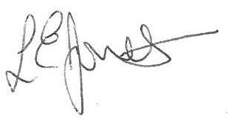
Executive Headteacher

