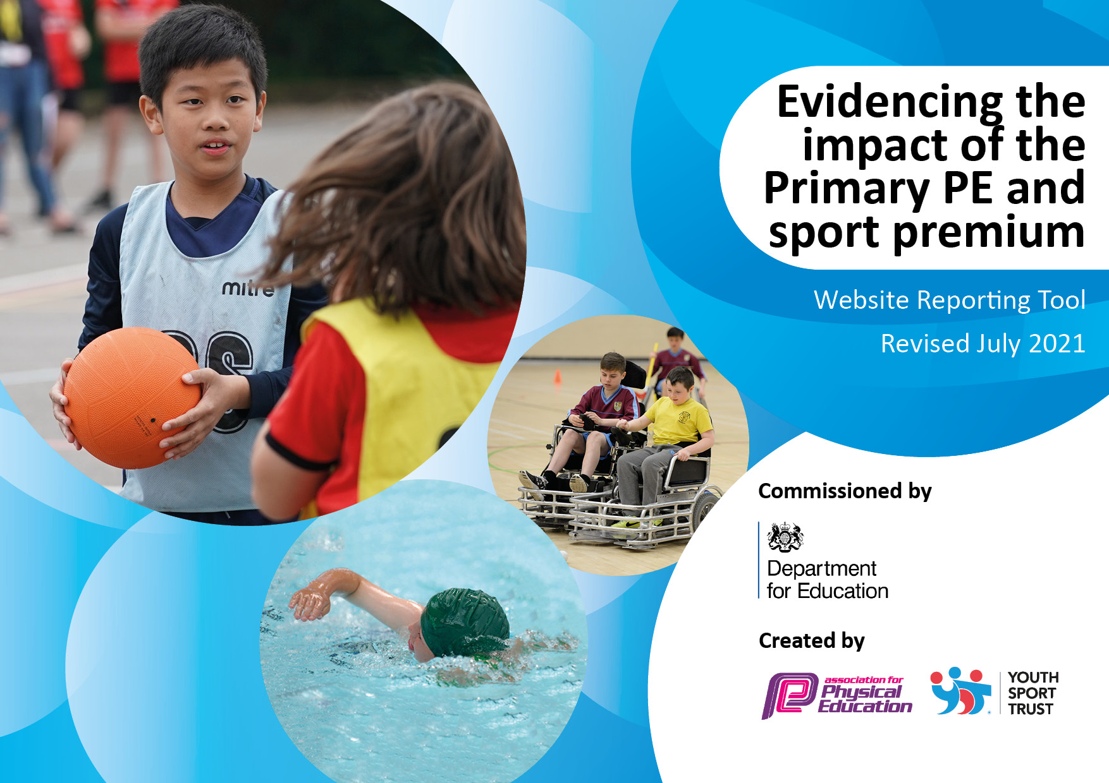



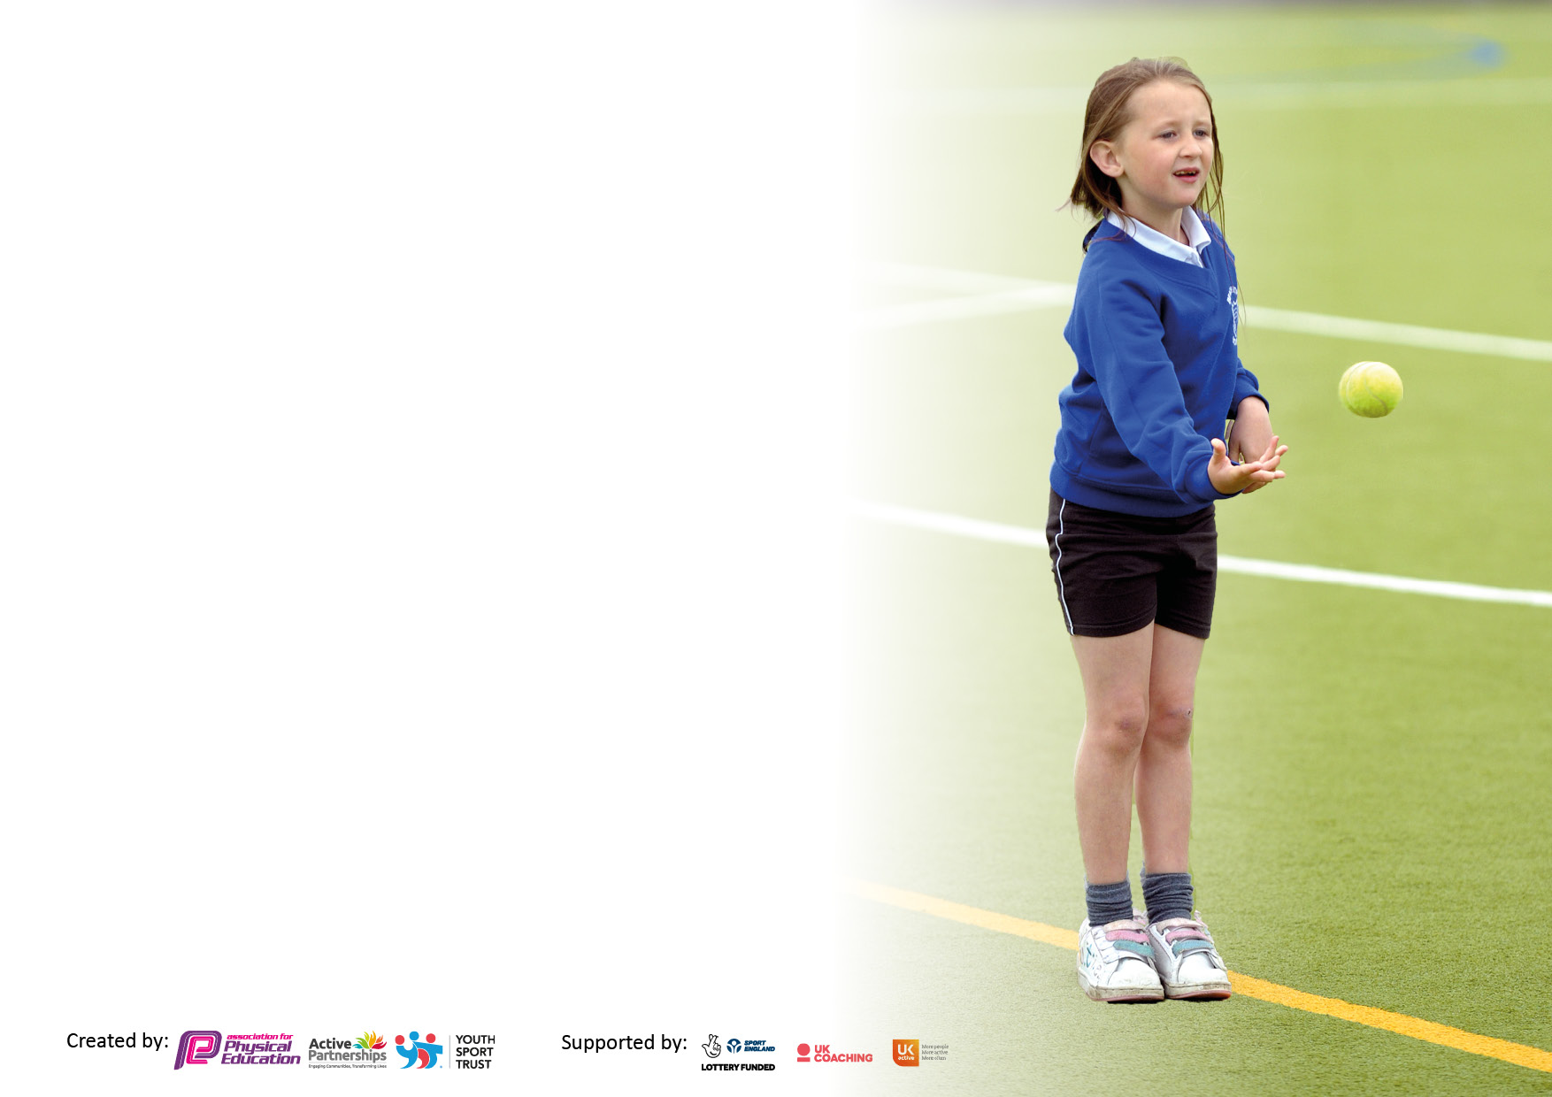

It is important that your grant is used effectively and based on school need. The [Education Inspection Framework](https://assets.publishing.service.gov.uk/government/uploads/system/uploads/attachment_data/file/843108/School_inspection_handbook_-_section_5.pdf) makes clear there will be a focus on **‘whether leaders and those responsible for governors all understand their respective roles and perform these in a way that enhances the effectiveness of the school’**.

Under the [Quality of Education](https://assets.publishing.service.gov.uk/government/uploads/system/uploads/attachment_data/file/843108/School_inspection_handbook_-_section_5.pdf) Ofsted inspectors consider:

**Intent** - Curriculum design, coverage and appropriateness

**Implementation** - Curriculum delivery, Teaching (pedagogy) and Assessment

**Impact** - Attainment and progress

To assist schools with common transferable language this template has been developed to utilise the same three headings which should make your plans easily transferable between working documents.

Schools must use the funding to make **additional and sustainable** improvements to the quality of Physical Education, School Sport and Physical Activity (PESSPA) they offer. This means that you should use the Primary PE and sport premium to:

* Develop or add to the PESSPA activities that your school already offer
* Build capacity and capability within the school to ensure that improvements made now will benefit pupils joining the school in future years
* The Primary PE and sport premium should not be used to fund capital spend projects; the school’s budget should fund these.

Pleasevisit[gov.uk](https://www.gov.uk/guidance/pe-and-sport-premium-for-primary-schools)fortherevisedDfEguidanceincludingthe5keyindicatorsacrosswhichschoolsshoulddemonstrate animprovement.Thisdocumentwillhelpyoutoreviewyourprovisionandtoreportyourspend.DfEencouragesschools to use this template as an effective way of meeting the reporting requirements of the Primary PE and sport premium.

We recommend you start by reflecting on the impact of current provision and reviewing the previous spend.

Schools are required to [publish details](https://www.gov.uk/guidance/what-maintained-schools-must-publish-online#pe-and-sport-premium-for-primary-schools) of how they spend this funding, including any under-spend from 2019/2020, as well as on the impact it has on pupils’ PE and sport participation and attainment. **All funding must be spent by 31st July 2022.**

We recommend regularly updating the table and publishing it on your website throughout the year. This evidences your ongoing self-evaluation of how you are using the funding to secure maximum, sustainable impact. Final copy must be posted on your website by the end of the academic year and no later than the 31st July 2021. To see an example of how to complete the table please click [HERE](http://www.afpe.org.uk/physical-education/wp-content/uploads/afPE-Example-Template-Indicator-2018-Final.pdf).



**Support for review and reflection - considering the 5 key indicators from DfE, what development needs are a priority for your setting and your pupils now and why? Use the space below to reflect on previous spend and key achievements and areas for development.**

|  |  |
| --- | --- |
| Key achievements to date until July 2020: | Areas for further improvement and baseline evidence of need: |
| **Royd achieved the KS1 Sheffield Sport Mark Gold award.**  **A sustainable CPD model has been implemented so that experienced staff receive 3 weeks of dance, gymnastics and games based coaching with the PE leader or a specialist coach whilst NQTs or newly appointed staff receive 6 weeks of dance, gymnastics and games based coaching.**  **Royd achieved the Sheffield School Sport Partnership Award for staff CPD.**  **Subject leader presented at the Sheffield School Partnership ceremony focusing on developing a sustainable CPD model.**  **Standards in PE lessons are rated as good/outstanding across school.**  **All children participate in 2 hours of quality PE provision.**  **Lunchtime supervisors have received CPD by the PE coordinator.**  **Levels of children participating in activities at lunchtimes have increased.**  **All KS1 children participate in “Active 15” weekly activity (either a mile of the week or a physical activity challenge including skipping, hopping, star jumps etc).**  **Royd attends the family of schools participation events for a range of sports.**  **Increased after school activities are on offer and the levels of children participating in activities has also increased.**  **Foundation Stage outdoor provision has developed and attainment in Physical Development is strong.**  **Subject leader has strong knowledge and attends the termly cluster of schools professional development and support meetings.**  **Staff meetings have been dedicated to PE and being active and in turn has raised the quality of PE lessons and increased the number of lessons that require physical activity across school.**  **The number of Teach Active (Maths of the Day) sessions across school has increased.**  **Foundation Stage have received the Charter Mark and have been recognised by the Local Authority as specialising in active maths sessions (supported through Teach Active (Maths of the Day) sessions.**  **Inspirational sports coaches and people to work with the children, either for a one-off day or a series of sessions have been introduced (e.g. Balance bikes, Judo).**  **Established intra-school competitions are in place (e.g. Royd Football World Cup and Multiskills).**  **Termly parent workshops were provided for parents and children so that they could participate in physical activity together (e.g. aerobics afternoon, skipping school).** | **To further invest in Foundation Stage 2 outdoor provision to provide broader opportunities for Physical Development activities.**  **To use Sports Leaders children from the Junior School to further enhance Physical Activity and target the “least active”**  **To develop increased confidence, knowledge and skills in outdoor adventure activities and athletics based on staffs RAG ratings.** |

**Details with regard to funding**

Please complete the table below.

|  |  |
| --- | --- |
| Total amount carried over from 2019/20 | £0 |
| Total amount allocated for 2020/21 | £17,030 |
| How much (if any) do you intend to carry over from this total fund into 2021/22? | £0 |
| Total amount allocated for 2021/22 | £16,960 |
| Total amount of funding for 2021/22. To be spent and reported on by 31st July 2022. | £16,960 |

**Swimming Data**

Please report on your Swimming Data below.

|  |  |
| --- | --- |
| Meeting national curriculum requirements for swimming and water safety.  N.B. Complete this section to your best ability. For example you might have practised safe self-rescue techniques on dry land which you can then transfer to the pool when school swimming restarts.  **Due to exceptional circumstances priority should be given to ensuring that pupils can perform safe self rescue even if they do not fully meet the first two requirements of the NC programme of study** |  |
| What percentage of your current Year 6 cohort swim competently, confidently and proficiently over a distance of at least 25 metres?  **N.B.** Even though your pupils may swim in another year please report on their attainment on leaving primary school at the end of the summer term 2020.  Please see note above | 68% |
| What percentage of your current Year 6 cohort use a range of strokes effectively [for example, front crawl, backstroke and breaststroke]?  Please see note above | 74% |
| **What percentage of your current Year 6 cohort perform safe self-rescue in different water-based situations?** | 94% |
| Schools can choose to use the Primary PE and sport premium to provide additional provision for swimming but this must be for activity **over and above** the national curriculum requirements. Have you used it in this way? | No |

**Action Plan and Budget Tracking**

Capture your intended annual spend against the 5 key indicators. Clarify the success criteria and evidence of impact that you intend to measure to evaluate for pupils today and for the future.

|  |  |  |  |  |
| --- | --- | --- | --- | --- |
| **Academic Year:** 2020 / 21 | **Total fund allocated:** £17,030 | **Date Updated: June 2021** | |  |
| **Key indicator 1:** The engagement of all pupils in regular physical activity – Chief Medical Officer guidelines recommend that primary school pupils undertake at least 30 minutes of physical activity a day in school | | | | Percentage of total allocation: |
| 34.5% |
| **Intent** | **Implementation** | | **Impact** |  |
| Your school focus should be clear what you want the pupils to know and be able to do and about  what they need to learn and to  consolidate through practice: | Make sure your actions to achieve are linked to your intentions: | Funding allocated: | Evidence of impact: what do pupils now know and what can they now do? What has changed?: | Sustainability and suggested next steps: |
| All children to undertake minimum of 30 minutes physical activity per day in school. | To embed 5 a day helping to contribute towards children being active for 30 minutes per day.  To establish Active 15 (either a mile of the week or a physical activity challenge including skipping, hopping, star jumps etc).  Increased opportunities at lunchtimes  To increase the number of active lessons across school (e.g. Teach Active – Maths of the Day)  To develop Physical Development opportunities in Foundation Stage, enhancing the outdoor provision  To provide opportunities for parents to participate with their child in 30 minute physical activities. | £252  £539  £0 (money assigned from previous SSP budgets)  £445.00  £4482.00  £122.50 | 5 a day has had a significant impact on the delivery of PE lessons. Children are active immediately at the start of lessons once they are changed resulting in no children waiting for other children whilst they are getting changed and increasing physical activity time. It has also been used to prepare children for learning within other lessons developing engagement and behaviour.  Signage has been purchased to develop the schools original Mile of the Week activity. Broadening the experiences on offer has developed children’s engagement and enthusiasm of physical activity. Staff and children are aware of the benefits of exercise and all KS1 timetables feature an Active 15 activity where they exercise for 15 minutes.  The children have a range of stations including a dance stage, balance bikes, football pitch, climbing apparatus and multiskills sports trolley. This has resulted in strong engagement and behaviour at lunchtimes. It has also increased the number of opportunities that the children have to be physically active. An additional lunchtime supervisor is employed so that 20% of the least active children are engaged with physical activity.  Maths planning features a greater number of maths lessons that involve children being active. It has raised attitudes and attainment in maths whilst promoting healthier, happier and more confident children. Foundation Stage have received the charter mark and have been recognised by the Local Authority as specialising in Active Maths.  Children’s gross and fine motor skills have improved and their control over the body, particularly muscles and physical coordination have developed. 85% achieved E ELG in this area in FS2. The range of activities have also broadened their experiences and developed PSHE skills such as turn taking.  Children developed their agility, balance and co-ordination as part of an ‘aerobics’ and ‘skipping school’ physical activities. 20% of parents attended and participated in the ‘aerobics’ physical activities. 51% of parents attended and participated in the ‘skipping school’ physical activities. | **Longer term for Children**  Profile and awareness of physical activity is increased.  Culture and ethos of school ensure that being physically active is part of daily school life.  **Longer term for Staff**  Ongoing CPD for staff to develop knowledge and skills.  **Next Steps**  Revisit staff training (e.g. Chief medical guidelines) to develop new staffs knowledge and skills. |
| **Key indicator 2:** The profile of PESSPA being raised across the school as a tool for whole school improvement | | | | Percentage of total allocation: |
| 17.2% |
| **Intent** | **Implementation** | | **Impact** |  |
| Your school focus should be clear what you want the pupils to know and be able to do and about  what they need to learn and to  consolidate through practice: | Make sure your actions to achieve are linked to your intentions: | Funding allocated: | Evidence of impact: what do pupils now know and what can they now do? What has changed?: | Sustainability and suggested next steps: |
| To ensure that Physical Education, Physical Activity and Wellbeing are at the core of the school improvement plan and that all stakeholders regard this highly | The PE lead is to attend PE network meetings as part of the Cluster G arrangement and School Sports Partnership meetings hosted by LINKs.  Staff meetings linked to PE and physical activity  Dance iMoves package  The PE lead it to monitor PE on a half termly basis with the following focuses: policy, pupil voice, planning looks, observations / drop ins, assessment checks, analysing data, report to governors.  To raise the profile of PE and Physical activity by dedicating a display to this in the hall | £750  £845  £663  £660  £0 | PE lead has received up to date information as part of the School Sports Partnership in regards to the spending of SSP as well as accessing ideas to further develop PE within school. Best practice has also been shared amongst Cluster G schools to also further develop PE within school.  Dedicated staff meetings for both teachers and TAs have been assigned to PE (e.g. games, gymnastics, dance, Outdoor Adventure Activities (OAA), athletics, Active Maths) in order to raise the profile or both PE and Physical activity across school. Lunchtime supervisors have also received staff training to develop their understanding of the importance of Physical Activity.  A dance scheme that features modern dances, interactive movies, lesson plans and ﬂashcards that have resulted in easy to plan and teach lessons that are suitable for all abilities and learning styles. This has raised the profile of dance across school.  Raised profile of PE through the leadership structure put in place. Personalised feedback has strengthened staffs planning, delivery and assessment of PE. Governors have a clear understanding of SSP and its impact.  All stakeholders are aware of the vast range of PE and Physical activity opportunities that take place across the school. Pupils are enthused by the vast range of opportunities and are willing participants. | **Longer term for Children**  Children have a vast range of PE and Physical Activity available.  PE and Physical activity are embedded in the timetable and culture and ethos of the school.  **Longer term for Staff**  Middle leadership capacity has developed.  Ongoing CPD for staff to develop knowledge and skills.  **Next Steps**  The PE lead is to develop the other teacher who forms part of the Physical Development team to further increase the capacity of middle leadership. |

|  |  |  |  |  |
| --- | --- | --- | --- | --- |
| **Key indicator 3:** Increased confidence, knowledge and skills of all staff in teaching PE and sport | | | | Percentage of total allocation: |
| 7.9% |
| **Intent** | **Implementation** | | **Impact** |  |
| Your school focus should be clear | Make sure your actions to | Funding | Evidence of impact: what do | Sustainability and suggested |
| what you want the pupils to know | achieve are linked to your | allocated: | pupils now know and what | next steps: |
| and be able to do and about | intentions: |  | can they now do? What has |  |
| what they need to learn and to |  |  | changed?: |  |
| consolidate through practice: |  |  |  |  |
| Successfully implement the PE curriculum, providing continued support to staff in planning, delivery and assessment.  *Please note that there are 7 teachers and each teacher is worth 14.3% when conducting these findings.* | PE lead to provide athletics staff meeting training to develop confidence, knowledge and skills in delivering athletics.  PE lead to provide Outdoor Adventure Activity staff meeting training to develop confidence, knowledge and skills in delivering OAA.  Specialist dance coach to deliver a staff meeting on dance using iMoves to develop confidence, knowledge and skills in delivering dance.  Staff meetings linked to PE and Physical Activity | £200  £200  £221 (iMoves online package)  £100 staff meeting  £600 | Prior to the training as part of a staff survey 42.9% of staff reported that they were happy to teach athletics however they would like to develop their skills further. The remaining 57.1% of staff reported that they were either confident teaching athletics or were confident teaching athletics to other staff in order to support them. After the training 85.8% of staff reported that they were confident teaching athletics (increase of 42.9%). Feedback provided by the PE lead shows that all teachers have developed their confidence, knowledge and skills of teaching athletics. All lesson observations / drop ins conducted by SLT deem outcomes of lessons to be of a strong standard.  Prior to the training as part of a staff survey 57.2% of staff reported that they were happy to teach OAA however they would like to develop their skills further and 14.3% of staff reported that they needed further OAA training. The remaining 28.5% of staff reported that they were either confident teaching OAA or were confident teaching OAA to other staff in order to support them. After the training 85.8% of staff reported that they were confident teaching OAA (increase of 57.3%). Feedback provided by the PE lead shows that all teachers have developed their confidence, knowledge and skills of teaching dance. All lesson observations / drop ins conducted by SLT deem outcomes of lessons to be of a strong standard.  Due to the strong profile of observations in dance the school has reduced its CPD model where 3 sessions of dance was delivered to experienced members teachers (week 1 – teacher observes coach, week 2 – teacher team teaches with the coach, week 3 – teacher delivers the session and the coach feeds back).  All lesson observations / drop ins conducted by SLT deem outcomes of lessons to be of a strong standard.  Further dedicated staff meetings for both teachers and TAs have been assigned to PE or Physical Activity (e.g. games, gymnastics, Active Maths) in order to raise the profile or both PE and Physical Activity across school. There is a greater clarity and consistency across classes and challenge with lessons. | **Longer term for Children**  All children participate in 2 hours of PE each week.  Bespoke and inclusive PE curriculum with a games focus and a dance/gymnastics focus linked to the aims of the curriculum: agility, balance and coordination.  **Longer term for Staff**  Team teaching of PE involving teachers (including monitoring and evaluation) ensures a sustainable and graduated process of upskilling staff.  Enhanced capacity and effectiveness of middle leadership.  **Next Steps**  To continue with the existing CPD moving into the next academic year to embed newly appointed staffs skills. |
| **Key indicator 4:** Broader experience of a range of sports and activities offered to all pupils | | | | Percentage of total allocation: |
| 35.8% |
| **Intent** | **Implementation** | | **Impact** |  |
| Your school focus should be clear | Make sure your actions to | Funding | Evidence of impact: what do | Sustainability and suggested |
| what you want the pupils to know | achieve are linked to your | allocated: | pupils now know and what | next steps: |
| and be able to do and about | intentions: |  | can they now do? What has |  |
| what they need to learn and to |  |  | changed?: |  |
| consolidate through practice: |  |  |  |  |
| Increase sport offering both in curriculum and though out of school clubs, targeting “non-active” children with a varied and excited provision | To develop active break and lunchtimes to ensure children get a broader range of physical activity  Introduce a broader range of after school clubs for the children to participate in  To increase the number of intramural competitions held within school  Sheffield Hallam Children’s university  To increase the number of “inspirational one off events”  To embed a broader range of sporting opportunities for children to participate in within the 2 hour PE curriculum  Forest schools | £3,300  £2,090  £0  £680  Part of the LINKS payment  £0 (money assigned from previous SSP budgets)  £0 (money assigned from previous budget – not SSP) | The children have a range of stations including a dance stage, balance bikes, football pitch, climbing apparatus and multiskills sports trolley. This has resulted in strong engagement and behavior at lunchtimes. It has also increased the number of opportunities that the children have to be physically active.  After school clubs include gymnastics, dance, football (twice a week), circuit training, aerobics, skipping, box fit. Family of Schools competitions include balance bikes, ball skills, inclusive sports, football and tennis. 55% of children attended after school clubs.  All children participate in an annual football tournament where they compete against one another. All children participate in an annual sports day where a range of multiskills linked to sports and agility, balance and coordination are developed.  A national initiative that encourages and celebrates participation in a wide range of inspiring learning opportunities outside school hours. National research shows a clear link between participation in study support activities and academic progress due to increased self-esteem and confidence. Research in Sheffield shows that children and young people who participate in out of school CU activities achieve better at both KS2 and KS4 and exceed their estimated results.  Children have participated in an aerobics session conducted by an aerobics instructor along with parents. Children have participated in a judo event with a professional judo instructor who works for Team GB. Both events have developed their agility, balance and coordination and exposed them to opportunities that the vast majority of children have had experience of before. This has also led to children joining external clubs.  As part of PE the children participate in weekly 1 hour sessions based on the following sports: football, tennis, orienteering, rugby, athletics and hockey. As part of the other 1 hour PE session the children alternate between dance and gymnastics. All aspects of PE lessons have developed their agility, balance and coordination and exposed them to opportunities that the vast majority of children have had experience of before. This has also led to children joining external clubs and attending after school clubs.  All reception children participate in a half term (morning per week) Forest Schools sessions. This has resulted in the children: building confidence and independence, learning outdoors, physical fitness, health benefits, improved mental health, broader learning experiences. Parents have participated in sessions and this has led to parents valuing and using the outdoors more for things such as walks. | **Longer term for Children**  Exposure to a wide range of physically active experiences on an ongoing basis  Annual access to intramural competitions for all children.  **Longer term for Staff**  CPD for all teachers and teaching assistants to strengthen the planning, delivery and assessment of PE. CPD for all lunchtime supervisors to provide physically active lunchtimes.  **Next Steps**  To further investigate and implement “inspirational one off events” (e.g. judo, aerobics).  Revisit staff training (e.g. Chief medical guidelines) to develop new staffs knowledge and skills. |

|  |  |  |  |  |
| --- | --- | --- | --- | --- |
| **Key indicator 5:** Increased participation in competitive sport | | | | Percentage of total allocation: |
| 4.6% |
| **Intent** | **Implementation** | | **Impact** |  |
| Your school focus should be clear | Make sure your actions to | Funding | Evidence of impact: what do | Sustainability and suggested |
| what you want the pupils to know | achieve are linked to your | allocated: | pupils now know and what | next steps: |
| and be able to do and about | intentions: |  | can they now do? What has |  |
| what they need to learn and to |  |  | changed?: |  |
| consolidate through practice: |  |  |  |  |
| Ensure that all children participate in at least 2 competitive sport events across the school within an academic year. | To work with the School Sports Partnership, Links, to develop competitive sporting opportunities across the Family of Schools.  To increase the number of intramural competitions held within school | £761  £0 | Family of Schools competitions include balance bikes, ball skills, inclusive sports, football and tennis.  All children participate in an annual football tournament where they compete against one another. All children participate in an annual sports day where they compete against each other and participate in a range of multiskills linked to sports and agility, balance and coordination are developed. | **Longer term for Children**  Access to intramural competitions inside of school  Access to competitive sports as part of Family of Schools  **Longer term for Staff**  Greater staff involvement in organising and supporting intramural competitions held within school  **Next Steps**  The PE lead is to develop the other teacher who forms part of the Physical Development team to further increase the capacity of middle leadership. |

|  |  |
| --- | --- |
| Signed off by | |
| Head Teacher: |  |
| Date: | 1st June 2021 |
| Subject Leader: |  |
| Date: | 1st June 2021 |
| Governor: |  |
| Date: | 1st June 2021 |