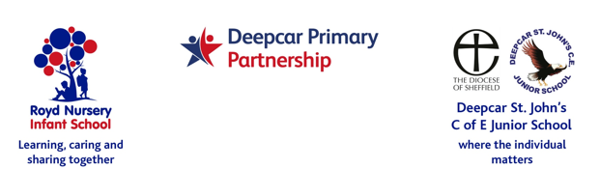
Newsletter December 2021

Staff News
Mrs Lizzie Musgrave will be starting maternity leave in January 2022. Mr Sean Sly will also be having his paternity leave at some point early in the new year. We will, of course, keep you posted with their exciting news.
School Reopens
Children return back to school on Tuesday 4th January 2022.

Raffle prizes
Thank you to the three families that very kindly donated raffle prizes for Royd’s Christmas raffle.
Information Sessions for Parents/Carer
We have not received any responses from parents/carers. Please get in touch with suggestions.
Sporting News
Y3 benchball competition took place last week. St John’s sent two teams. They had an amazing time and thoroughly enjoyed the experience. Mr Priest commented about their exemplary behavior and excellent sportsmanship. To top the afternoon off, the teams came first and second.

Next Week sports leaders from St John’s are running two fun lunchtime Christmas sporting activities/games. These will take place on Wednesday 15th at St John’s and Thursday 16th at Royd.
Fundraising
Many thanks to everyone for supporting our recent charity collections and school fundraising.
We have raised the following amounts. We have such wonderful supportive families at school. Thank you.

Event | Royd NI | St John’s Junior
Collection for British legion  Poppy Appeal | £221.02 | £257.60
School Fund- SWFC signed shirt | £240
School Fund - Break the rules day | £219.20 | £227.00
Children in Need | £188.26 | £176.76
Christmas Jumper day | TBC | £119.20

Christmas Dinners
Christmas Dinners next week are on the following days:
Royd Thursday 16th December
St John’s Tuesday 14th December

After school clubs next half term
Letters have been/are being sent out this week. Please return as soon as possible.

Christmas parties
Please note change to FS2, Y1, Y2 and rainbow room next week.
Year | Class | Teacher | Date
Nursery -  start of week | Class 5 | Miss Terry | Monday 13th December
Nursery - end of week | Class 5 | Miss Terry | Thursday 16th December
Reception | Class 1  Class 2 | Miss Brook  Miss Brown | Friday 17th December
Year 1/2 | Class 7  Class 8  Class 9 | Miss Bamford  Miss Payne  Miss Rawding | Friday 17th December
 | Rainbow Room | Mrs Swales | Friday 17th December
Year 3 | Mrs Bradwell  Mrs Bell and Mrs Thompson |  | Monday 13 December
Year 4 | Miss Danks  Miss Steward |  | Thursday 16th December
Year 5 | Miss Woods-Booth  Mrs Riley and Mrs Stewart |  | Thursday 16th December
Year 6 | Mr Horner |  | Friday 17th December

please pack a goody bag with treats for your child to enjoy. This food will be additional to their lunch. Please do NOT send in any products that contain nuts as some children in school have severe nut allergies
Royd Nursery Infant

January 2022
12 – Wacky hair day
14 – Rocksteady music introduction
27- Sleeping Beauty Pantomime AM

February 2022
11- Wear red day- Valentine day
Deepcar St John’s

January 2022
12- Wacky hair day
w/c 10 - Poetry week@ St John’s
27 - Sleeping Beauty Pantomime PM

February 2022
4 - Young Voices Concert
11- Wear red day – Valentine Day

