

Royd Nursery Infant School

Carr Road, Deepcar

Sheffield, S36 2PR

Tel 0114 288 2594

Email [enquiries@royd.sheffield.sch.uk](mailto:enquiries@royd.sheffield.sch.uk)

[www.roydnurseryinfants.co.uk](http://www.roydnurseryinfants.co.uk)

Headteacher: Louise Jones

7 February 2022

Dear Parent/Carers,

I am sure you have heard of the dangers of internet use by young children and yet just a few simple steps can help keep them safe.

To help you understand what the issues are and receive practical help, we are holding an Information Session supported by Thomas Winterbottom from the Sheffield Safeguarding Children’s Board.

The session will be on Tuesday 8 March 2022 from 5.30 pm until 6.30 pm via zoom using the following link;

<https://zoom.us/j/99018620016?pwd=dlc1RHR0ZkdsazYrZjI3U292dlNjdz09>  
Meeting ID: 990 1862 0016 Passcode: 04BXMj

For an idea of numbers if you would like to join us, please sign and return the slip as soon as possible or email Paula in the School Office on [pstuart@royd.sheffield.sch.uk](mailto:pstuart@royd.sheffield.sch.uk). Thank you.

Yours sincerely,

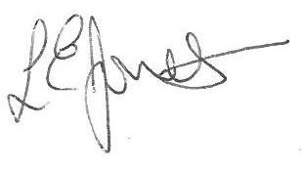

Louise Jones Sean Sly

Executive Head Acting Deputy Head

----------------------------------------------------------------------------------------------------------------------------------**Online/Internet Safety Workshop Tuesday 8 March 2022**

Name of Child : Class :

Yes, I / We would like to attend the Information Session.

No I/We will not be attending.

Signed : _____________________________________________ Parent / Carer

