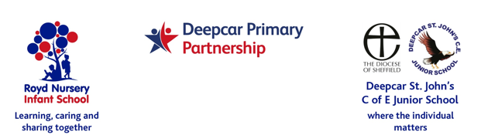
5 January 2022

Dear Parent/Carers,

We have organised for the children from both schools to attend the pantomime ‘Beauty and the Beast’ on Thursday 27 January 2022.

For children at Royd Infants this will be in the morning. For children at Deepcar Juniors this will be in the afternoon. The cost is £5.00, which for a professional production with full stage setting, lights and professional actors is an excellent price.

If you would like your child to attend, please complete the slip below to the school office applicable to your child/ren and return by Monday 24 January 2022. Payment is by Parentmail. Thank you.

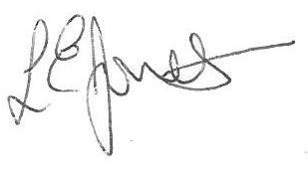
Yours sincerely,

Louise Jones
Executive Head
-------------------------------------------------------------------------------------------------------------------
Beauty and the Beast January 2022

Name of child : Class :

I give permission for my child to attend Beauty and the Beast.

Payment of £5 has been made by Parentmail

Signed ____________________________________________________ Parent/carer

