Car parking

Dear Parents/Carers,

To the vast majority of parents/grandparents and carers, I would like to say a big thank you for your responsible parking around school.

However, I recently received numerous comments from parents/carers very concerned about dangerous parking around both schools. I witnessed this myself earlier this week with several cars parked by parent/carers on double yellow lines and road junction corners waiting to collect their children. In addition, I received an email describing a very near miss with a child who could have been injured.

Mrs Higgingbottom, who works on the road crossing, commented how bad the situation has become in recent weeks.

This situation is an accident waiting to happen and is not acceptable. We have over 300 children across the schools who must get home safely.
- Please park more responsibly.
- Give yourself more time to find a parking space or
- walk to and from school and do your bit for the environment

Buses will not travel along St Margaret’s Avenue near to school closing time due to parents/carers parking on corners of junctions with buses unable to manoeuvre around them. This will affect many local residents, including the elderly, to get home.

I am in touch with the Council and local Police who will be monitoring and visiting the area in the coming weeks.

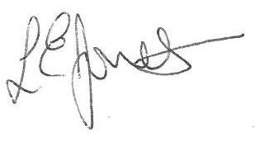
Yours sincerely,

Louise Jones
Executive Head

