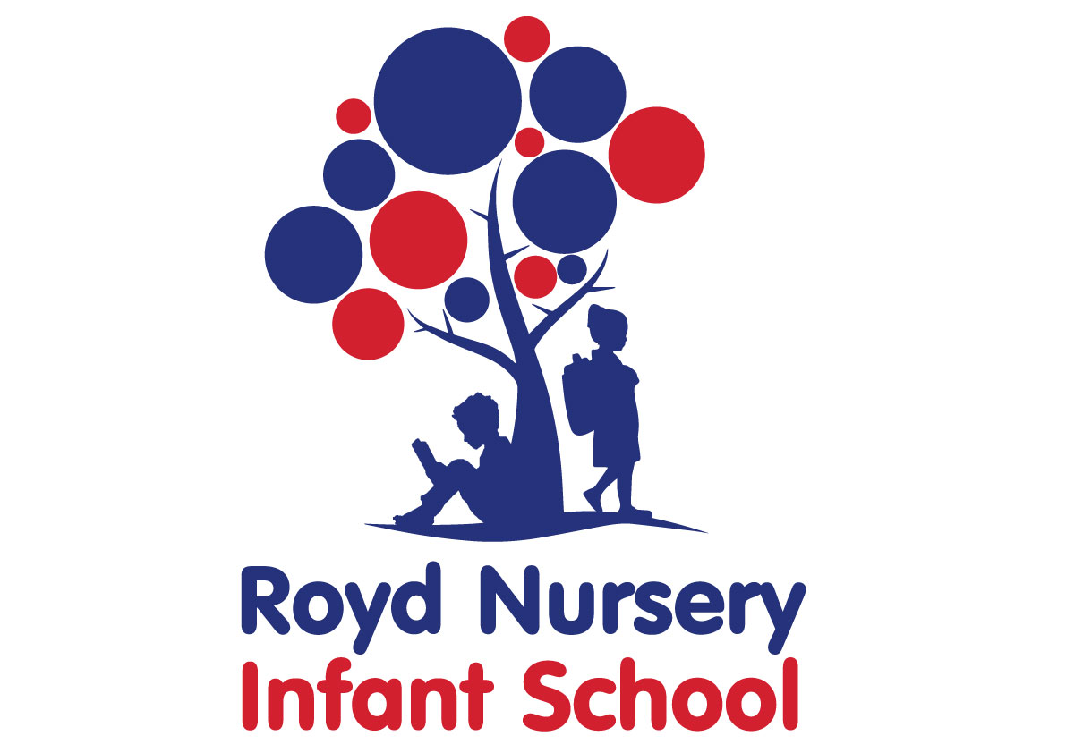
Policy: Promoting
British Values

Adopted by Governing Body on | September 2020
Headteacher | Louise Jones
Date of Review | September 2021

TEACHING BRITISH VALUES
All maintained schools must meet the requirements set out in section 78 of the Education Act 2002 and promote the spiritual, moral, social and cultural (SMSC) development of their pupils. Through ensuring pupils’ SMSC development, school can also demonstrate they are promoting fundamental British Values.
Fundamental British Values are Democracy, the rule of law, individual liberty and mutual respect and tolerance of those with different faiths and beliefs
The DfE have recently reinforced the need “to create and enforce a clear and rigorous expectation on all schools to promote the fundamental British values of democracy, the rule of law, individual liberty and mutual respect and tolerance of those with different faiths and beliefs.”
At Royd Nursery Infant School these values are reinforced regularly and in the following ways:
Democracy:
Each class from FS2 to Year 2 hold elections for the representative on the school council. With meet weekly. In the past we have visited the town Hall to hold meetings.
We listen to children’s voice by sending out pupil questionnaires and finding out how we can improve teaching and learning for all subjects.
We listen to parent’s voice through regular consultations in the form of parental focus groups, feedback from sessions and questionnaires
Through our school behaviour policy we encourage our children to act as caring, tolerant young citizens who are respectful of themselves and others. They will develop a range of skills to enable them to be good communicators in a variety of ways. Pupils learn how to defend and argue points of view during speaking and listening activities.
The Rule of Law:
We consistently reinforce our high expectations of children through our school behaviour policy. Each class generate their own classroom rules. Children are taught the value and reasons behind our expectations that they are there to protect us, that everyone has a responsibility and that there are consequences when rules are broken.
We have visits and presentations by the police/ fire service, paramedics and nurses.
.Assemblies are held on school law/ rules where it is discussed why we have to certain expectations
Individual Liberty:
Within school, children are actively encouraged to make ‘good choices’, knowing that they are in a safe and supportive environment. As a school we educate and provide boundaries for young children to make choices safely, through our provision of a safe environment and empowering teaching. Children are encouraged to know, understand and exercise their rights and personal freedoms.
Mutual Respect:
A major part of our school ethos and behaviour policy has evolved around mutual respect of one another. All staff and children are encouraged to act in this way by caring, sharing and listening to others.
This is evidenced in the use of peer activities, PE and sporting events. The engagement of children when conducting charity work
Tolerance of those of Different Faiths and Beliefs:
We aim to enhance children’s understanding of different faiths and beliefs by learning about and participating in a range of celebrations throughout the year taught through our RE curriculum.
Children have the opportunity to investigate customs and try different foods from other cultures.
Links have been developed with a Sheffield multi faith school and reciprocal dates take place each year.

