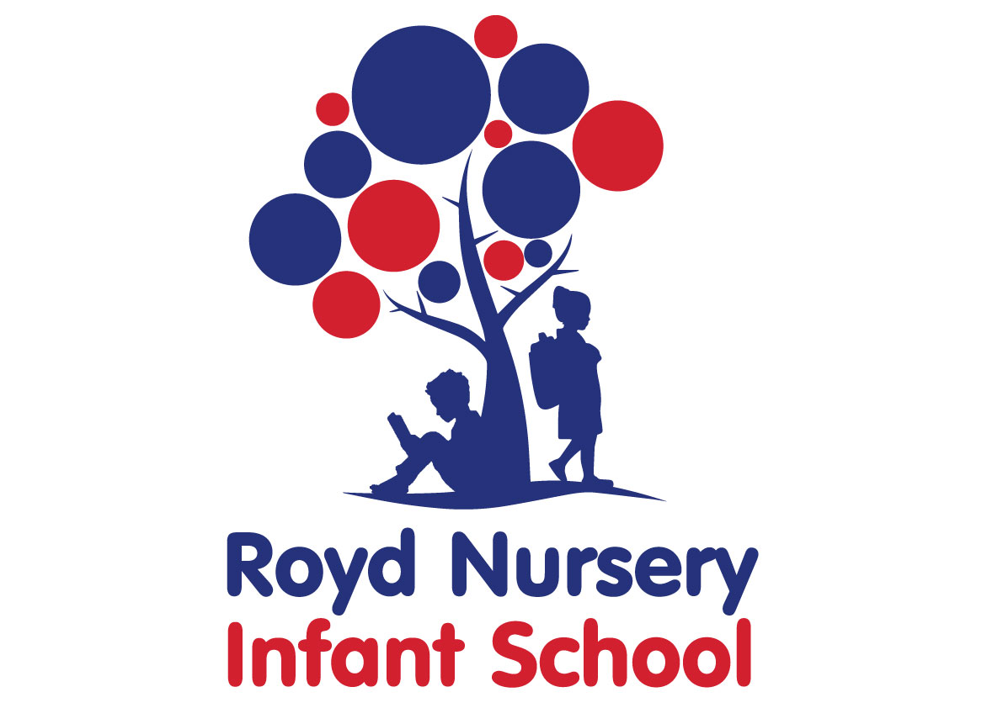
Policy: School information published on a website

Adopted by Governing Body on | September 2020
Headteacher | Louise Jones
Date of Review | September 2021

The Purpose of the Policy
- to define the minimum information to be published on the school website, as set out in statute;
- to set out school expectations for additional information to be published on the school website;
- to set out key responsibilities for ensuring the accuracy and the updating of the website.

1. Rationale and statutory content

The School Information (England) (Amendment) Regulations 2016, which came into force on 1 September 2016, give schools the statutory responsibility to make certain prescribed pieces of information available on websites. The contents of this section are taken directly from those Regulations.

The information maintained schools are required to publish is:

School contact details
Royd Nursery Infant Schools website must include the following:
- the school’s name
- the school’s postal address
- the school’s telephone number
- the name of the member of staff who deals with queries from parents and other members of the public
- the name and contact details of the special educational needs (SEN) co-ordinator (SENCO)

Admission arrangements
Sheffield City Council decide the schools admissions. Please contact the local authority to find out about your admission arrangements (refer to the ‘Admissions’ policy on the website for contact details).

Ofsted reports
Royd Nursery Infant School must publish either:
- a copy of the school’s most recent Ofsted report
- a link to the report on the Ofsted website

Exam and assessment results

Requirements for data include: Key stage 2 (end of primary school) results, Key stage 4 (end of secondary school) results, Key stage 5 (16 to 18) information. Royd Nursery Infant School however do publish their assessment results for GLD, Phonics screening and Key Stage 1.

Performance tables
Royd Nursery Infant School must include a link to the school and college performance tables and your school’s performance tables page.

Curriculum
Royd Nursery Infant School must publish:
- the content of its school curriculum in each academic year for every subject, including Religious Education even if it is taught as part of another subject or subjects, or is called something else
- the names of any phonics or reading schemes you’re using in key stage 1
- a list of the courses available to pupils at key stage 4, including GCSEs
- how parents or other members of the public can find out more about the curriculum your school is following

Behaviour policy
Royd Nursery Infant School should publish details of its school’s behaviour policy.
The policy must comply with Section 89 of the Education and Inspections Act 2006.
Read advice on developing and publishing your school’s behaviour policy.

School complaints procedure

Royd Nursery Infant School must publish details of its school’s complaints procedure, which must comply with Section 29 of the Education Act 2002.

Royd Nursery Infant School must also publish any arrangements for handling complaints from parents of children with special educational needs (SEN) about the support the school provides.

Pupil premium
Royd Nursery Infant School must publish a strategy for the school’s use of the pupil premium.
For the current academic year, Royd Nursery Infant School must include:
- its school’s pupil premium grant allocation amount
- a summary of the main barriers to educational achievement faced by eligible pupils at the school
- how school will spend the pupil premium to overcome those barriers and the reasons for that approach
- how school will measure the effect of the pupil premium
- the date of the next review of the school’s pupil premium strategy
For the previous academic year, Royd Nursery Infant School must include:
- how school spent the pupil premium allocation
- the effect of the expenditure on eligible and other pupils

PE and sport premium for primary schools
Royd Nursery Infant School receives PE (physical education) and sport premium funding. Royd Nursery Infant School must publish:
- how much funding school received
- a full breakdown of how school have spent the funding or will spend the funding
- the effect of the premium on pupils’ PE and sport participation and attainment
- how school will make sure these improvements are sustainable
- how many pupils within their year 6 cohort can do each of the following:
  - swim competently, confidently and proficiently over a distance of at least 25 metres
  - use a range of strokes effectively
  - perform safe self-rescue in different water-based situations

Special educational needs (SEN) and disability information
Royd Nursery Infant School must publish an SEN information report on its school’s policy for pupils with SEN and should update it annually.
Royd Nursery Infant School should update any changes occurring during the year as soon as possible.
The report must comply with:
- section 69 of the Children and Families Act 2014, including:
  - the arrangements for the admission of disabled pupils
  - the steps you have taken to prevent disabled pupils from being treated less favourably than other pupils
  - the facilities you provide to help disabled pupils to access the school
  - information as to the plan prepared by the governing body or proprietor under paragraph 3 of schedule 10 to the Equality Act 2010 (accessibility plan) for:
    - increasing the extent to which disabled pupils can participate in the school’s curriculum
    - improving the physical environment of the school for the purpose of increasing the extent to which disabled pupils are able to take advantage of education and benefits, facilities and services provided or offered by the school
    - improving the delivery to disabled pupils of information which is readily accessible to pupils who are not disabled
- regulation 51 and schedule 1 of the Special Educational Needs and Disability Regulations 2014 where appropriate
- section 6 of the Special educational needs and disability code of practice: 0 to 25 years
You can find details of what you must include in schedule 1 of the Special Educational Needs and Disability Regulations 2014, and section 6 of the Special educational needs and disability code of practice: 0 to 25 years.

Equality objectives
Public bodies, including local-authority-maintained schools, are covered by the public sector equality duty in the Equality Act 2010 and the Equality Act 2010 (Specific Duties) Regulations 2011. This means Royd Nursery Infant School have to publish:
- details of how the school is complying with the public sector equality duty - you should update this every year
- the school’s equality objectives - you should update this at least once every 4 years
Details of these publishing obligations are set out in Equality Act 2010: advice for schools

Governors’ information and duties
Royd Nursery Infant School must publish up to date:
- details of the structure and responsibilities of the governing body and its committees
- information about each governor, including their:
  - full name, date of appointment, term of office, date they stepped down (where applicable) and who appointed them (in accordance with the governing body’s instrument of government)
  - business and financial interests
  - governance roles in other educational institutions
  - any material interests arising from relationships between governors or relationships between governors and school staff (including spouses, partners and close relatives)
  - attendance record at governing body and committee meetings over the last academic year

Charging and remissions policies
Royd Nursery Infant School must publish its school’s charging and ‘remissions’ policies (this means when you cancel fees). The policies must include details of:
- the activities or cases where your school will charge pupils’ parents
- the circumstances where your school will make an exception on a payment you would normally expect to receive under your charging policy

Values and ethos
Royd Nursery Infant School website should include a statement of your school’s ethos and values.

2. Adding and removing information

The school website is a very public ‘face’ of the school. It is accessed by parents, prospective parents, and those who just want to find out more about our school. As such it is important that the content reflects the high standards we expect in all other aspects of our school life. The ability to edit and add content is password protected. Password access is controlled. It is the Headteacher’s responsibility to keep the website up-to-date. All members of staff, however, are expected to draw attention to any inaccuracies or out-of-date information. It is the responsibility of the Governing Body to ensure that the school’s statutory obligations are being met. This responsibility may be delegated to an individual governor.

3. Identifying pupils

Where photographs of children are used no pupil name is published alongside. All parents are asked to give, or not give, permission for their child’s photograph to be used on the school website.

