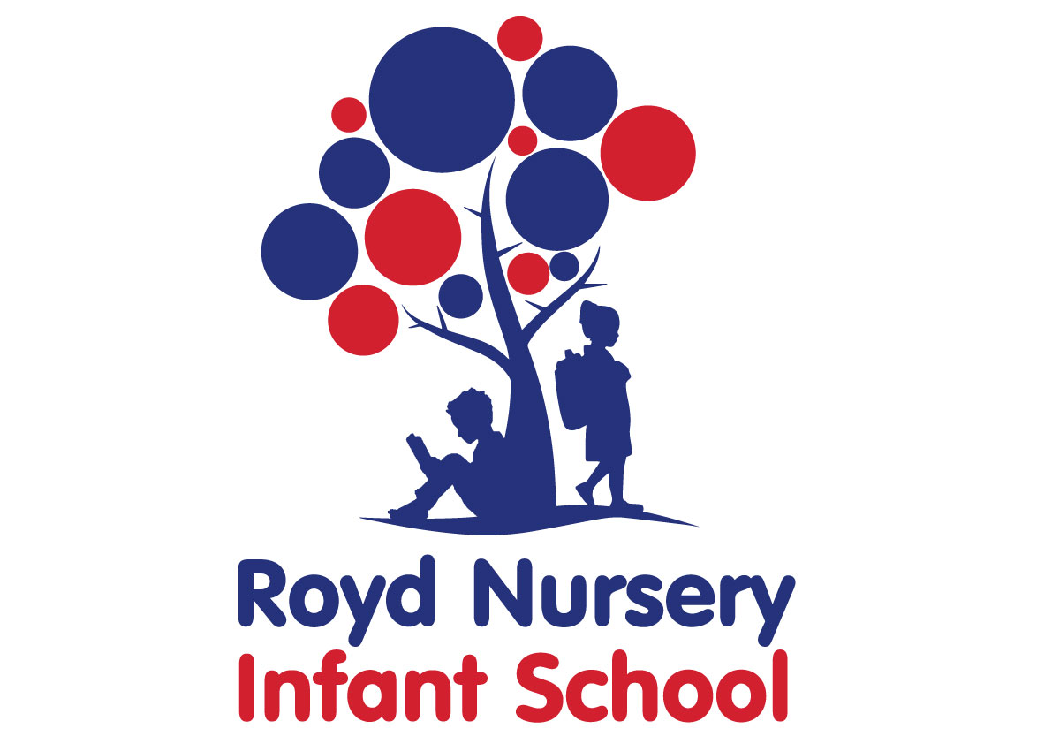

Policy:

Science

Adopted by Governing Body on | September 2020
Headteacher | L Jones
Date of Review | September 2021

Contents:
Statement of intent
- Legal framework
- Roles and responsibilities
- The curriculum
- Cross-curricular links
- Teaching and learning
- Planning
- Assessment and reporting
- Equipment and resources
- Health and safety
- Homework
- Equal Opportunities
- Monitoring and review

Statement of intent

Science provides the foundation for understanding the world around us. It can not only teach pupils about the world they live in, but also how to study it and make sense of various phenomena. As such, it is a fundamental aspect of all children’s learning.

Through adherence to this policy, Royd Nursery Infant School will not only ensure statutory compliance with the national curriculum, but also that all pupils have a solid grounding in science and a positive attitude towards scientific knowledge and experimental processes.

The aims of this policy include:
- Developing pupils’ interest in, and enjoyment of, science. By building on children’s curiosity, the science curriculum will help to instil a positive attitude towards science in pupils.
- Delivering all the requirements of the national curriculum in relation to science and covering major scientific concepts.
- Ensuring science lessons are purposeful, accurate and imaginative.
- Ensuring pupils have sufficient scientific knowledge to understand both the uses and implications of science, today and in the future. This will also give pupils an appreciation of the changing nature of scientific knowledge.
- The development of pupils’ ability to pose questions, investigate these using correct techniques, accurately record their findings using appropriate scientific language and analyse their results.
- Helping pupils develop the skills of prediction, hypothesising, experimentation, investigation, observation, measurement, interpretation and communication.
- Making pupils aware of and alert to links between science and other school subjects, as well as their lives more generally.

Legal framework
  - This policy has due regard to statutory legislation and guidance including, but not limited to, the following:
- DfE (2013) ‘Science programmes of study: key stages 1 and 2’
- DfE (2014) ‘Statutory framework for the early years foundation stage’
- The Control of Substances Hazardous to Health Regulations (COSHH) 2002
- The Reporting of Injuries, Diseases and Dangerous Occurrences Regulations (RIDDOR) 2013
  - This policy will be used in conjunction with the following school policies and procedures:
- Health and Safety Policy
- Accident Reporting Procedure Policy
- Equal Opportunities Policy

Roles and responsibilities
  - The science co-ordinator and curriculum team is responsible for:
- Preparing policy documents, curriculum plans and schemes of work for the subject.
- Reviewing changes to the national curriculum and advising on their implementation.
- Monitoring the learning and teaching of science, providing support for staff where necessary.
- Encouraging staff to provide effective learning opportunities for pupils.
- Helping to develop colleagues’ expertise in the subject.
- Organising the deployment of resources and carrying out an annual audit of all science resources.
- Liaising with teachers across all phases.
- Communicating developments in the subject to all teaching staff.
- Leading staff meetings and providing staff members with the appropriate training.
- Organising, providing and monitoring CPD opportunities in the subject.
- Ensuring common standards are met for recording and assessment.
- Advising on the contribution of science to other curriculum areas, including cross-curricular and extra-curricular activities.
- Collating assessment data and setting new priorities for development of science in subsequent years.

  - The classroom teacher is responsible for:
- Acting in accordance with Royd Nursery Infant School Science Policy, ensuring that lessons are taught in line with the school’s Health and Safety Policy at all times.
- Liaising with the science co-ordinator and curriculum team about key topics, resources and supporting individual pupils.
- Ensuring that all of the relevant statutory content is covered within the school year.
- Monitoring the progress of pupils in their class and reporting this on an annual basis.
- Reporting any concerns regarding the teaching of the subject to the science co-ordinator and curriculum team or a member of the senior leadership team (SLT).
- Undertaking any training that is necessary in order to effectively teach the subject.

The curriculum
  - The school aims to assist pupils in achieving attainment targets set out in the national curriculum. By the end of each key stage, pupils are expected to know, apply and understand the matters, skills, and processes specified in the national curriculum. Pupils will learn a broad range of subject knowledge and draw on disciplines such as maths, science, computing and art.

EYFS
  - All pupils in the EYFS are taught science as an integral part of the topic work covered during the academic year.
  - All art objectives within the EYFS are underpinned by the following three prime areas outlined in the ‘Statutory framework for the early years foundation stage’:
- Communication and language
- Physical development
- Personal, social and emotional development
  - There are four specific areas through which the three prime areas are strengthened and applied:
- Literacy
- Mathematics
- Understanding the world
- Expressive arts and design
  - The science curriculum in the EYFS focusses on the specific areas of understanding the world.
  - Pupils will be taught to:
- Safely use and explore a variety of materials, tools and techniques, experimenting with colour, design and texture, form and function.
- Represent their own feelings through art, as well as music, dance, role play, storytelling and D&T.

KS1
  - Pupils will be taught:
- ask simple questions and recognising that they can be answered in different ways
- observe closely, using simple equipment
- perform simple tests
- identify and classify
- use their observations and ideas to suggest answers to questions
- gather and record data to help in answering questions

Cross-curricular links
  - Wherever possible, the science curriculum will provide opportunities to establish links with other curriculum areas.
  - English
- Pupils are encouraged to use their speaking and listening skills to describe what is happening.
- Pupils’ writing skills are developed through recording their planning, what they observe and what they found out.
- Science based texts are sometimes used in English lessons and in guided reading sessions.

  - Maths
- Science will involve a degree of numeracy at all levels.
- Pupils use their knowledge and understanding of measurement and data handling.
- Where appropriate, pupils record their findings using charts, tables and graphs.

  - Computing
- Pupils will use computing to locate and research information.
- Computing will be used to record findings, using text, data and tables.
- Pupils are encouraged to use calculators and other electronic devices, gaining confidence throughout their school experience.
  - PSHE
- Health education is taught as part of the science unit about ourselves, which covers:
- Health and growing
- Teeth and eating
- Moving and growing
- Keeping healthy
- Life cycles
  - History
- Scientific discoveries and the contribution of individuals to science will be studied.
  - Spiritual, moral, social and cultural (SMSC) development
- Pupils’ development will be focussed on the vastness of science and the natural world, encouraging a sense of awe.
- Pupils are encouraged to think about the effect of scientific discoveries on the modern world.
- Current scientific developments and issues will be discussed in the classroom, where appropriate.

Teaching and learning
  - Science lessons are delivered through continuous provision for pupils in the EYFS. KS1 children receive a block of science lessons during topic lessons depending on whether science is a focus for that half term.
  - The school uses a variety of teaching and learning styles in science lessons that are matched to the activity and ability of pupils. The main aim of these lessons is to develop pupils’ knowledge, skills and understanding.
  - Teaching and learning styles are adapted to support pupils with SEND to ensure these pupils continue to have their confidence and self-esteem raised.
  - Pupils will be taught to describe associated processes and key characteristics in common language, as well as understand and use technical terminology and specialist vocabulary.
  - The school uses a mixture of whole-class teaching, group work and individual activities. Pupils are given the opportunity to work on their own and collaborate with others, listening to their peers’ ideas and treating these with respect.
  - Principles for effective teaching include:
- Setting tasks in the context of pupils’ prior knowledge.
- Promoting active learning.
- Inspiring, exciting and motivating pupils to know more.
  - Strategies for effective teaching include:
- Ensuring the teaching methods used suit the purpose and needs of the pupils.
- Providing a meaningful context and clear purpose when assigning tasks.
- Using focussed practical tasks to help pupils develop and evaluate science work.
- Ensuring tasks are built on skills and understanding.
  - The classroom teacher will work with the Science subject leader and curriculum team to ensure that the needs of all pupils are met by:
- Setting tasks which can have a variety of responses.
- Providing resources of differing complexity, according to the ability of the pupils.
- Setting tasks of varying difficulty, depending on the ability group.
- Utilising TAs to ensure that pupils are effectively supported.
  - As part of science, pupils are provided with topic books, which they are required to present their work in. The topic book is used to evidence pupils’ responses to a variety of information.
  - Topic books are an essential record of individual pupils’ experiences and ideas throughout a year, and will be seen as evidence for assessment and reporting purposes.
  - Lessons will allow for a wide range of scientific enquiry, including the following:
- Questioning, predicting and interpreting
- Pattern seeking
- Practical experiences
- Collaborative work
- Carrying out investigations
- Carrying out time-controlled observations
- Classifying and grouping
- Undertaking comparative and fair testing
- Researching using secondary sources
  - Displays of science work on topic displays are used to celebrate achievement and support teaching and learning.
  - The school promotes displays of science work on topic displays in classrooms to influence how pupils feel about their environment, convey standards and promote high expectations.
  - Displays are used to communicate ideas, stimulate interest, celebrate pupils’ work, reflect the ethos of the school and respond to pupils’ interests.

Planning
  - All relevant staff members are briefed on the school’s planning procedures as part of staff training.
  - Throughout school, science is taught as a discrete lesson and as part of cross-curricular themes when appropriate.
  - Teachers will use the key learning content in the DfE’s ‘Science programmes of study: key stages 1 and 2’ and the national curriculum as a starting point for their planning.
  - Issues of health and safety are addressed in the planning and delivery of the science curriculum.
  - Lesson plans will demonstrate a balance of interactive and independent elements used in teaching, ensuring that all pupils engage with their learning.
  - Lesson plans will demonstrate the balance of visual, auditory and kinaesthetic elements used in teaching, ensuring that all pupils with different learning styles can access the learning experience.
  - There will be a clear focus on direct, instructional teaching and interactive oral work with the whole class and targeted groups.
  - The school creates long-term, medium-term and short-term plans for the delivery of the art curriculum – these are as follows:
- Long-term: includes the topics studied in each term during the key stage
- Medium-term: includes the details of work studied each term
- Short-term: includes the details of work studied during each lesson
  - The Science subject leader and curriculum team is responsible for reviewing and updating long-term and medium-term plans, and communicating these to teachers.
  - Teachers are responsible for reviewing and updating short-term plans, building on the medium-term plans, taking into account pupils’ needs and identifying the methods in which topics could be taught.
  - Long-term planning will be used to outline the units to be taught within each year group.
  - Medium-term planning will be used to outline the vocabulary and skills that will be taught in each unit of work, as well as highlight the opportunities for assessment.
  - Medium-term plans will identify learning objectives, main learning activities and differentiation.
  - Medium-term plans will be shared with the Science subject leader and curriculum team to ensure there is progression between years.
  - Short-term planning will be used flexibly to reflect the objectives of the lesson, the success criteria and the aims of the next lesson.
  - All lessons will have clear learning objectives, which are shared and reviewed with pupils.

Assessment and reporting
  - Pupils will be assessed, and their progression recorded, in line with the school’s Assessment Policy.
  - By the end of each key stage, pupils are expected to know, apply and understand the matters, skills and processes specified in the relevant programme of study.
  - An EYFS profile will be completed for each pupil in the final term of the year in which they reach age five.
  - The progress and development of pupils within the EYFS is assessed against the early learning goals outlined in the ‘Statutory framework for the early years foundation stage’.
  - The progress and development of pupils within KS1 is assessed against the descriptors outlined in the national curriculum.
  - Throughout the year, teachers will plan on-going creative assessment opportunities in order to gauge whether pupils have achieved the key learning objectives.
  - Assessment will be undertaken in various forms, including the following:
- Talking to pupils and asking questions
- Discussing pupils’ work with them
- Marking work against the learning objectives
- Pupils’ self-evaluation of their work
- Classroom tests and formal exams
  - Teachers will record pupils’ ability and progression through two types of assessment – formative and summative.
  - Formative assessment, which is carried out informally throughout the year, will be used to identify pupils’ understanding of subjects and inform their immediate lesson planning.
  - In terms of summative assessments, the results of end-of-year assessments will be passed to relevant members of staff, such as pupils’ future teachers, in order to demonstrate where pupils are at a given point in time.
  - Summative assessments are also used at the end of a unit of work. Teachers will make a judgement about the work of each pupil in relation to the national curriculum.
  - Parents will be provided with a written report about their child’s progress during the Summer term every year. This will include information on pupils’ attitudes towards art, understanding of methods, investigatory skills and the knowledge levels they have achieved.
  - Verbal reports will be provided at parents’ evenings during the Autumn and Spring terms.
  - The progress of pupils with SEND will be monitored by the SENCO.

Equipment and resources
  - The school has a selection of centrally stored materials, tools and equipment to ensure that all pupils have access to the necessary resources.
  - The school library contains resources and topic books to support pupils’ research. The school receive books form Sheffield City Council Library on the topic focus for each half term. Books are displayed in the classroom linked to the half termly topic.
  - The science budget covers the cost of materials and replacement tools. Class teachers are required to maintain the tools and equipment in their classrooms.
  - Pupils may occasionally be asked to bring materials from home if they can; however, to provide all pupils with the same opportunities, the school will provide for pupils who are unable to do this.
  - Display walls are utilised and updated on a half termly basis, in accordance with the area of art being taught at the time.
  - At the start of each school year, the Science subject leader and curriculum team will work with the head teacher to assess the school’s science tools, materials and equipment to ensure there is sufficient equipment for pupils, allowing for funds to be allocated where necessary. The science co-ordinator and curriculum team is for negotiating requests from staff members and ensuring resources are bought within the amount allocated in the annual budget.

Health and safety
  - Staff members will act in accordance with the school’s Health and Safety Policy at all times.
  - Accidents and near-misses will be reported following the procedure outlined in the school’s Accident Reporting Procedure Policy.
  - All staff members will be shown how to correctly use equipment as part of their induction training.
  - Any ‘new’ activities which a teacher has not used in the classroom before will be trialled prior to being performed with pupils.
  - Pupils are allowed full access to a wide range of materials in science, to maximise their learning experience; however, health and safety concerns are inherent with this subject, including storing materials and tools, and the use of equipment.
  - PPE, such as gloves and eye protection, is made available to all pupils and teachers where required.
  - The risks of each task and the tools required will be assessed by the classroom teacher and Science subject leader and curriculum team before lessons, and relevant PPE will be compulsory based on their decisions.
  - All tools and equipment will be checked before the start of every lesson by the classroom teacher.
  - Pupils will be taught to use tools and equipment properly by the classroom teacher before use. They will also be fully briefed on the importance of how to correctly use tools and equipment.
  - All tools and equipment are stored in the store cupboard at the end of each day. Science equipment, such as funnels, are stored in a central store room. Classrooms are not accessed during lunch and break times by children to prevent unsupervised access to potentially harmful tools or equipment.

Homework
  - Homework will be set on a weekly basis and will follow and build upon curriculum content. The content of the homework will be decided by the class teacher and monitored by SLT. Throughout the academic year there will be a range of homework provided linked to differing subjects.
  - Parents will receive a weekly newsletter informing them about the main topics and units of work that will be covered.
  - Parents will be encouraged to discuss the homework that is set with their child. If they have any queries or other comments about the homework, parents should make an appointment to see their child’s class teacher.

Equal opportunities
  - We are an inclusive school that ensures all pupils are provided with equal learning opportunities, regardless of social class, gender, culture, race, disability or learning difficulties. Our Equal Opportunities Policy ensures all pupils are able to achieve their potential in all areas of the curriculum.
  - In order to ensure pupils with SEND achieve to the best of their ability, outcomes are adapted, and the delivery of the science curriculum is differentiated for these pupils, in line with the school’s SEND Policy.
  - The planning and organising of teaching strategies for science will be reviewed on an annual basis by the Science subject leader and curriculum team to ensure that no pupil is at a disadvantage.
  - The school aims to maximise the use and benefits of science as one of many resources to enable all pupils to achieve their full potential.

Monitoring and review

  - This policy will be reviewed on an annual basis by the Science subject leader and curriculum team and head teacher.
  - Any changes made to this policy will be communicated to all members of staff and the governing board.
  - All members of staff directly involved with teaching science are required to familiarise themselves with this policy.

