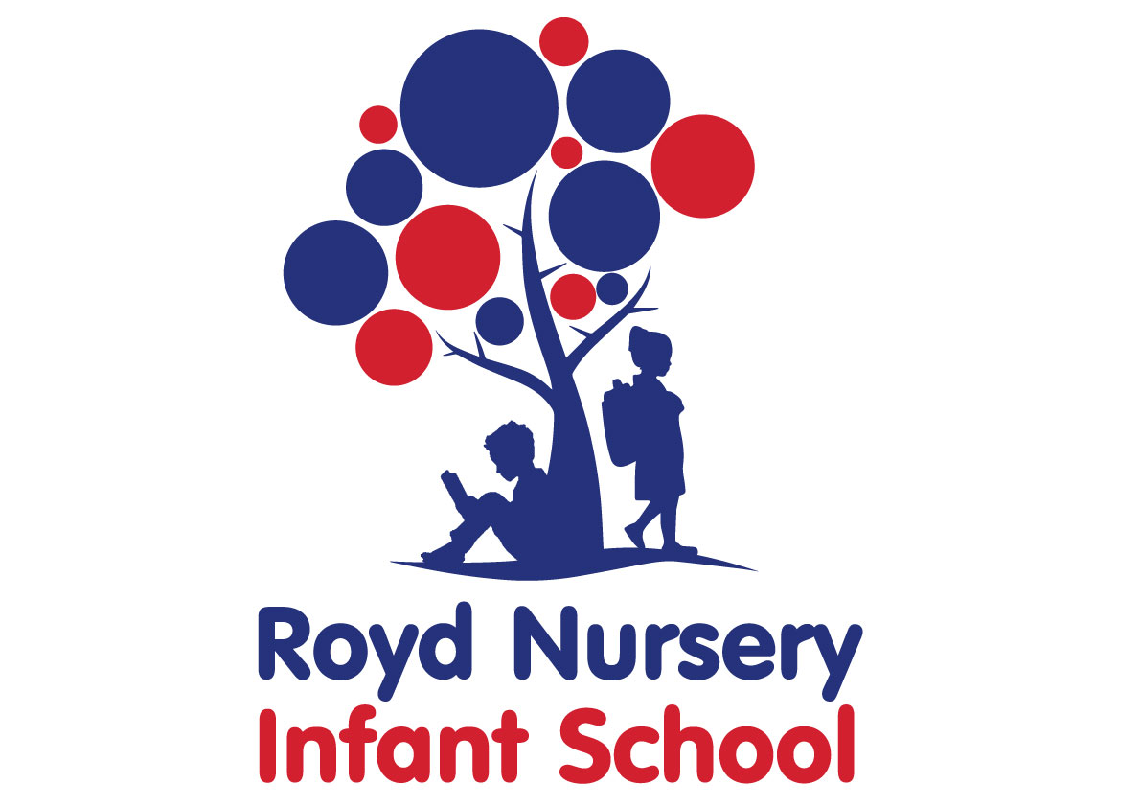

Policy: Sex and relationships Education

Adopted by Governing Body on | September 2020
Headteacher | L Jones
Date of Review | September 2021

Sex and Relationships Education Policy
Royd Nursery Infant School recognises that the prime responsibility of bringing up children rests with parents, and realises that parents are the key figure in helping their children cope with the emotional and physical aspects of growing up, and in preparing them for the challenges and responsibilities which sexual maturity brings
All sex education in the school is delivered within the framework of the Early Years Foundation Stage, National curriculum programmes of study and the new curriculum for 2014.
Aims
We teach sex education in the context of the school’s aims and values.
- Sex education is part of a wider social, personal, spiritual and moral education process
- Children should be taught to have respect for their own bodies
- Children should learn about responsibilities to others. It is important to build positive relationships with others, involving trust and respect.
- Children need to learn the importance of taking responsibility for their own actions

Curriculum
Pupils are taught
- To name the parts of the body correctly;
- That animals, including humans, move, feed, grow, use their senses and reproduce
- That human can produce babies and these babies grow into children and then into adults
- To recognise differences between themselves and others
- To be aware of and understand the different compositions of human families and relationships within them
- To understand that they have rights over their bodies, to understand
- Develop skills to help them protect themselves.
Children in KS1 will not be taught about sexual activity

The themes for Sex and Relationship Education are taught through
- PSHE
- Circle time
- Science sessions
- PE sessions
- setting up rules
- Assembly and collective worship
- RE
seal materials

Monitoring
Monitoring takes place through the following means;
- Teachers’ planning
- Curriculum review,
- Curriculum team reports
- Lesson observations
- Work scrutiny
Review
This policy will be reviewed annually by the Governing Body

