22nd February 2021
WORLD BOOK DAY 2021 - Thursday 4th March
Dear Parents/Carers.
On Thursday 4th March both schools will be taking part in World Book Day 2021.
This is a worldwide celebration of reading, books, authors and illustrators. A key aim of World Book Day is to give every child in the UK and Ireland a book of their own to keep, by distributing World Book Day Tokens to children. Children can exchange this token for one of eight exclusive World Book Day Books at participating booksellers.
Reading is the biggest indicator to a child succeeding in the future.
‘Reading for pleasure is the single biggest indicator of a child's future success, more than family circumstances, parents’ educational backgrounds or income.’ – Organisation for Economic Co-Operation & Development.
We usually ask children to come to school dressed as their favourite book character. Obviously the country will still be in lock down but we would still like to make it an enjoyable and memorable day for the children. Next Thursday, whether your child will be at home or in school, we are asking that they either dress up as a book character or wear some comfy pyjamas for the day. We understand that shopping for new outfits/items is very difficult at the moment.

We would really like to share some photos of the children so if your child is at home please send photographs via the school facebook messenger.

The schools will be completing various activities linked to books both remotely and at school during the day.

Due to home-learning, we have signed up for the digital book token. The link is https://www.worldbookday.com/wp-content/uploads/2021/01/booktoken_PrimaryUK.pdf
You can check which book-sellers are participating at www.booksellers.org.uk/wbd

Yours sincerely,
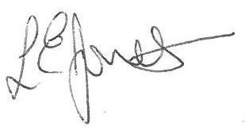
Louise Jones
Head Teacher

