This Week
We have been learning new digraphs (2 letters 1 sound e.g. sh) and split digraphs (2 letters that split in the middle to make way for a consonant e.g. a-e in cake) in our phonics sessions. We have been practising reading and writing some tricky words at sight. In maths we have been learning all about pattern – looking at repeating patterns using different things such as colours, 2D shapes, actions etc. Remember a repeating pattern copies itself and is the same over and over again. We have also been looking at symmetrical patterns and learning that the pattern must be the same on each side – a way to learn this is by looking at butterfly wings and noticing they are the same on each wing.
Online learning  The link for online learning is attached  https://meet.google.com/oho-zmaa-mzh  9.15-9.35 – phonics  10.15-10.35 – spelling  11.15-11.35 – ninja numbers  12.35-12.55 – maths  1.35-1.55 – writing | Stars of the week  Mia-Rose – for a great attitude towards home learning and some beautiful handwriting  Molly – for working hard at home and some lovely creative work  Aylah – for applying yourself in all your online learning and trying your best  Freya E – for always working super hard at home with your learning
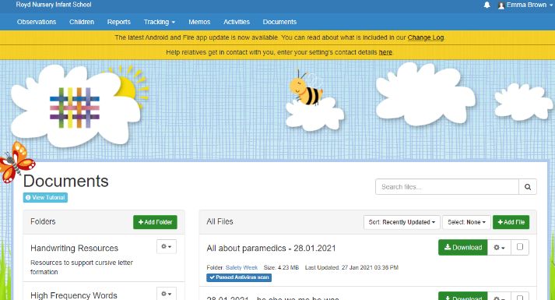
Homework
Activities that are linked to the learning we have been doing online and in school are uploaded onto Tapestry for you to access and complete. When you log in, there is a documents tab that you can click on and then download the activities you need to access.
Reminders
We love seeing what you have been up to on Tapestry as well as looking at your hard work. We would love to see photos of you doing things that make you happy e.g. baking a cake or getting crafty or going for a walk.

