This Week
We have been learning new digraphs (2 letters 1 sound e.g. sh) and split digraphs (2 letters that split in the middle to make way for a consonant e.g. a-e in cake) in our phonics sessions. We have been practising reading and writing some tricky words at sight. In maths we have been learning all about shape space and measure, where we have covered 2D and 3D shapes, weight, height and capacity. When looking at 2D shapes we use the vocabulary vertices (corners) and edges (sides) and when looking at 3D shapes we used the vocabulary vertices, edges and faces.
Online learning  The link for online learning is attached  https://meet.google.com/oho-zmaa-mzh  9.15-9.35 – phonics  10.15-10.35 – spelling  11.15-11.35 – ninja numbers  12.35-12.55 – maths  1.35-1.55 – writing | Stars of the week  Freya M – for a great attitude towards home learning and always applying yourself to your learning  Jonah – for working hard at home and producing some fantastic learning  Samuel – for applying yourself in all your online learning and challenging yourself  Sebastian – for always working super hard at home with your learning and taking care with your work
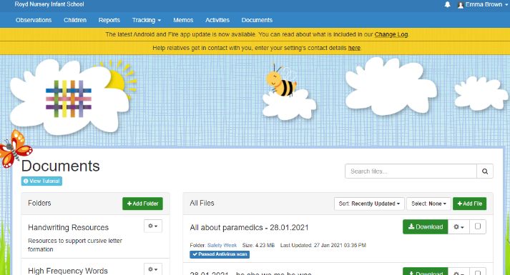
Homework
Activities that are linked to the learning we have been doing online and in school are uploaded onto Tapestry for you to access and complete. When you log in, there is a documents tab that you can click on and then download the activities you need to access.
Reminders
Please enjoy your half-term and spend time with your family doing what you enjoy and makes you happy. We will see you back online or in school on Monday 22nd Feb!

