This Week
We have been learning new digraphs (2 letters 1 sound e.g. sh) and trigraphs (3 letters 1 sound e.g. air) in our phonics sessions. We have been practising reading and writing some tricky words at sight. In maths we have been learning all about number bonds and making the same number in lots of different ways. E.g. 2+6 makes 8 or 5+3 makes 8 or 4+4 makes 8. We have used different objects to help us make our number bonds.
Online learning  The link for online learning is attached  https://meet.google.com/oho-zmaa-mzh  9.15-9.35 – phonics  10.15-10.35 – spelling  11.15-11.35 – ninja numbers  12.35-12.55 – maths  1.35-1.55 – writing | Stars of the week  Rudie – for a great attitude towards online learning and great contributions  Ned – for a great attitude towards online learning and great contributions  Eddie – for applying yourself in all your learning, especially writing  Alex – for always working super hard at home with your learning
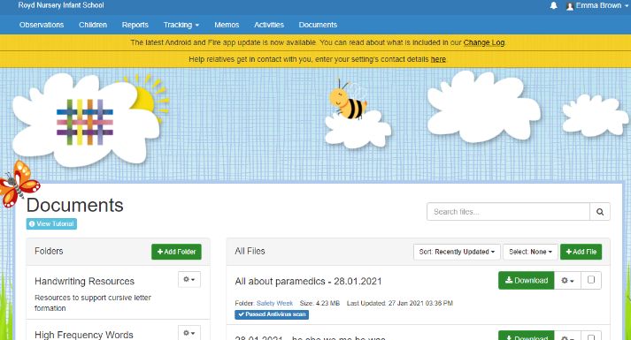
Homework
Activities that are linked to the learning we have been doing online and in school are uploaded onto Tapestry for you to access and complete. When you log in, there is a documents tab that you can click on and then download the activities you need to access.
Reminders
If your child has a lexia account, please remember to log them on each day so they can access the activities. If you need any support with this please email Miss Brown (ebrown@royd.sheffield.sch.uk) or Miss Brook (hbrook@royd.sheffield.sch.uk)

