This Week
This week we have continued looking at the story ‘A Squash and a Squeeze’ by Julia Donaldson. We listened carefully to different parts of the story and acted out what we heard e.g. we used drama to walk like an old lady and move like farm animals. We have also demonstrated our understanding of the story by answering questions such as, which animal goes into the old lady’s house first? In maths, we have been developing our number sense by looking at missing numbers, which group of objects has the most or the least and one more and one less than a number.
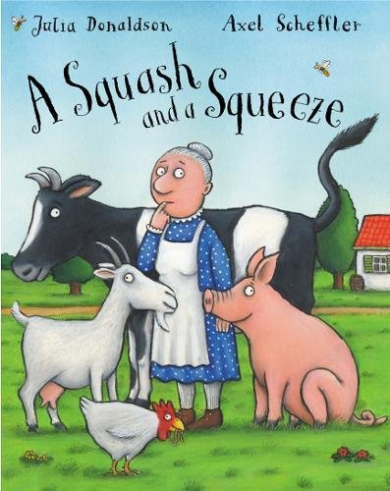 | Stars of the week  This week’s stars of the week are…  COULD YOU CHOOSE A CHILD FROM THE BEGINNING OF THE WEEK AND FROM THE END OF THE WEEK?s  Children are rewarded star of the week if they do something that really impresses a member of staff.
Homework
Each Wednesday (beginning of the week children) and Friday (full-time and end of the week children), homework will be handed out to your child. This homework should be completed and returned to your child’s class teacher by the date stated on the sheet. Homework can be returned by uploading photographs to Tapestry or a physical copy can be handed in too. Homework is based on current learning being completed by the children at school. It has been great seeing so many homework activities uploaded onto Tapestry!
Reminders
First day back to school – Monday 22nd February

