This Week
This week we have been looking at the story ‘What the Ladybird heard? By Julia Donaldson. We have been looking at the characters and learning new vocabulary. We have been spotting the words that rhyme. In maths we have been looking at matching the correct number to the correct amount of objects.
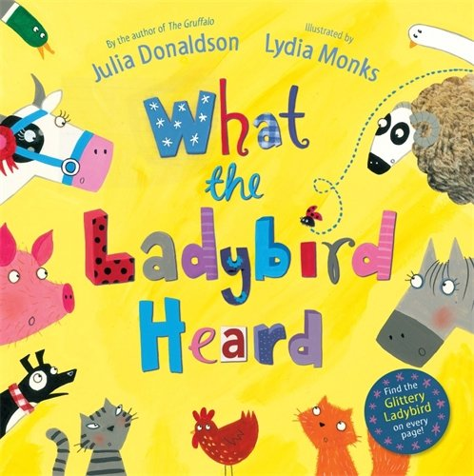  Could you create a farm scene from the book, What the Ladybird heard? | Stars of the week  This week’s stars of the week are…  Rio- always looking after our toys.  Georgina- always bein polite.  A big well done to the children! You have put a big smile on Miss Burwell, Miss Hosford and Mrs Bailey’s faces!
Homework
Each Wednesday (beginning of the week children) and Friday (full-time and end of the week children), homework will be handed out to your child. This homework should be completed and returned to your child’s class teacher by the date stated on the sheet. Homework can be returned by uploading photographs to Tapestry or a physical copy can be handed in too. Homework is based on current learning being completed by the children at school. It has been great seeing so many homework activities uploaded onto Tapestry!
Reminders
On the 7th July we have Creature Ark coming into Nursery.

