
Weekly Newsletter
W.B. 6.9.21

This week:

As part of English the children have continued to learn about the traditional tale Little Red Riding Hood. The children have used pictures from the story and ordered them correctly so they can sequence the story in order. The children listened to the story and identified key features such as the characters, setting and main events. Year 2’s have also had a session focusing on describing the characters of the story and the setting (where the story takes place) also. In addition, the children came up with ambitious vocabulary adjectives (a word that describes a noun) and verbs (doing or being words) to annotate the images given.
Can your child sequence the story of Little Red Riding Hood to you at home? Can your child explain what a noun is? (Person, place or thing). Can your child describe what an adjective is? (A word to describe a noun). Can your child explain what a verb is? (A doing word – sprinting, yawning, went).
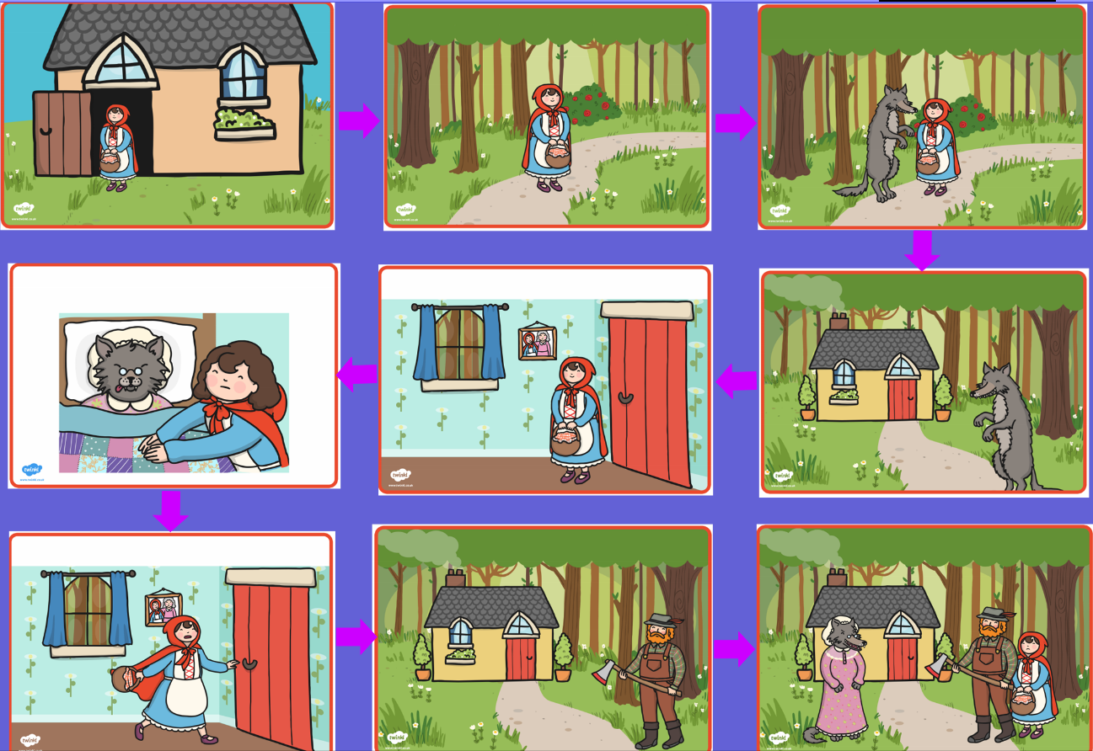

As part of Maths the children have been looking at the value of numbers using an abacus and dienes. The children have also had fun using numicon to find number bonds of 2 digit numbers ranging from 10-100. The children finished the week focussing on ‘more or less than’ of a number using the following symbols: ‘<’, ‘>’ and ‘=’. Children had to look at the amount of tens and ones in each number to determine which number was the biggest. They then had to draw the correct symbol to complete the calculation. E.g. 42 < 89.
At home please can you support your child with comparing numbers to see which has a smaller or bigger value.

The children’s topic this half term is ‘Bounce’. As part of topic lessons children have continued completing art-based activities. They have continued to look at the primary colours. Ask your child to name the primary colours (red, yellow and blue). The children then made secondary colours (orange, green and purple) by mixing two primary colours together. After this, the children drew their own observational pictures of a tennis ball and mixed two primary colours (blue and yellow) together to paint their ball green. Can you ask your child which two of the primary colours mixed together makes?

Reminders:
Class 7 PE days are Tuesday and Friday.
Class 8 PE days are Tuesday and Thursday.
Class 9 PE days are Thursday and Friday.

Attendance for KS1:
Class 7 - 100 – %
Class 8 - 100 – %
Class 9 - 100 – %

Homework
Homework will mainly be handed out on a Wednesday. On the odd occasion it may be on a different day due to timetable changes. Please return homework on a Monday. Handing it on a Monday gives you the opportunity before the weekend to ask the teacher any questions so that you are clear of how to support your child if unsure. There is a tray in each class where the homework needs to be returned. Please ask the teacher where this tray is if unsure.

Spellings
Spellings are handed out each Thursday and your child will be tested on these spellings the following Thursday. Children will receive a list of spellings to practise each week. In addition to the spellings, children will be tested on a sentence containing the words. However, the sentence will not be sent home. This is to see if they can apply the spelling currently within their writing. Can you get your child to practise applying the words by creating their very own sentences?

Reading Diaries
Children in KS1 have all been provided with a Home Reading Diary. Please fill this in daily based on your child reading a couple of pages of a book or a whole book. Please return the Reading Diary to school each day and leave it in their book bags. There are books situated in the classroom for your child to take home daily. Reading is extremely important to your child’s development so we really encourage your child to read a book or pages of a book daily. If you are unsure of your child’s reading book colour then please ask your teacher.

Thank you
Miss Rawding, Miss Bamford & Mrs Musgrave

