
Weekly Newsletter
W.B. 6.9.21

This week:
As part of English this week the children have continued their first story writing genre of the year with Little Red Riding Hood. The children have used pictures from the story and ordered them correctly so they can sequence the story in order. Once they had completed this the children we able to verbally share sentences that could be applied to each stage of the story. Year 1’s also focused on describing the characters of the story and the setting (where the story takes place). In addition, the children came up with ambitious vocabulary adjectives (a word that describes a noun) and verbs (doing or being words) to annotate the images given.
Can your child sequence the story of Little Red Riding Hood to you at home? Can your child explain what a noun is? (Person, place or thing). Can your child describe what an adjective is? (A word to describe a noun). Can your child explain what a verb is? (A doing word – jumping, knitting, went).
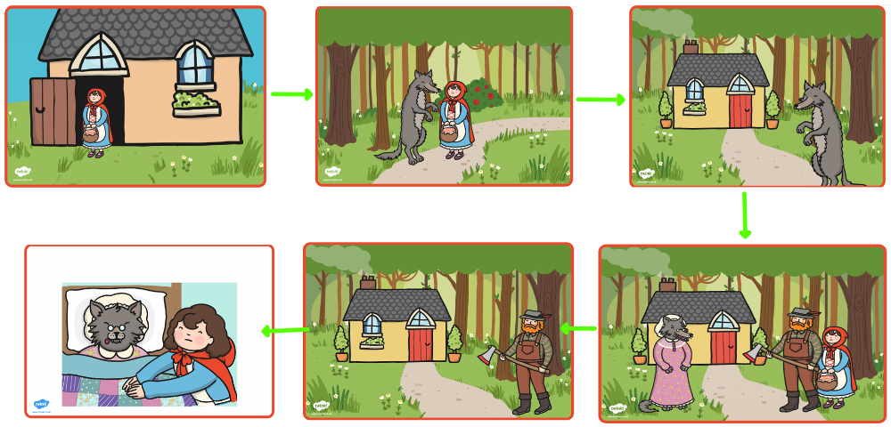

As part of Maths the children have been looking at the most and least in amounts of objects. Children had to count the items in the pictures, compare the amounts and identify which image had the most or the least amount of objects. They then progressed onto looking at equal amounts and the children had to count and identify which two pictures had the same amount of objects or which was equal to a number provided.
At home please can you support your child with counting the amounts of objects and comparing which has the most and the least or equal amounts.

The children’s topic this half term is ‘Bounce’. As part of topic lessons children have continued completing art-based activities. They have looked at the primary colours. Ask your child to name the primary colours (red, yellow and blue). The children then looked at secondary colours (orange, green and purple) as well as primary colours and sorted a range of objects that were different shades of these colours into the correct colour. After this, the children painted their own observational pictures of rugby and tennis balls and evaluated their art work. Can you get your child to paint using these techniques?

Reminders:
Class 7 PE days are Tuesday and Friday.
Class 8 PE days are Tuesday and Thursday.
Class 9 PE days are Thursday and Friday.

Attendance for KS1:
Class 7 – 96.1%
Class 8 – 96.9%
Class 9 – 100%

Homework
Homework will mainly be handed out on a Wednesday. On the odd occasion it may be on a different day due to timetable changes. Please return homework on a Monday. Handing it on a Monday gives you the opportunity before the weekend to ask the teacher any questions so that you are clear of how to support your child if unsure. There is a tray in each class where the homework needs to be returned. Please ask the teacher where this tray is if unsure.

Spellings
Spellings are handed out each Thursday and your child will be tested on these spellings the following Thursday. Children will receive a list of spellings to practise each week. In addition to the spellings, children will be tested on a sentence containing the words. However, the sentence will not be sent home. This is to see if they can apply the spelling currently within their writing. Can you get your child to practise applying the words by creating their very own sentences?

Reading Diaries
Children in KS1 have all been provided with a Home Reading Diary. Please fill this in daily based on your child reading a couple of pages of a book or a whole book. Please return the Reading Diary to school each day and leave it in their book bags. There are books situated in the classroom for your child to take home daily. Reading is extremely important to your child’s development so we really encourage your child to read a book or pages of a book daily. If you are unsure of your child’s reading book colour then please ask your teacher.

Thank you
Miss Rawding, Miss Bamford & Mrs Musgrave

