
Weekly Newsletter
W.B. 29.11.21

This week:
As part of English this week the children have continued with their writing genre; information text. Children wrote some more compound sentences using the coordinating conjunction ‘and’. Children know that ‘and’ is used to join two simple sentences together to make a compound sentence, for example – The Jacob’s Ladder was a very exciting Victorian toy and it was a visual illusion. The children were then ready to start planning their own information text by writing key bullet points and choosing which Victorian toy they’d like to write about. The children were extremely creative in the next two lessons when producing their very own information text! They remembered all of the key elements including, heading, subheading, paragraphs and technical words to do with the subject. They also remembered their capital letters, full stops and even used ambitious words!

Can your child tell you an interesting fact about the Victorian toy they wrote about?
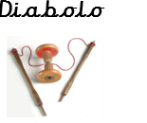
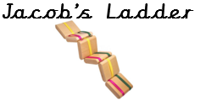
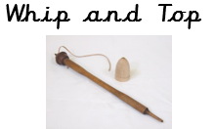
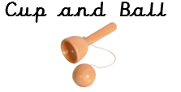

As part of Maths this week children have started learning about shape. They looked at 2D shapes and 3D shapes and discussed their properties, such as how many vertices, edges and faces they have. For example, a triangle has 3 vertices and 3 edges. It doesn’t have any faces because 2D shapes do not have faces. The children know that the faces on a 3D shape are the shapes of different 2D shapes. For example, the faces on a cube are square. A square-based pyramid has 5 vertices, 8 edges and 5 faces, 4 of which are triangular faces and 1 is a square face.

Please look at the information below with your child:

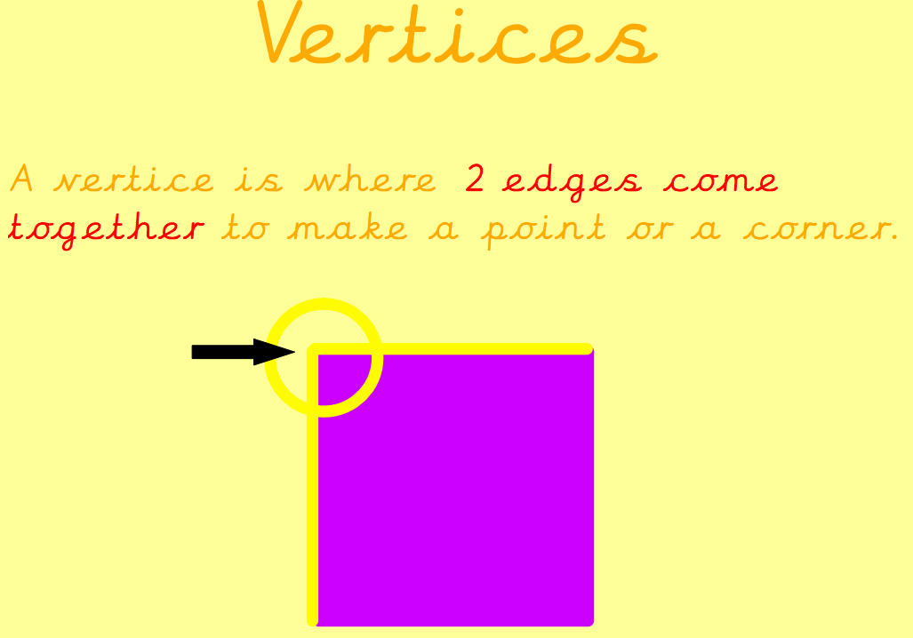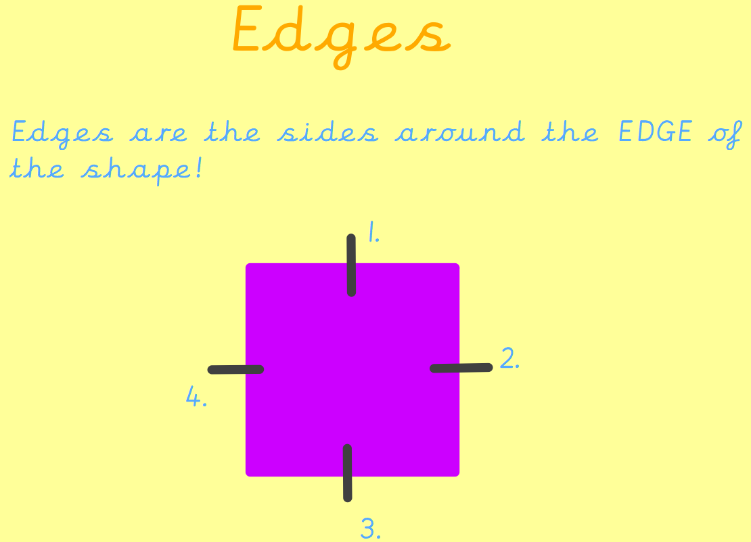

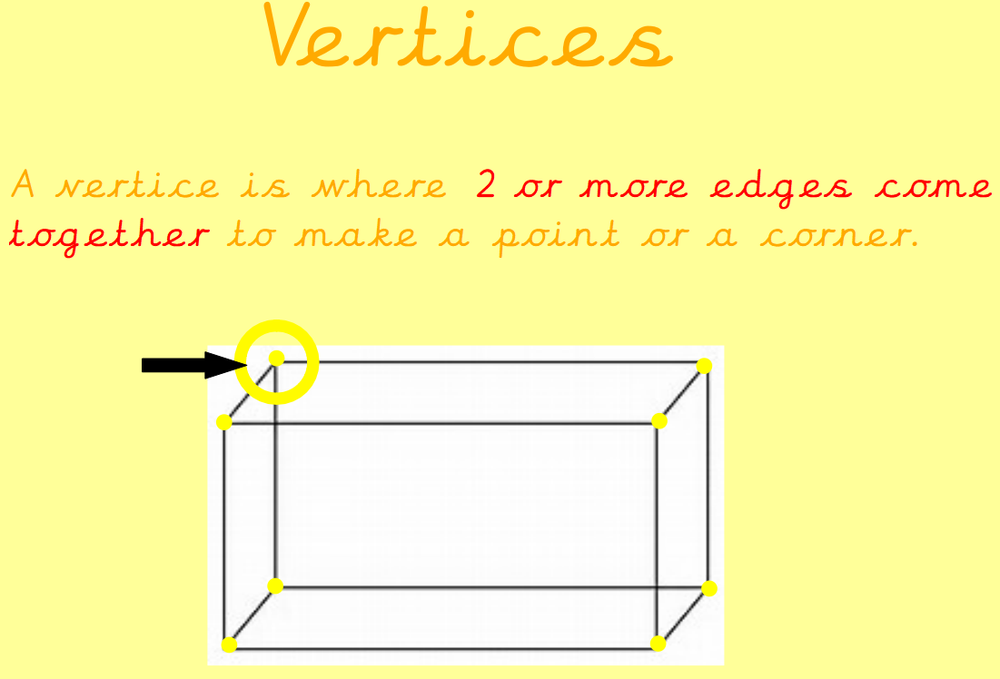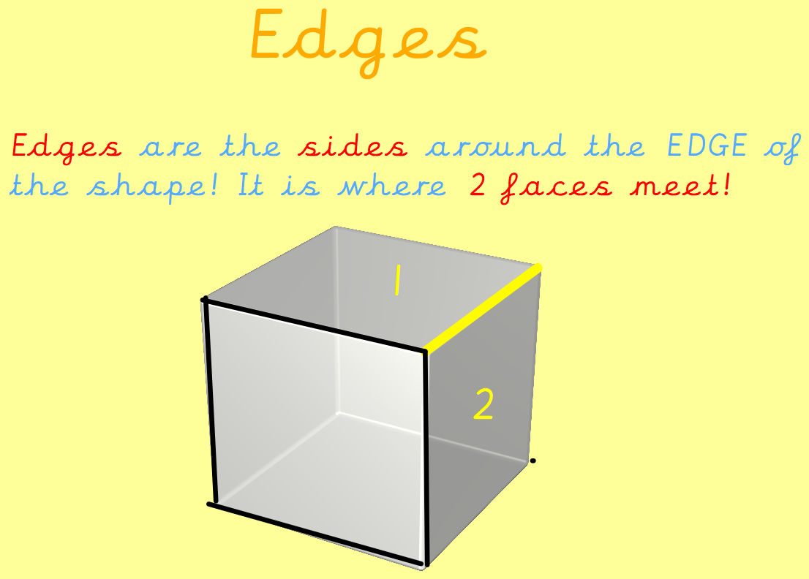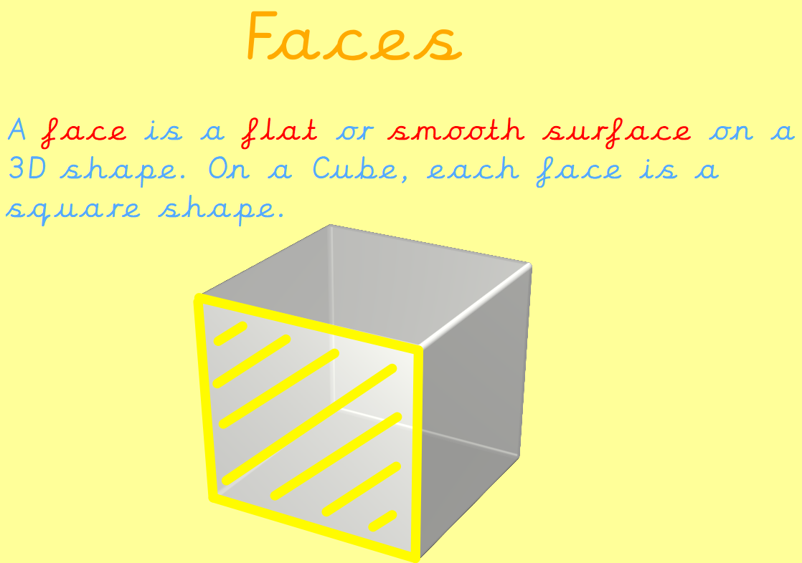

Can your child tell you the properties of these shapes?

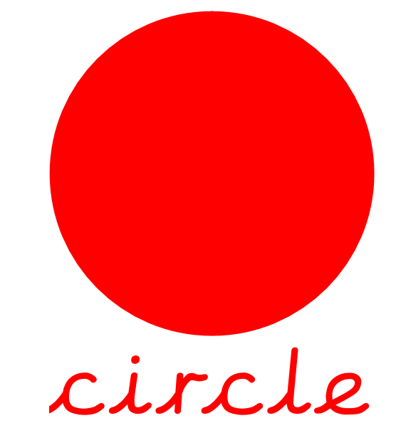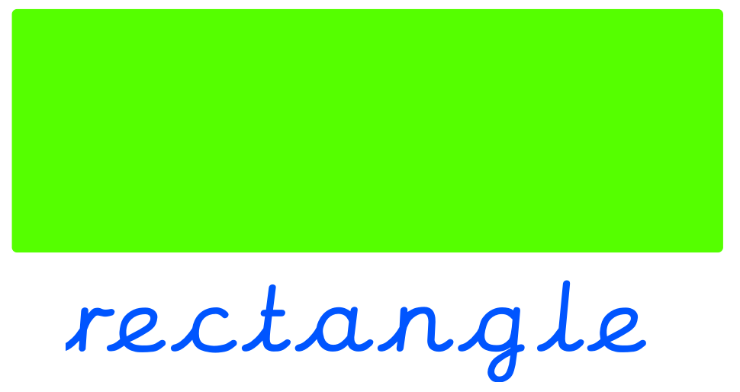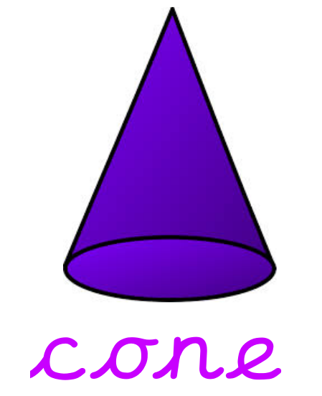

The children’s topic this half term is ‘Memory Box’. As part of topic lessons, children have completed a sketch based on a class theme. The children applied the sketching skills they had previously learnt including stippling, hatching and circulism. We then moved onto our Design and Technology learning. Cutting is such an important skill in DT so this is what we focused on in our first lesson. Children learnt the correct way to hold scissors and cut before applying these skills to cut a range of lines and shapes.

Can your child demonstrate how to correctly cut a range of materials?

Reminders:

Class 7 PE days are Tuesday and Friday.
Class 8 PE days are Tuesday and Thursday.
Class 9 PE days are Tuesday and Friday.

Attendance for KS1:
Class 7 – 92.9%
Class 8 – 94.8%
Class 9 – 93.2%

Homework
Homework will mainly be handed out on a Wednesday. On the odd occasion it may be on a different day due to timetable changes. Please return homework on a Monday. Handing it on a Monday gives you the opportunity before the weekend to ask the teacher any questions so that you are clear of how to support your child if unsure. There is a tray in each class where the homework needs to be returned. Please ask the teacher where this tray is if unsure.

Spellings
Spellings are handed out each Thursday and your child will be tested on these spellings the following Thursday. Children will receive a list of spellings to practise each week. In addition to the spellings, children will be tested on a sentence containing the words. However, the sentence will not be sent home. This is to see if they can apply the spelling currently within their writing. Can you get your child to practise applying the words by creating their very own sentences?

Reading Diaries
Children in KS1 have all been provided with a Home Reading Diary. Please fill this in daily based on your child reading a couple of pages of a book or a whole book. Please return the Reading Diary to school each day and leave it in their book bags. There are books situated in the classroom for your child to take home daily. Reading is extremely important to your child’s development so we really encourage your child to read a book or pages of a book daily. If you are unsure of your child’s reading book colour then please ask your teacher.

Thank you
Miss Rawding, Miss Bamford & Miss Payne

