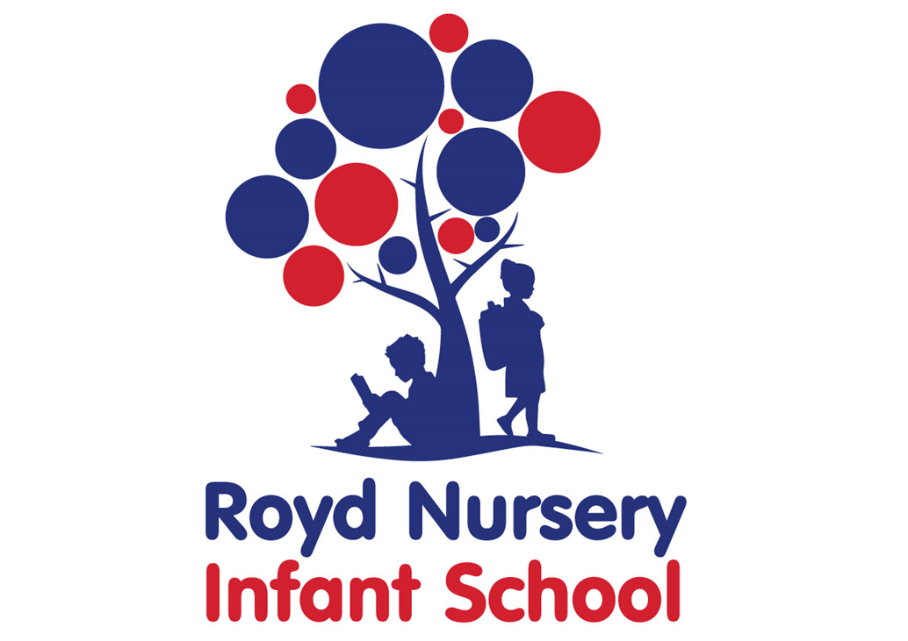

Remote Education Provision
Information for Parents

Remote education provision: information for parents
This information is intended to provide clarity and transparency to pupils and parents or carers about what to expect from remote education over the coming weeks.

The remote curriculum: what is taught to pupils at home?

What should my child expect from immediate remote education?
School moved to remote learning on Wednesday 6th January. We posted activities for children to complete on the Tapestry learning platform in Early Years and Purple Mash in Key Stage 1. Please contact the school office for login details.
Each day you will have activities to complete in the following areas:
- English- reading, writing, phonics and spelling
- Maths
- Foundation subjects including PE
Activities will consist of a combination of five lesson inputs by the teacher in Reception and six input sessions in KS1. Work will be set on Purple Mash and Tapestry for children to complete and upload.

Will my child be taught broadly the same curriculum as they would if they were in school?
We teach the same curriculum remotely as we do in school wherever possible. We will use a range of resources such as teacher power points.

Remote teaching and study time each day

How long can I expect work set by the school to take my child each day?
We expect that remote education (including remote teaching and independent work) will take pupils broadly three hours each day possibly a little less for the younger children.

Accessing remote education

How will my child access any online remote education you are providing?
Across school we use online platforms to deliver remote education.
We use the following:
Five times a day in Reception, we have Google Meets sessions with teacher input followed by work activities set up on Tapestry.
Six times a day in Year 1 and Year 2, we have Google Meets sessions with teacher input followed up by work activities on Purple Mash.
Contact the school office if you don’t have any log is.

If my child does not have digital or online access at home, how will you support them to access remote education?
We recognise that some pupils may not have suitable online access at home. We take the following approaches to support those pupils to access remote education:
- If you cannot access our online platforms due to not having the technology please call the school office on 2882594
- We have some school tablets that we will loan out during the current lockdown

How will my child be taught remotely?
We use a combination of the following approaches to teach pupils remotely:
Some examples of remote teaching approaches:
- live teaching (online lessons)
- Reading books pupils may have at home
- Pre-recorded videos linked to learning outcomes
- Commercially available websites supporting the teaching of specific subjects or areas, including video clips or sequences such as Lexia

Engagement and feedback

What are your expectations for my child’s engagement and the support that we as parents and carers should provide at home?
We expect all pupils to engage with remote education each day during term time unless they are unwell.
We ask all parents and carers to support this by setting routines to support their child’s education for example being ready for Google Meets calls or by setting up a timetable for children to complete their tasks.
If you are having any problems managing remote education at home please contact the school office.
When we have a full complement of staff, work will be marked daily. Some work with acknowledged and others will be marked in depth. There will be work that needs to be improved and teachers will give written or verbal feedback. We would expect all parents to support their child with this improvement work.

How will you check whether my child is engaging with their work and how will I be informed if there are concerns?
Teachers will monitor daily attendance at Google Meets sessions and work submitted onto Purple Mash and Tapestry. If we identify any issues that require any follow up, or if we see a child is not engaging with remote learning, we will contact parents and carers to discuss this further and offer support if necessary.

How will you assess my child’s work and progress?
Feedback can take many forms and may not always mean extensive written comments for individual children. For example, whole-class feedback or quizzes marked automatically via digital platforms are also valid and effective methods, amongst many others. Our approach to feeding back on pupil work is as follows:
Our aim is to maximise engagement through digital platforms and offer feedback electronically. We will use Tapestry and Purple mash to offer comments on children’s work. Online feedback may be the form of feedback to a whole group. In some cases, it may be verbal feedback on video conferencing or by telephone.

Additional support for pupils with particular needs

How will you work with me to help my child who needs additional support from adults at home to access remote education?
We recognise that some pupils, for example some pupils with special educational needs and disabilities (SEND), may not be able to access remote education without support from adults at home. We acknowledge the difficulties this may place on families, and we will work with parents and carers to support those pupils in the following ways:
We will routinely contact families who have children with SEND or are considered vulnerable during any period of school closure.
Firstly, we would look at how we can support you in helping your child access the existing content. In some cases, we may also:
- Arrange 1:1 virtual meetings with a familiar staff member
- Provide additional materials tailored to their needs
- Offer additional advice
- These responses are bespoke to families and children please contact us if you would like additional help

Remote education for self-isolating pupils
Where individual pupils need to self-isolate but the majority of their peer group remains in school, how remote education is provided will likely differ from the approach for whole groups. This is due to the challenges of teaching pupils both at home and in school.

If my child is not in school because they are self-isolating, how will their remote education differ from the approaches described above?
If the majority of the class are in, this means that the teaching staff will be in school. This may mean that support for children self-isolating may take a different form. Work would still be uploaded onto Purple mash and/or Tapestry, the same that is being set in school.

