Nursery Parents and Carers:
Homework starting from Monday 11th May 2020 that will last for 2 weeks (end date Friday 22nd May 2020). Please note that w/c Monday 25th May is half term, therefore there will be no homework. Please follow the guidance in this pack and this will help your child to keep on track with the national curriculum for when they return to school.
Daily expectations involved
- 2 play based learning activities per day
- Watching phonic speed sounds.
- Reading a book with your child.
- 2 initial sounds per day.
- Completing maths activities daily.
Please repeat anything your child is not secure with.

Play based learning
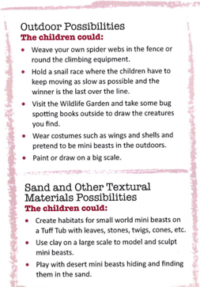
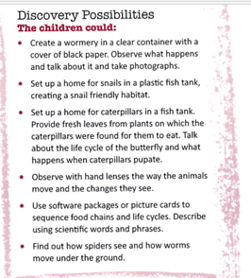
Nursery’s topic this half term is called ‘Why do spider eat flies?’ As part of the Nursery curriculum children should have the opportunity to learn through play and exploration. Below is some suggested activities your child can complete. Please choose a couple of these activities to complete each day.
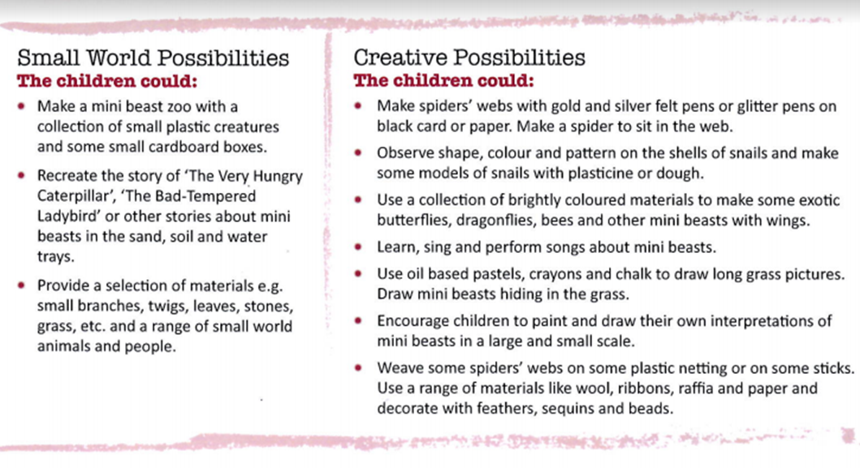

Reading
Please read a book daily with your child. The following website is where you can access free books: https://www.oxfordowl.co.uk/for-home/find-a-book/library-page/?fbclid=IwAR08_sImZbWDzoo57OfcXsyZBBdBgboprOSRhpiDc6_MXL0OLl5vw6y2dlc
You will need to register and create a log in but all the ebooks are free.
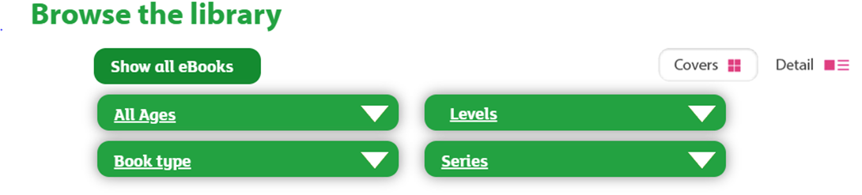
Please go onto the website provided and scroll down to find the following:
Please select “All ages” and then click on “3-4 years”.

Phonics
Phonics is an important part of the Early Years Foundation Stage and is taught daily. Please go to the following website: https://www.ruthmiskin.com/en/find-out-more/help-during-school-closure/
Please click on the ‘Youtube Channel’ (highlighted in blue at the end of the first line) and watch set 1 speed sounds at 9.30am.

Writing
As part of your previous homework packs, your child was asked to practise writing the alphabet and to spell their name. School are aware that some children will still be working on these targets so please continue to do so. In addition to this please can you write the initial sound for the picture using cursive writing.
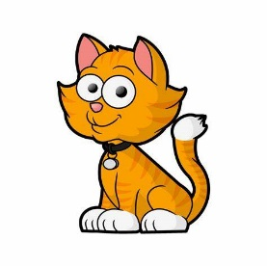
o g a t

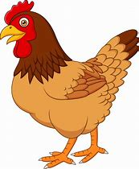
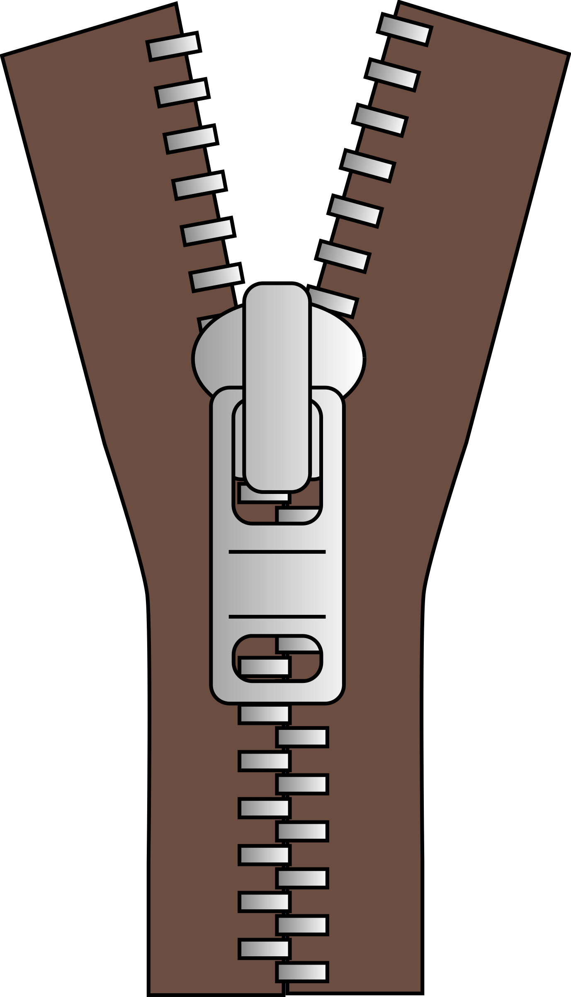
i p e n
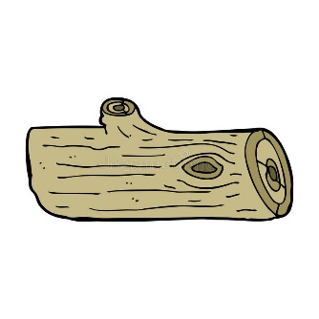
o g a n
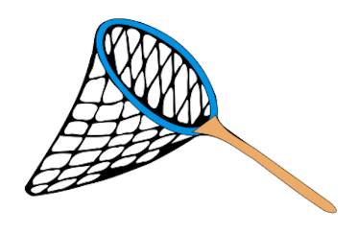
e n e t
u n i n

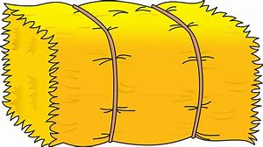
a y u g
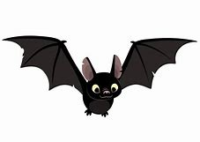
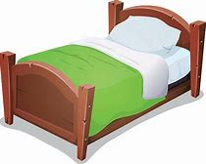
a t e d
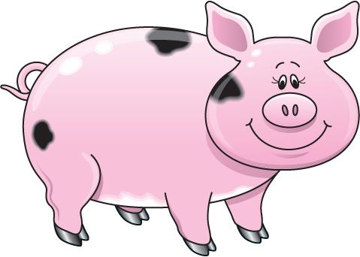
i g i n

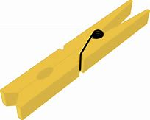
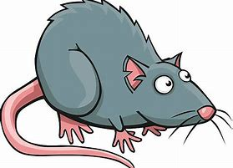

a t e g

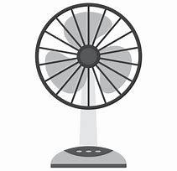
a t a n

Maths
As part of your previous homework packs, your child was asked to count forwards and backwards using a number line, look at positional language and match the correct quantity to the numeral. Please continue to revisit these previous activities. In this pack, we will look at comparing two groups, separating a number into different groups. Please complete a maths activity daily.
Comparing
In Nursery we have begun to compare two groups and to recognise whether they have the same number or a different number in each group. Your children also need to be able to recognise which group has the biggest number or the smallest number.
Practical tasks
Talk about comparing when using everyday objects.
For example: You have 3 cars in one hand and 3 cars in the other hand. Does each group have the same number?
Encourage the children to say they are the same and to explain how they know they are the same? Try this with different objects around the house.

When your child has understood this. Can they add one more to the group or make it one less for the groups to be the same? Can they recognise which group has more or less?
For example: I have 4 cars in one group and 3 cars in another group. How many more cars do I need to add to make the groups the same?
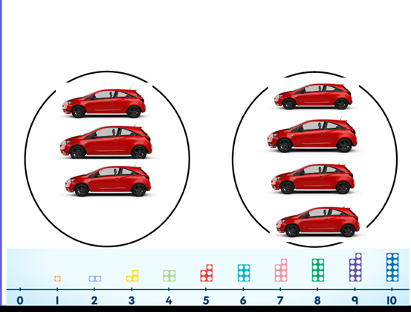

Can you use objects from home to compare two groups together?
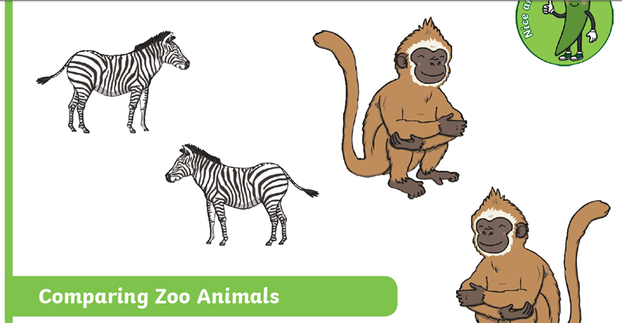
Can you explain whether these pictures are the same or different?

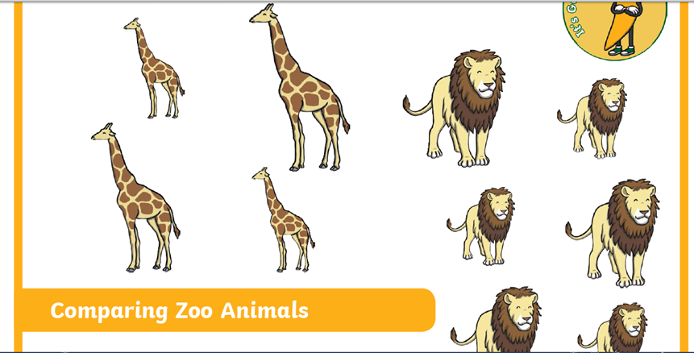

There are lots of activities on Twinkl that link to comparing objects to help your child with their learning.
Making groups
As well as the children describing when a group is the same. The children also need to use objects too separate a number into different groups and understanding the value is the same.
For example: I have 4 pens. They can be separated into groups.

We can have 4 groups of 1.

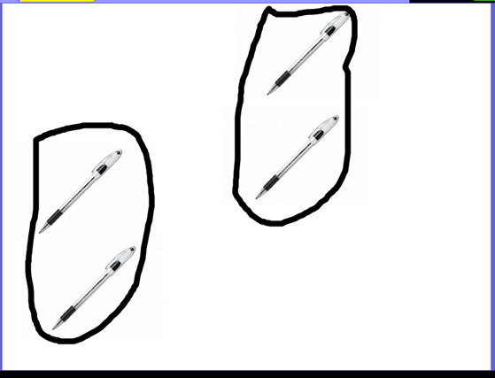

I can have 2 groups of 2.

I can have one group of 3 and one group of 1.

Can you use different objects to make different groups? Can you write the number next to your group? See if you can use the hands to help you compare and make groups.
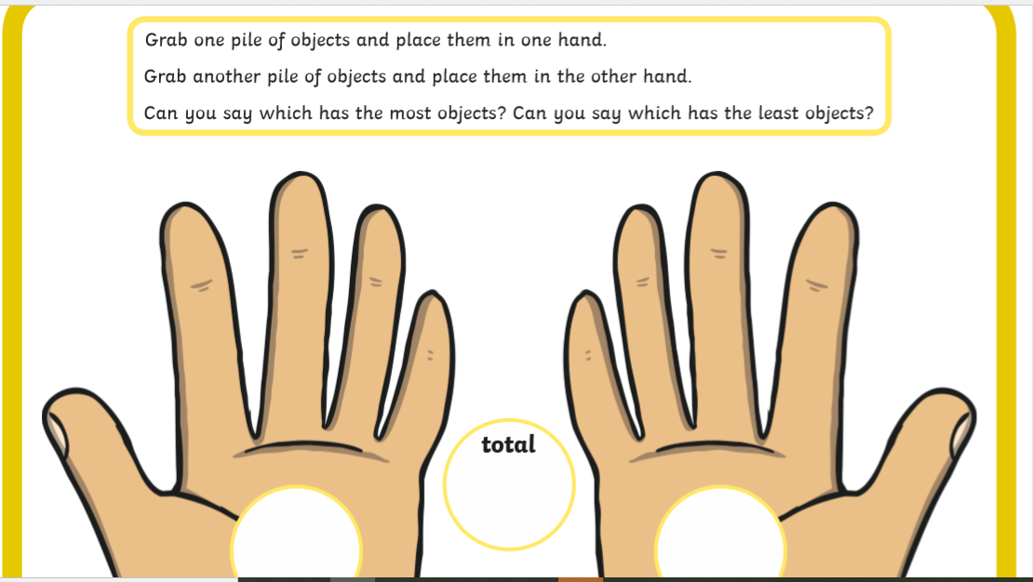

Here is a link for Twinkl where there are interactive ways of helping your children to compare and separate numbers into groups. https://www.twinkl.co.uk/resource/eyfs-maths-speedy-starters-comparing-numbers-and-quantities-30-50-amp-40-60-months-lesson-ideas-tf-n-441

For extra fun and engaging activities “Twinkl ” have given all parents an incredible offer- all content on their website is free for one month! All you have to do is go to www.twinkl.co.uk/offer enter your email address and create a password and use the code: UKTWINKLHELPS.
If you click on the EYFS section there you will find a vast range of activities for your child to enjoy!

The expectation is that all parents and carers will follow this daily model so that when all children return back to school, they are all at the same point. We will be continuing with learning with the knowledge that they have been learning the above at home, so please ensure your child completes the short activities above.
This pack is for your child to begin week commencing Monday 11th May and is designed to last until Friday 22nd May. Please return this pack to your child’s class teacher on the day of return to Royd.

