Reception Parents and Carers:
Homework starting from Monday 11th May 2020 that will last for 2 weeks (end date Friday 22nd May 2020). Please note that WC Monday 25th May 2020 is half-term and therefore no homework will be set. Please follow the guidance and this will help your child to keep on track with the Early Years Curriculum for when they return to school.

Daily learning expectations involve:
- 2 play-based learning activities per day
- Reading 1 book per day
- Phonics speed sounds
- Write 1 simple sentence per day
- Time 1 or 2 activities per day
- Please repeat anything your child is not secure with

Play-based learning
Reception topic this half-term is called ‘Why Do Spiders Eat Flies?’ As part of the Reception curriculum, children should have the opportunity to learn through play and exploration. Below are some suggested activities for your child to complete. Please choose a couple of these activities to complete each day.
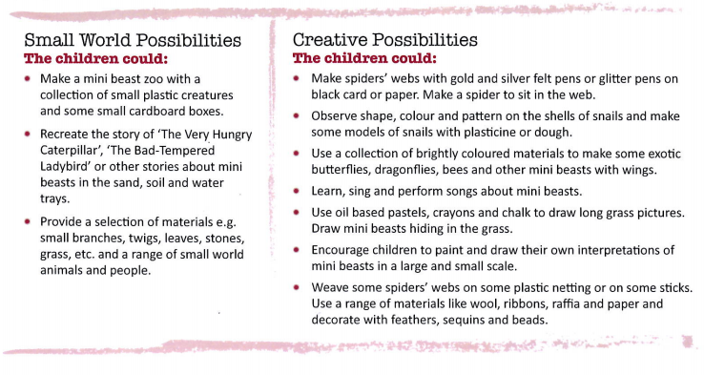

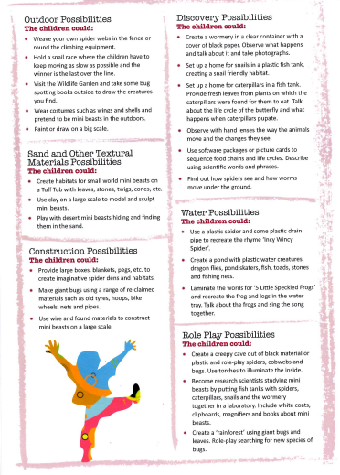

Reading
Please read a book daily from the following website: https://www.oxfordowl.co.uk/for-home/find-a-book/library-page/?fbclid=IwAR08_sImZbWDzoo57OfcXsyZBBdBgboprOSRhpiDc6_MXL0OLl5vw6y2dlc
You will need to register and create a log in but all the eBooks are free.
Please go on the website provided and scroll down to find the following: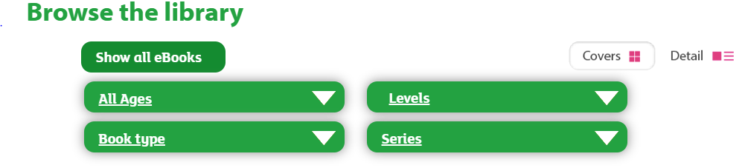
Select “levels” and then “book band” and select the required book band colour for your child. At this point in the academic year expected standard (at age related expectation) your child would be reading book band 3: yellow. However, if your child is greater depth or exceeding the Early Learning Goal (above age related expectation) they would be reading book band 4 blue. If your child is working towards the Early Learning Goal (below age related expectation), please select the required book band level dependent on your child’s reading capability from the following options:
Book band 1 pink
Book band 2 red
If your child is finding the book band level particularly hard or too easy, please access the book level either before or after the ones we have recommended, as you feel appropriate.
As part of parents’ evening, you received some coloured comprehension questions linked to the book bands. Please also ask your child these questions when they read to you.
Reading is crucial to your child’s development, please also make sure that you read books and poems for your child’s enjoyment daily!

Phonics
Phonics is an important part of the Early Years and is taught daily. When your child gets into Y1 they will sit a Phonics screening test; in order for your child to stay on track, it is important that they consolidate the sounds that they have already been taught and learn new phonemes which they can then apply in their reading and writing.
Please go to the following website:
https://www.ruthmiskin.com/en/find-out-more/help-during-school-closure/
Please click on ‘YouTube channel’ (highlighted in blue at the end of the first line) see below:
It will direct you to a page like this:
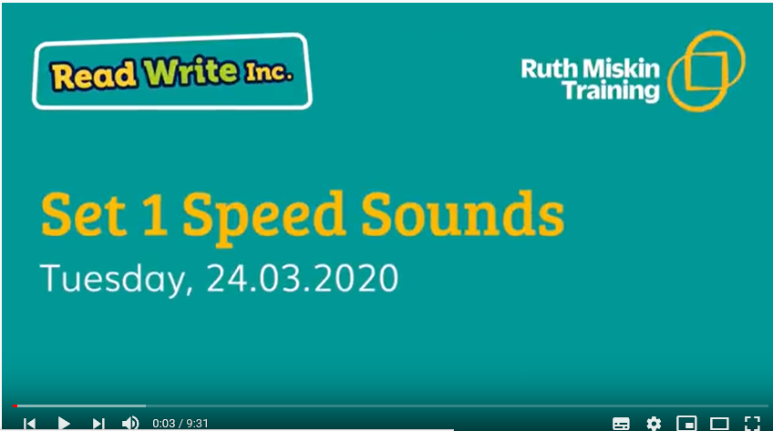
Please watch and complete the following daily:
Set 1: 9:30am
Set 2: 10.00am

Writing
As part of your previous homework pack your child was asked to complete 5 spellings a day from the ‘high frequency word’ lists provided. School are aware that some children may still need to practise spelling ‘high frequency’ words. Please continue to do this and in addition please get your child to write one simple sentence per day. Examples of simple sentences include;
Example 1 – The fat cat sat on a green rug.
Example 2 - She can jump in the wet mud.
As part of your child’s simple sentence please make sure that they have a capital letter at the start of a sentence and a full stop at the end of a sentence. Any words that are spelt incorrectly please help your child to correct them.

Ideas for sentence writing prompts –
- What is your favourite mini-beast?
- If you were a mini-beast what would you look like?
- Where do mini-beasts live?
- Write a fact-file about a mini-beast
- If you go on a mini-beast hunt, write about what you found
- Keep a diary about what you have been doing each day
- Write about your favourite book
- Who is in your family?
- What are your favourite foods and why?
- Invent your own mini-beast and describe it

Maths
In your previous homework packs we have asked you to practise adding and subtracting and doubling, halving and sharing. At this point in the year we would move onto having a look at time and money. Please make sure you do this on a very practical level exploring the language of these areas before moving onto more formal methods. See the examples below:
Time
Language relating to time –
A big part of learning about time is using language related to time to explore learning.
- Talk about your child’s daily routine with them
  - Draw pictures of different parts of your day e.g. breakfast, story and order them with your child
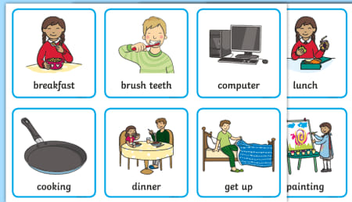
  - Make a first and next board and draw what activity you did first and what came next e.g. first having lunch, next playing with my cars
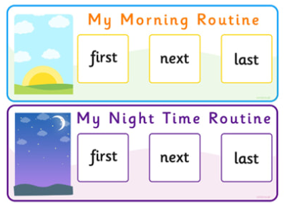
  - Discuss your child’s favourite part of the day with them

- Different parts of the day (e.g. morning, afternoon, night time)
- Linking different activities to different parts of the day (e.g. we have breakfast in the morning)
  - Draw pictures of different activities throughout the day and sort them into the correct part of the day
  - Discuss with your child what you are doing when e.g. it is the morning now so we have woken up and we are going to have breakfast
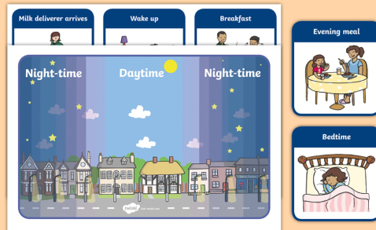

- Ordering the days of the week
- Days of the week songs on Youtube
- Talking about what the date is each day e.g. calendar
- Keeping a diary and writing about what you have done each day
- Questioning your child e.g. if it is Monday today, what day will it be tomorrow? It is Tuesday today; what day was it yesterday?
- Talking about what you do on different days e.g. on Monday I read a story with daddy at bedtime
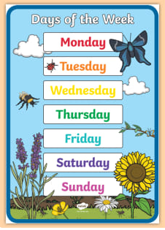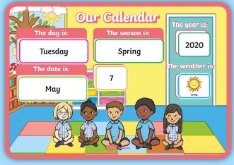

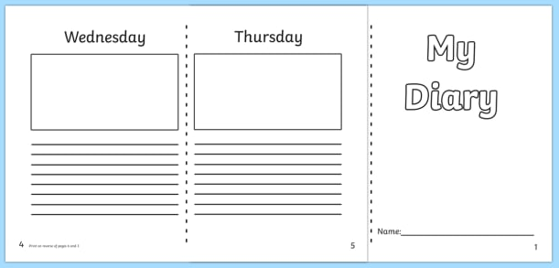

- Learning the months of the year
- Months of the year songs on Youtube
- Talking about the month your birthday is in
- Talking about special events in different months (e.g. Christmas is in December)
- Linking the seasons to the different months of the year

- Using simple methods to measure time
- How many … (jumps, hops, claps, times you write your name, hugs you can give mum/dad etc.) in a minute?
- How far can you walk before I count to 20?
- How many star jumps can you do in 10 seconds?

O’clock –
Once you have explored language relating to time you can move onto exploring clocks and telling the time (o’clock).
- Play ‘what’s the time Mr Wolf?’
- When you are doing something talk about what time it is e.g. we are having our lunch now because it is 12 o’clock
- Make a watch using paper, card etc.
- Have a look at what numbers are on a clock face
- Talk about the big hand (minute hand) and little hand (hour hand) on the clock and why they are moving
- O’clock bingo (twinkl)
- Make a bigger clock where you can move the hands to make different times
- Draw blank clock faces for the children to draw their own clock hands on to show different o’clock times
- Draw different o’clock cards to play snap
- Draw different o’clock times on clock faces – can they match to a numeral e.g. match the clock that says 7 o’clock to the numeral 7
- EXTENSION – extend your child to half past using the above activities when/if confident with o’clock

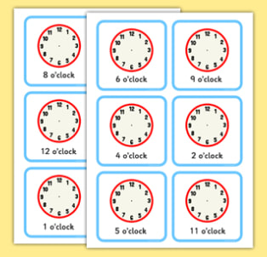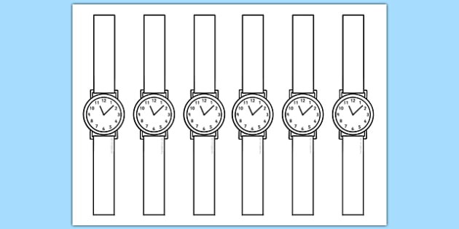

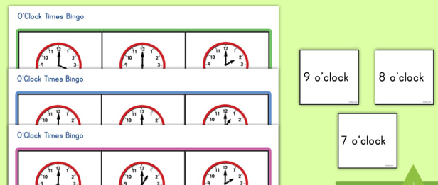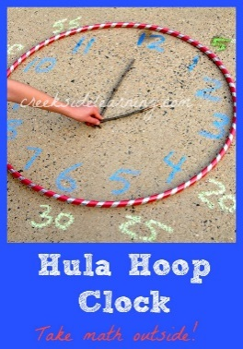

For extra fun and engaging activities “Twinkl” have given all parents an incredible offer – all content on their website is FREE for one month! All you have to do is go to www.twinkl.co.uk/offer enter your email address and create a password and use the code: UKTWINKLHELPS
If you click on the EYFS section, there you will find a vast range of activities for your child to enjoy!

The expectation is that all parents and carers will follow this daily model so that when all children return back to school, they are all at the same point. We will be continuing with learning with the knowledge that they have been learning the above at home, so please ensure your child completes the short activities above.
This pack is for your child to begin week commencing Monday 11th May and is designed to last until Friday 22nd May. Please return this pack to your child’s class teacher on the day of return to Royd. We would love to see some photographs of you exploring time and having a go at simple sentences.

1 | a | 28 | to | 55 | my | 82 | by
2 | an | 29 | I | 56 | her | 83 | time
3 | as | 30 | no | 57 | went | 84 | ask
4 | at | 31 | go | 58 | it’s | 85 | house
5 | if | 32 | into | 59 | from | 86 | about
6 | in | 33 | will | 60 | children | 87 | your
7 | is | 34 | that | 61 | just | 88 | day
8 | it | 35 | this | 62 | help | 89 | made
9 | of | 36 | then | 63 | said | 90 | came
10 | off | 37 | them | 64 | have | 91 | make
11 | on | 38 | with | 65 | like | 92 | here
12 | can | 39 | see | 66 | so | 93 | saw
13 | dad | 40 | for | 67 | do | 94 | very
14 | had | 41 | now | 68 | some | 95 | oh
15 | back | 42 | down | 67 | come | 96 | their
16 | and | 43 | look | 70 | were | 97 | people
17 | get | 44 | too | 71 | there | 98 | Mr
18 | big | 45 | he | 72 | little | 99 | Mrs
19 | him | 46 | she | 73 | one | 100 | looked
20 | his | 47 | we | 74 | when | 101 | called
21 | not | 48 | me | 75 | out
22 | got | 49 | be | 76 | what
23 | up | 50 | was | 77 | don’t
24 | mum | 51 | you | 78 | old
25 | but | 52 | they | 79 | I’m
26 | put | 53 | all | 80 | asked
27 | the | 54 | are | 81 | could

