Reception Parents and Carers:
Homework starting from Monday 25th May 2020 that will last for 3 weeks (end date Friday 12th June 2020). Please follow the guidance and this will help your child to keep on track with the Early Years Curriculum for when they return to school.

Daily learning expectations involve:
- 2 play-based learning activities per day
- Reading 1 book per day
- Phonics speed sounds
- Write 2 simple sentences per day
- Money 1 or 2 activities per day
- Please repeat anything your child is not secure with

Play-based learning
Reception topic this half-term is called ‘Which is the biggest dinosaur?’ As part of the Reception curriculum, children should have the opportunity to learn through play and exploration. Below are some suggested activities for your child to complete. Please choose a couple of these activities to complete each day.

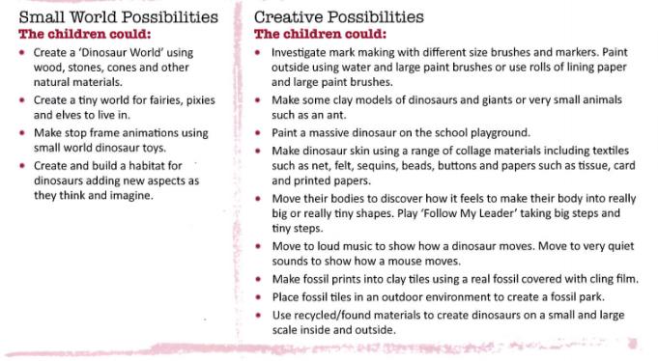
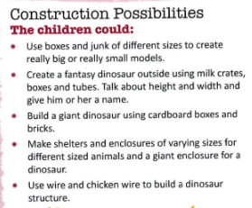
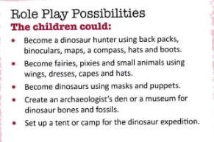

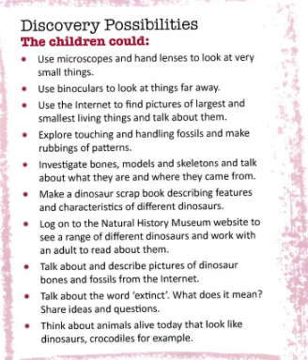
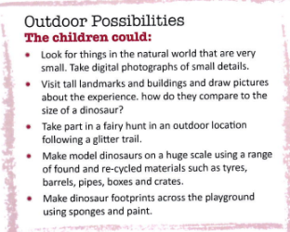

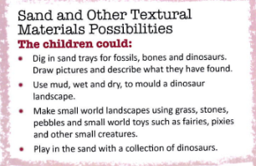

Reading
Please read a book daily from the following website: https://www.oxfordowl.co.uk/for-home/find-a-book/library-page/?fbclid=IwAR08_sImZbWDzoo57OfcXsyZBBdBgboprOSRhpiDc6_MXL0OLl5vw6y2dlc
You will need to register and create a log in but all the eBooks are free.
Please go on the website provided and scroll down to find the following: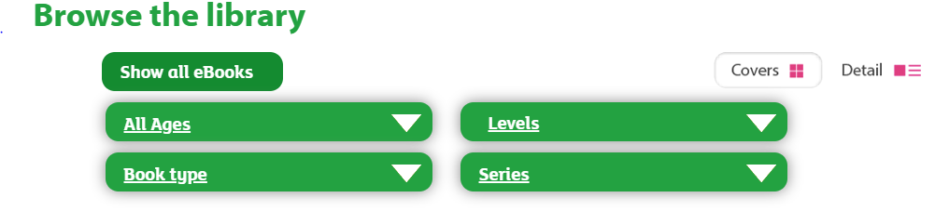
Select “levels” and then “book band” and select the required book band colour for your child. At this point in the academic year expected standard (at age related expectation) your child would be reading book band 4 blue. However, if your child is greater depth or exceeding the Early Learning Goal (above age related expectation) they would be reading book band 5 green. If your child is working towards the Early Learning Goal (below age related expectation), please select the required book band level dependent on your child’s reading capability from the following options:
Book band 2 red
Book band 3 yellow
Book band 6 orange
If your child is finding the book band level particularly hard or too easy, please access the book level either before or after the ones we have recommended, as you feel appropriate.
As part of parents’ evening, you received some coloured comprehension questions linked to the book bands. Please also ask your child these questions when they read to you.
Reading is crucial to your child’s development, please also make sure that you read books and poems for your child’s enjoyment daily!

Phonics
Phonics is an important part of the Early Years and is taught daily. When your child gets into Y1 they will sit a Phonics screening test; in order for your child to stay on track, it is important that they consolidate the sounds that they have already been taught and learn new phonemes which they can then apply in their reading and writing.
Please go to the following website:
https://www.ruthmiskin.com/en/find-out-more/help-during-school-closure/
Please click on ‘YouTube channel’ (highlighted in blue at the end of the first line) see below:
It will direct you to a page like this:
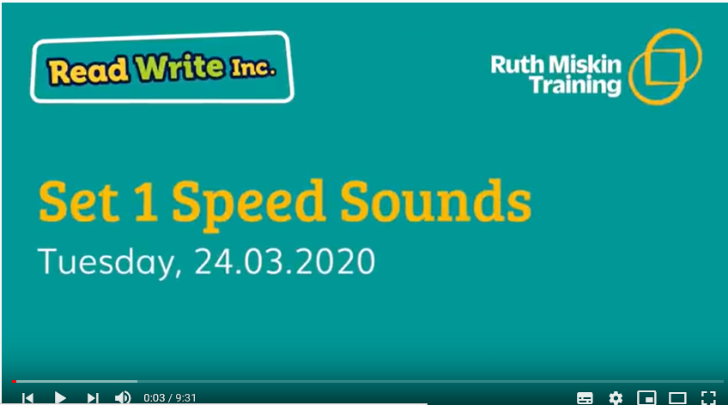
Please watch and complete the following daily:
Set 1: 9:30am
Set 2: 10.00am

Writing
As part of your previous homework pack your child was asked to write a simple sentence. This time we would like your child to write two simple sentences using the picture prompts on the next page. In addition to this please continue to practise writing and spelling ‘high frequency’ words. Examples of simple sentences include;
Example 1 (see image 1 below) – The girl has a bucket and spade. She is going to make a sandcastle.
Example 2 (see image 2 below) – The lady is shopping. She is buying food for a party.
Please encourage your child to look at the images, compose and say their sentences, write their sentences and then read their sentences back to check they make sense. As part of your child’s simple sentences please make sure that they have a capital letter at the start of a sentence and a full stop at the end of a sentence. Encourage your child to use their phonics knowledge to spell unfamiliar words such as ‘sandcastle’ as this will help build confidence.

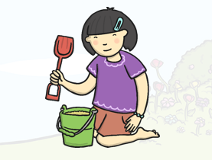
Image 1 Image 2

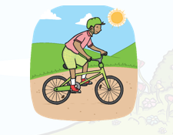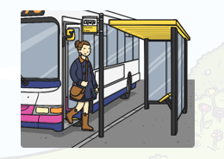
Image 4 Image 5

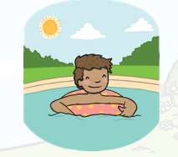

It is important that our children are communicating through the marks they make and using their phonics skills daily through play. We would love to see some fact sheets about your child’s favourite dinosaurs or maybe your child could use their imagination to write a story about their favourite dinosaur and its adventures.

If you have access to online facilities. Please hold down Ctrl + Alt and click on the below links for more writing activities (linked to dinosaurs) that you can download and have a go at.

https://www.twinkl.co.uk/resource/t-t-252812-dinosaurs-writing-stimulus-picture
https://www.twinkl.co.uk/resource/dinosaurs-early-writing-activities-t-e-2550024
https://www.twinkl.co.uk/resource/t-t-10882-dinosaur-factfile-worksheets
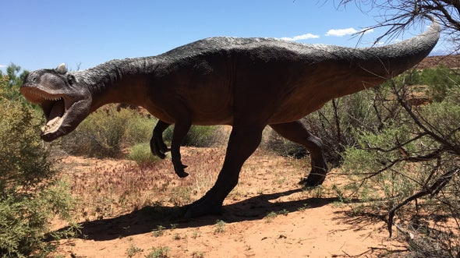

Maths
In your previous homework pack, we asked you to practise ‘time’. At this point in the year we would move onto having a look at ‘money’. Please make sure you do this on a very practical level exploring the language of these areas before moving onto more formal methods. See the examples below:
Money
Basic vocabulary relating to money – money, how much, cost, altogether, coins (recognising values) pence, pounds, cash, notes, change
- Explore and talk about money
  - Allow your child to explore what is in your purse or wallet. Talk about what they find and answer any questions they might have. Look at the different coins, colours, shapes, pictures that are on them. Ask questions such as what is it? Why do we need money? What sorts of things do we buy/pay for with money? Talk about daily routine and things that we pay for during the day for example water and electricity, food that we eat, transport etc. How do we earn money?

- Recognition of coins
  - Recognise and name the 8 different coins. Gather 8 different items and price them with each of the eight values e.g 1pence, 2pence, 50pence…Can your child select the right coin for each item? See the example below:

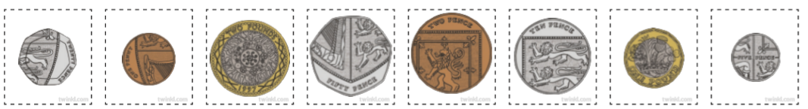
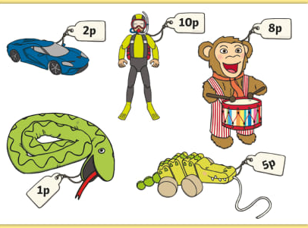

- Understand the value of each coin

  - Discuss the value of each coin and talk about which has the smallest value and the biggest value. Can your child put the coins in order from smallest to largest?

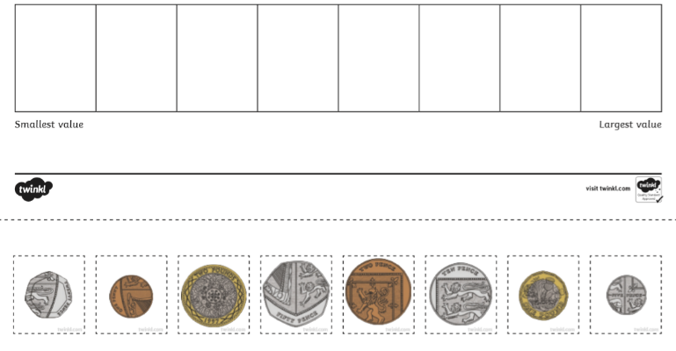

  - Ensure your child knows that 1pence is the smallest unit of money. Set up a shop and challenge your child: Give your child just pennies to start off with, can they give you the right amount do they understand the total they have given you? Now look at the other coins and explain to your child that they have used 5 pennies but 5 pennies is the same as using a 5 pence coin. Do this with the different values of money representing each coin with the amount of pennies e.g 10pence is the same as 10 pennies.
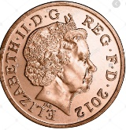
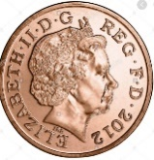
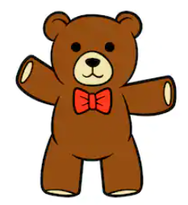
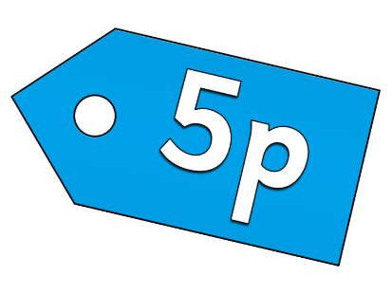

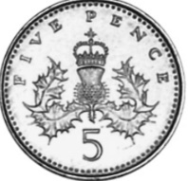
5 pennies are the same as 5pence coin

- Problem solve during play
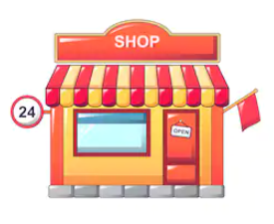
- Role play: Set up your own shop, it can be any type of shop; pizza, ice-cream and sweetie shops are some of our favourites. Give your child either a real purse or cut out the purse at the bottom of this page and add the eight different coins, plus extra coins if your child is confident with money. Add price tags to the items that you are selling and off you go! Remember to use vocabulary to do with money e.g how much, cost, total

Extension Task:
If your child is confident at recognising and selecting the right amounts and understands the value of the individual coins challenge your child! Encourage your child to problem solve for example when your child might need 2 or more coins to buy an item e.g an item that costs 12pence your child can apply their addition skills to find the 12 pence total. If they are applying addition skills confidently to solve money problems then you could introduce giving change, but we would suggest just giving change from 10pence and then 20pence at this stage.

For extra fun and engaging activities “Twinkl” have given all parents an incredible offer – all content on their website is FREE for one month! All you have to do is go to www.twinkl.co.uk/offer enter your email address and create a password and use the code: UKTWINKLHELPS
If you click on the EYFS section, there you will find a vast range of activities for your child to enjoy!

The expectation is that all parents and carers will follow this daily model so that when all children return back to school, they are all at the same point. We will be continuing with learning with the knowledge that they have been learning the above at home, so please ensure your child completes the short activities above.
This pack is for your child to begin week commencing Monday 25th May and is designed to last until Friday 12th June. Please return this pack to your child’s class teacher on the day of return to Royd. We would love to see some photographs of you exploring money and having a go at simple sentences.

