Year 2 Parents and Carers:
Homework starting from Monday 25th May 2020 that will last for 3 weeks (end date Friday 12th June 2020). Please follow the guidance in this pack and this will help your child to keep on track with the national curriculum for when they return to school.
Daily learning expectations involve:
- Reading 1 book per day
- Phonics speed sounds
- Topic- complete an activity per day
- Maths- complete a few time tasks per day
- Writing - 1 lesson per day
- Please repeat anything your child is not secure with.
Reading
Please read a book daily from the following website: https://www.oxfordowl.co.uk/for-home/find-a-book/library-page/?fbclid=IwAR08_sImZbWDzoo57OfcXsyZBBdBgboprOSRhpiDc6_MXL0OLl5vw6y2dlc
You will need to register and create a log in but all the eBooks are free.
Please go on the website provided and scroll down to find the following: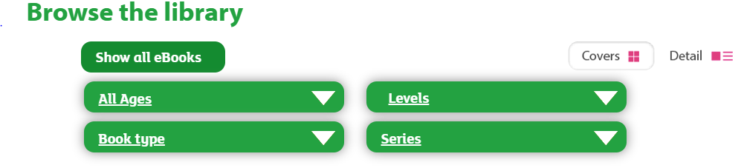
Select “levels” and then “book band” and select the required book band colour for your child. At this point in the academic year expected standard (at age related expectation) your child would be reading book band 11: lime. However, if your child is greater depth standard (above age related expectation) they would be reading book band 12: brown. If your child is working towards standard in reading (working below age related expectations) please select a colour that is appropriate for your child’s ability. As part of parents’ evening, you received some coloured comprehension questions linked to the book bands. Please also ask your child these questions when they read to you.
Phonics
Phonics is an important part of year 2 curriculum and is taught daily. Please click on the following link:
https://www.ruthmiskin.com/en/find-out-more/help-during-school-closure/
Once you have clicked on the link above, click on YouTube Channel which you will find under the subheading RWI Phonics lessons at home. Your child will need to compete set 2 speed sounds at 10am and set 3 speed sounds at 10:30am.
Topic
This half term the Year 2 topic is Moon Zoom. Below is a list of activities for your child to complete. Please choose one of the bullet points to focus on each day:

Maths
Below are some activities your child can complete on time. Please complete the following writing the digital and analogue time:
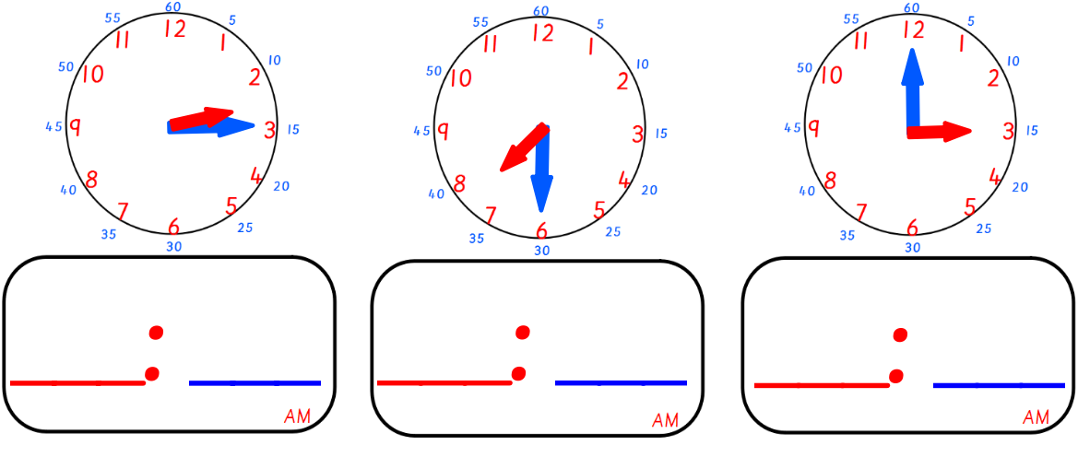

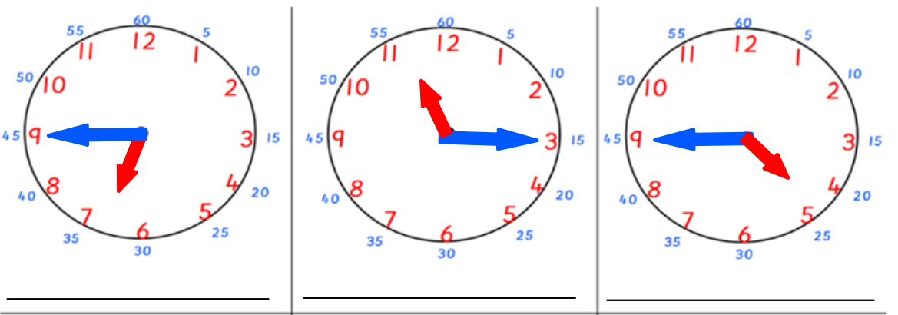

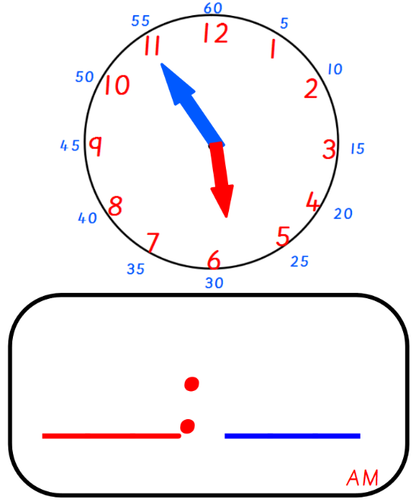
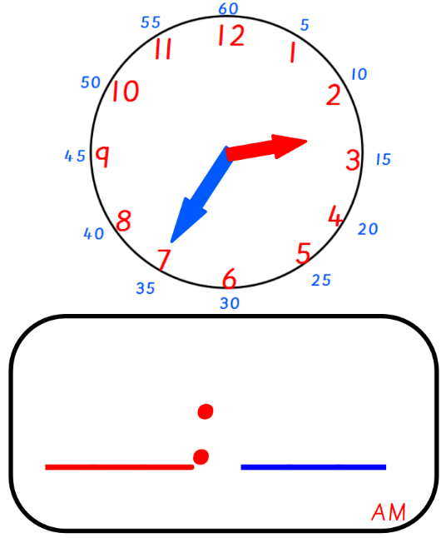
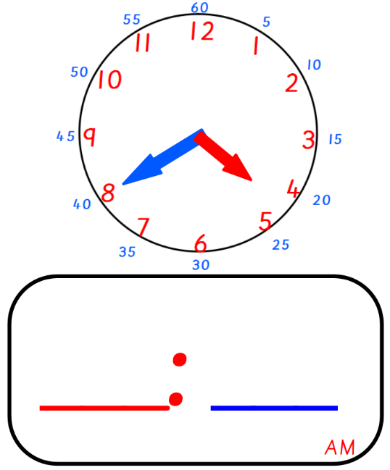

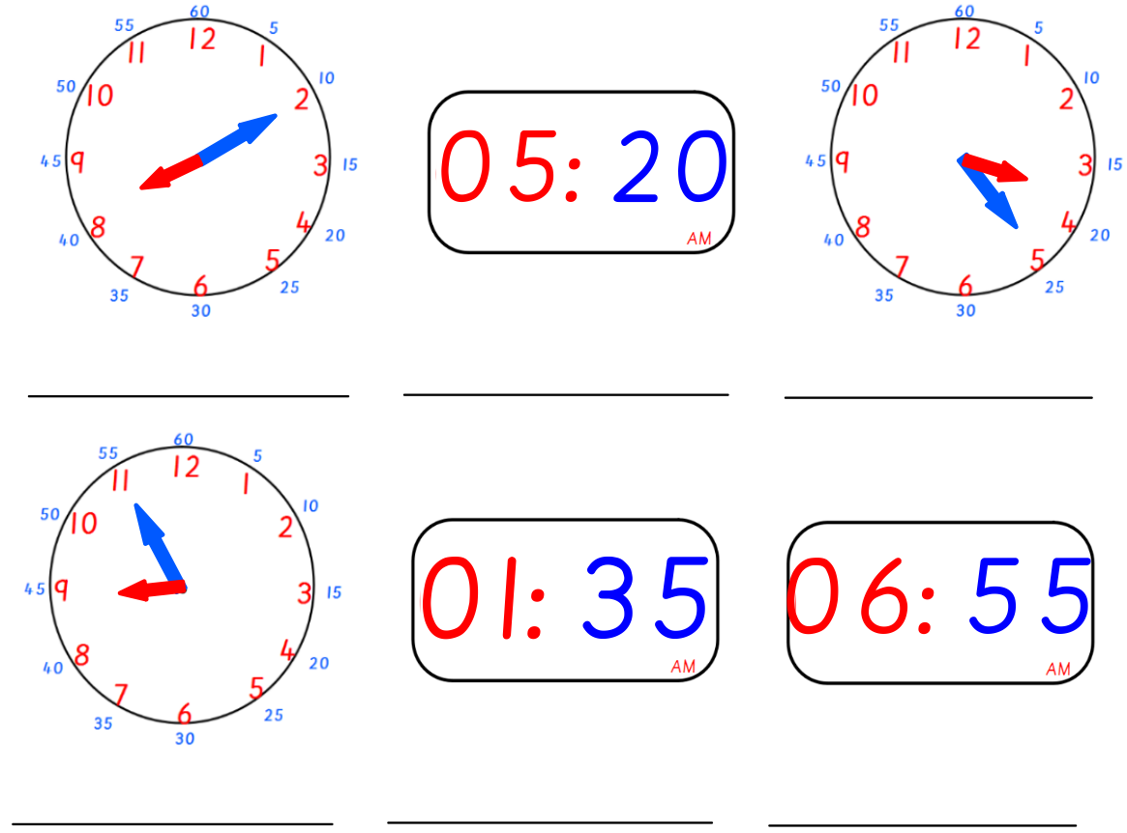

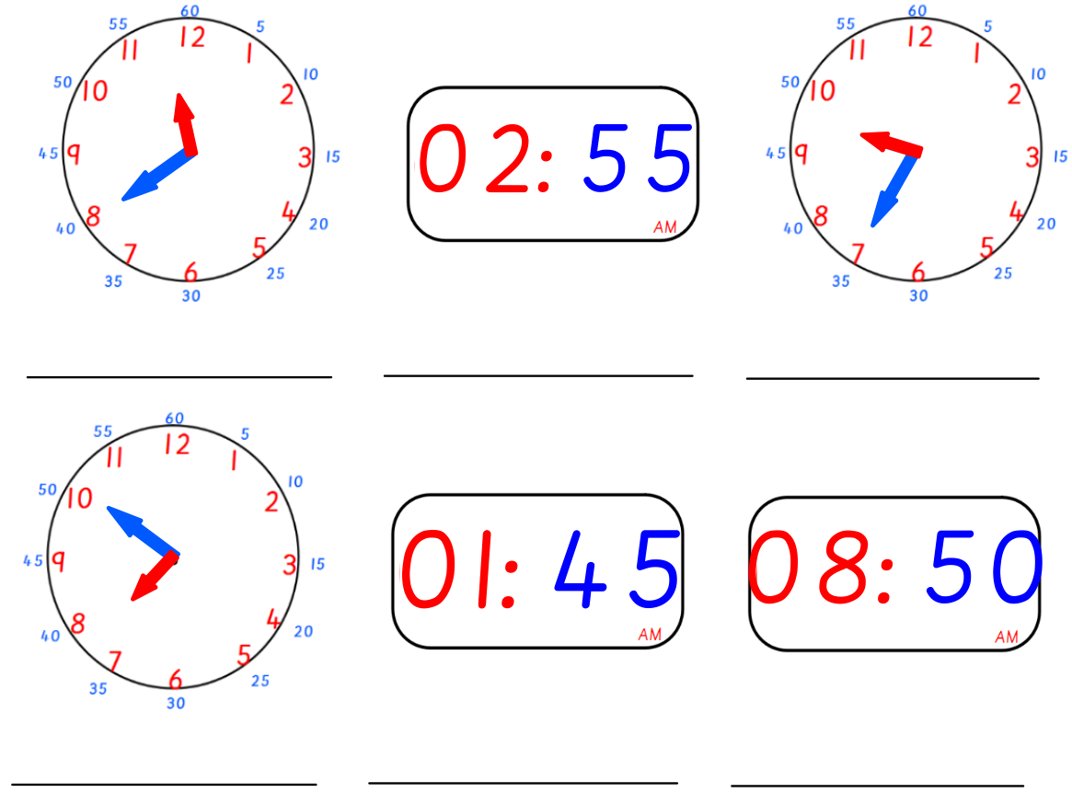

Have a go at drawing the hands on:
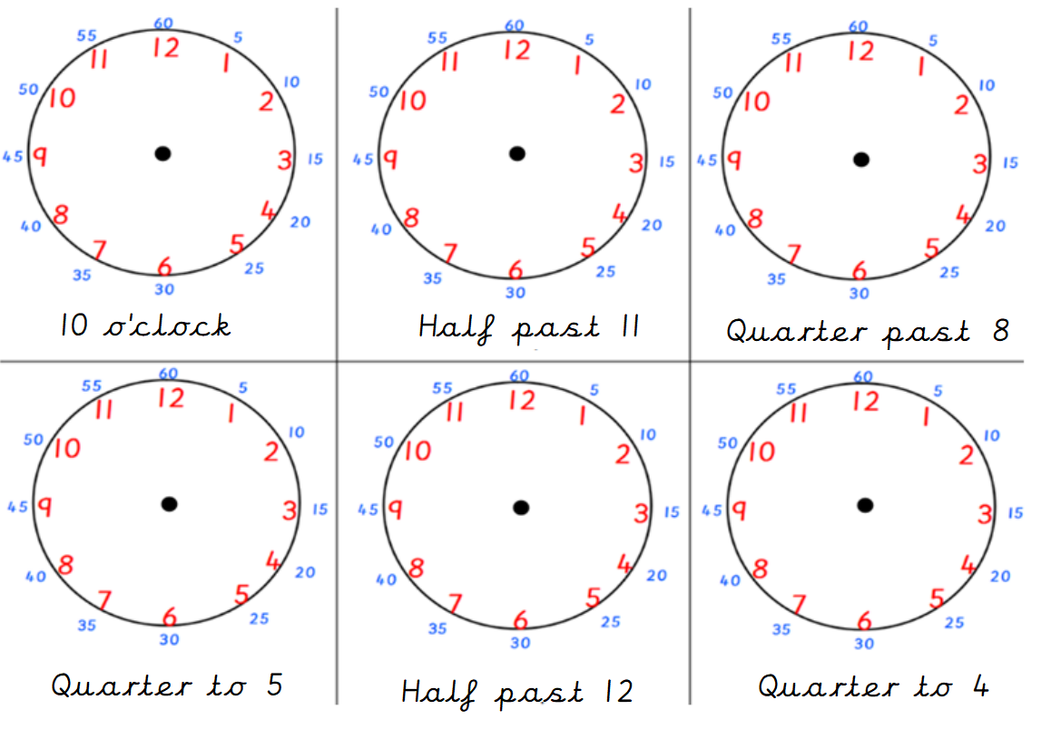

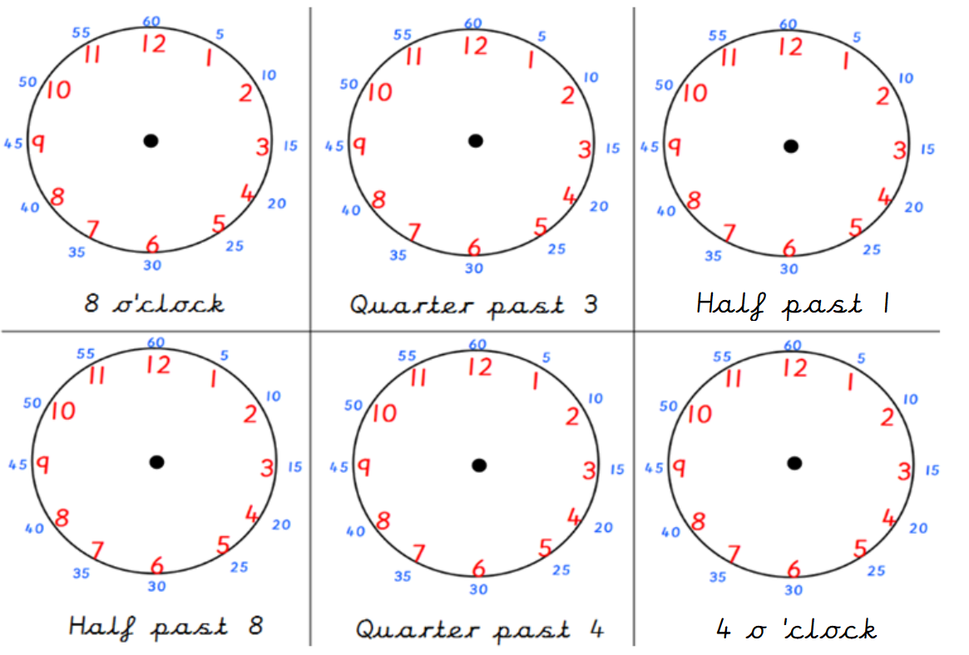

Have a go at completing the story:
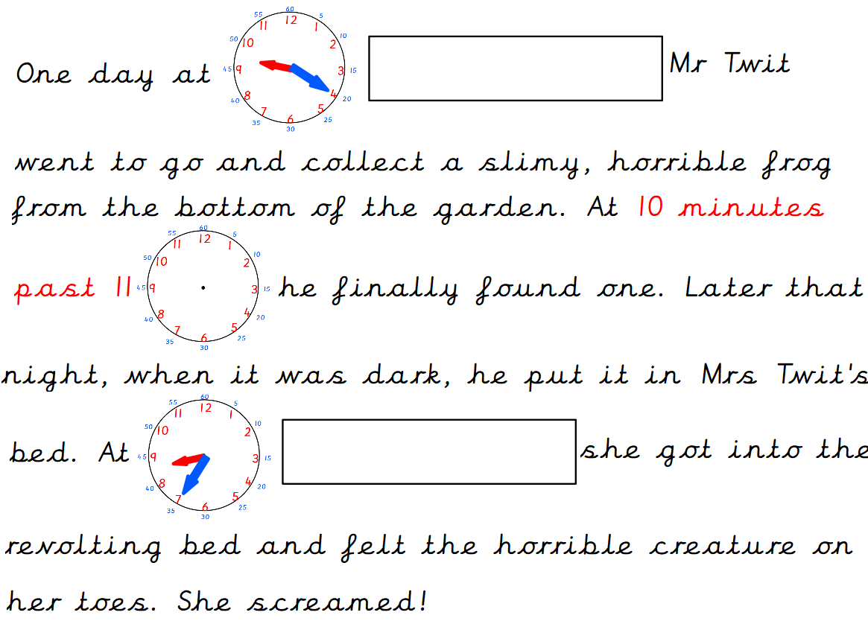
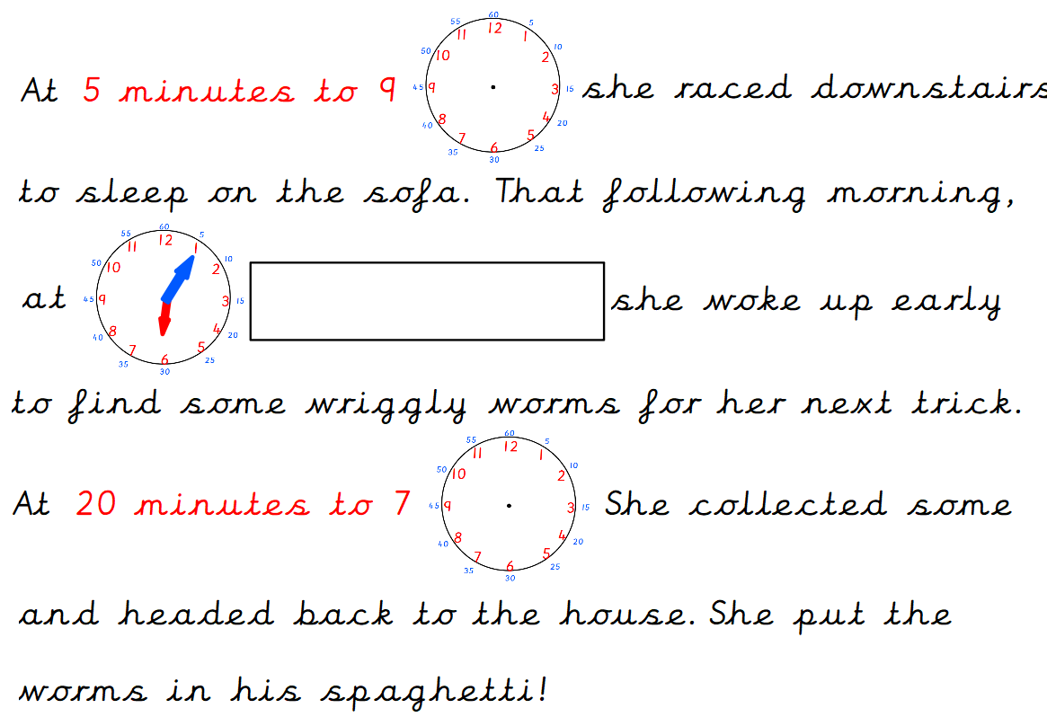

Writing
As part of the previous homework packs children were asked to complete 5 spellings per day from the spelling lists provided. School are aware that some children will still be working on these spellings in order to get them correct. Therefore, please continue to practise spelling the words from the previous homework.
In addition to this please complete the following activities linked to the suffixes. A suffix is a group of letters that go at the end of a root work to change its meaning. In Year 2 the suffixes that children are taught are as follows; -ed, -ful, -ly, -less, -ness, -ment, -ing, -er, -est, -s, -es and -ies. Box 1 is an explanation of spelling rules linked to the suffix. Box 2 is the teacher showing you how to apply the suffix to a root word using the spelling rules. Box 3 is what we would like your child to complete.
To provide further challenge, your child can apply their knowledge and use a word containing a suffix within a sentence e.g. The beautiful sun disappeared below the horizon and darkness filled the sky.

Lesson 1 – “ed”
Box 2
Root word | Suffix ed
cry | cried
pat | patted
dance | danced
trim | trimmed
marry | married
like | liked
copy | copied
force | forced
hop | hopped

Box 3
Root word | Suffix ed
skip
try
smile
empty
love
chat
chase
carry
nod

Box 1

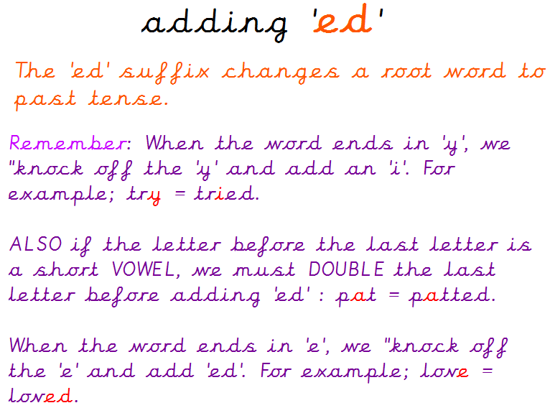
Lesson 2 – “ed”
Using one of the words that has “ed” please write a sentence. The sentence must also contain the word “and” or “but” or “or”.
For example – The young, kind girl was extremely cheerful and she danced all night long at the entertaining party.
- She cried out in pain when she fell over but nobody heard her.
- “Do you want to be married when you’re older or do you not?” asked Isabella inquisitively.
________________________________________________________________________________________________________________________________
________________________________________________________________________________________________________________________________
________________________________________________________________________________________________________________________________
Lesson 3 – “ing”
Box 1

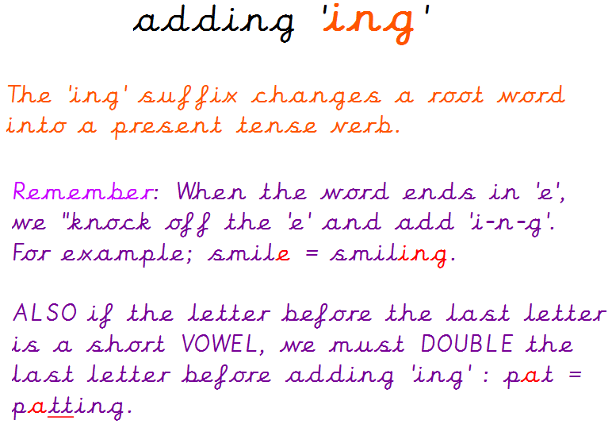
Box 3
Root word | Suffix ing
clap
write
win
bake
decide
shut

Box 2
Root word | Suffix ing
run | running
take | taking
knit | knitting
slip | slipping
come | coming
slide | sliding

Lesson 4 – “ing”
Using one of the words that has “ing” please write a sentence. The sentence must also contain the word “and” or “but” or “or”.
For example – Harry was taking his adorable dog for a walk in the mysterious woods and he ended up slipping over in some squelchy mud.
- An old woman was knitting a scarf, hat and gloves for her beautiful granddaughter but she didn’t know what colour she’d like.
- Sandra couldn’t decide whether she should go running or whether she should go on a long, scenic walk.
________________________________________________________________________________________________________________________________
________________________________________________________________________________________________________________________________
________________________________________________________________________________________________________________________________
Lesson 5 – “s” and “es”
Box 3
Root word | Suffixes s, es
bush
jump
stop
watch
fox
game

Box 2
Root word | Suffixes s, es
dog | dogs
stranger | strangers
fizz | fizzes
animal | animals
stretch | stretches
crash | crashes

Box 1

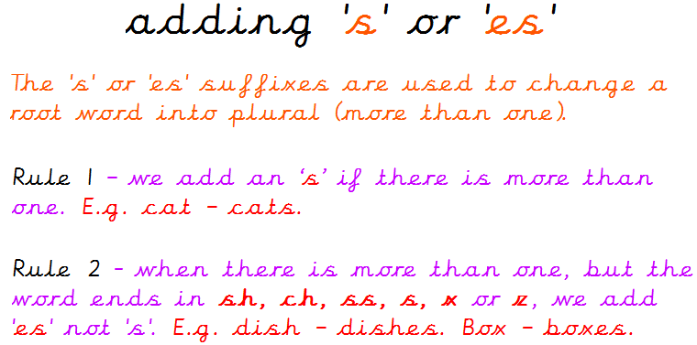

Lesson 6 – “s” and “es”
Using one of the words that has “s” or “es” please write a sentence. The sentence must also contain the word “and” or “but” or “or”. For example – The stranger crashes into an abandoned field and they discover some friendly animals.
- Joanne decided to do some stretches but she pulled a muscle in her leg.
- “Do you want to go and see the animals first or would you prefer to go straight to the park?” questioned Ben.
________________________________________________________________________________________________________________________________
________________________________________________________________________________________________________________________________
________________________________________________________________________________________________________________________________

Lesson 7 – “er”
Box 1

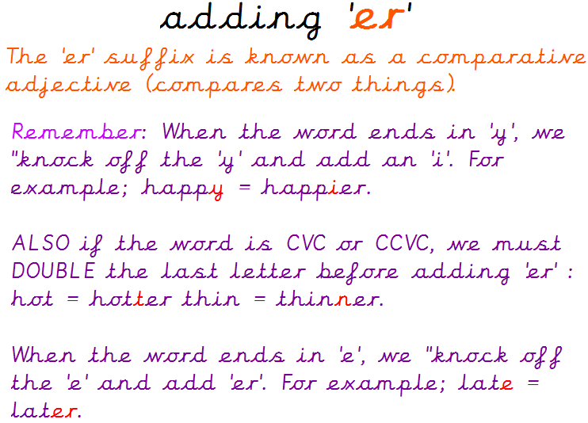
Box 3
Root word | Suffix er
cute
early
fit
late
friendly
glum
lucky
brave
thin

Box 2
Root word | Suffix er
happy | happier
grim | grimmer
nice | nicer
hot | hotter
scary | scarier
rude | ruder
lazy | lazier
mad | madder
simple | simpler

Lesson 8 – “er”
Using one of the words that has “er” please write a sentence. The sentence must also contain the word “and” or “but” or “or”.
For example – The shimmering sun is a lot hotter today and I am much happier that the weather is nicer.
- Ben’s mum got madder and madder but Ben found it hilarious which made her even angrier.
- Rachel couldn’t decide which cashier was ruder or which cashier was lazier because they were both the same.
________________________________________________________________________________________________________________________________
________________________________________________________________________________________________________________________________
________________________________________________________________________________________________________________________________
Lesson 9 – “est”
Box 1

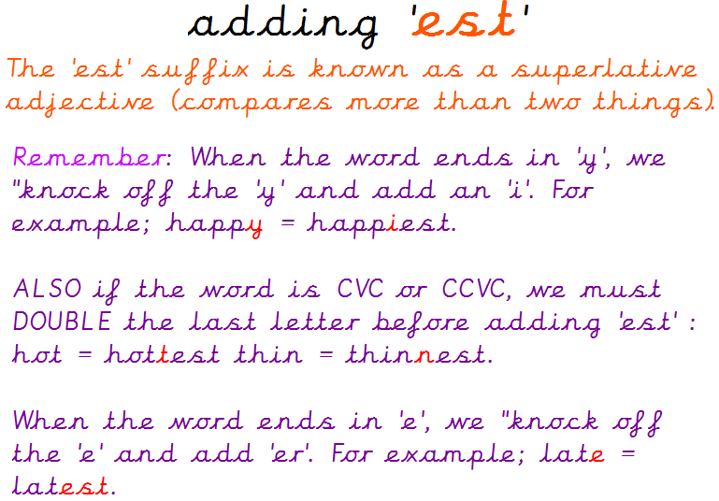
Box 3
Root word | Suffix est
easy
wide
big
fluffy
large
wet
noisy
sad
safe

Box 2
Root word | Suffix est
huge | hugest
fat | fattest
heavy | heaviest
dim | dimmest
tasty | tastiest
crude | crudest
red | reddest
fine | finest
windy | windiest

Lesson 10 – “est”
Using one of the words that has “est” please write a sentence. The sentence must also contain the word “and” or “but” or “or”.
For example – It was the windiest day outside and I was eating the tastiest scrumptious cake.
- I picked the reddest, juiciest looking apple but Mum said I wasn’t allowed to eat it yet.
- Which bag is the heaviest? Is it the leather, shabby looking one or is it the sapphire, sparkling bag?
________________________________________________________________________________________________________________________________
________________________________________________________________________________________________________________________________
________________________________________________________________________________________________________________________________

For extra fun and engaging activities “Twinkl” have given all parents an incredible offer – all content on their website is FREE for one month! All you have to do is go to www.twinkl.co.uk/offer enter your email address and create a password and use the code: UKTWINKLHELPS
If you click on the KS1 section, there you will find a vast range of activities for your child to enjoy!

The expectation is that all parents and carers will follow this daily model so that when all children return back to school, they are all at the same point. We will be continuing with learning with the knowledge that they have been learning the above at home, so please ensure your child completes the short activities above.
This pack is for your child to begin week commencing Monday 25th May and is designed to last until Friday 12th June. Please return this pack to your child’s class teacher on the day of return to Royd.

