Year 1 Parents and carers:
Homework starting from Monday 11th May 2020 that will last for 2 weeks (end date Friday 22nd May 2020). Please note that W/C Monday 25th May 2020 is half term and therefore no homework will be set. Please follow the guidance in this pack and this will help your child to keep on track with the national curriculum for when they return to school.
Daily learning expectations involve:
- Topic related tasks
- Reading 1 book per day
- Phonics speed sounds
- 1 suffix lesson per day
- Fractions (5 per day)
- Please repeat anything your child is not secure with.

Topic
This half term in Year 1, the children’s topic is The Enchanted Woodland. Below is a list of activities for your child to complete. Please choose one of the bullet points to focus on each day.
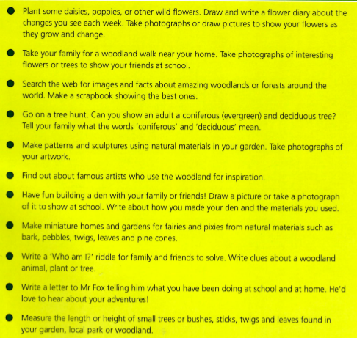
Reading
Please read a book daily from the following website: https://www.oxfordowl.co.uk/for-home/find-a-book/library-page/?fbclid=IwAR08_sImZbWDzoo57OfcXsyZBBdBgboprOSRhpiDc6_MXL0OLl5vw6y2dlc
You will need to register and create a log in but all the ebooks are free.
Please go on the website provided and scroll down to find the following: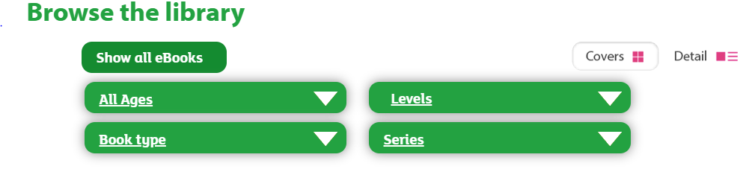
Select “levels” and then “book band” and select the required book band colour for your child. At this point in the academic year expected standard (at age related expectation) your child would be reading book band 5: green. However if your child is greater depth standard (above age related expectation) they would be reading book band 6 orange. If your child is working towards standard (above age related expectation), please select the required book band level dependent on your child’s reading capability from the following options:
Book band 1 pink
Book band 2 red
Book band 3 yellow
Book band 4 blue
As part of parents’ evening, you received some coloured comprehension questions linked to the book bands. Please also ask your child these questions when they read to you.
Phonics
As part of Year 1, a key aspect of the curriculum is daily phonics. If your child is expected standard (at age related expectation) or greater depth standard (above age related expectation) in reading, please go to the following website: https://www.ruthmiskin.com/en/find-out-more/help-during-school-closure/
Please click on ‘YouTube channel’ (highlighted in blue at the end of the first line) and watch Set 2 speed sounds at 10am and Set 3 speed sounds at 10.30am. This will help to keep your child on track with their reading.
If your child is working towards standard (below age related expectation) your child will also need to watch Set 1 speed sounds at 9.30am.

Writing
As part of the previous homework packs your child was asked to complete 5 spellings a day from the spelling lists provided. School are aware that some children will still be working on these spellings in order to get them correct. Therefore please continue to practise spelling the words from the previous homework. In addition to this, please complete the following activity linked to suffixes. A suffix is a group of letters that go at the end of a root word to change its meaning. In Year 1, the suffixes that children are taught are as follows: ed, ing, s, es, er, est.
Box 1 is an explanation of spelling rules linked to the suffix. Box 2 is the teacher showing you how to apply the suffix to a root word using the spelling rules. Box 3 is what we would like your child to complete.

Lesson 1 – “ed”
Box 1

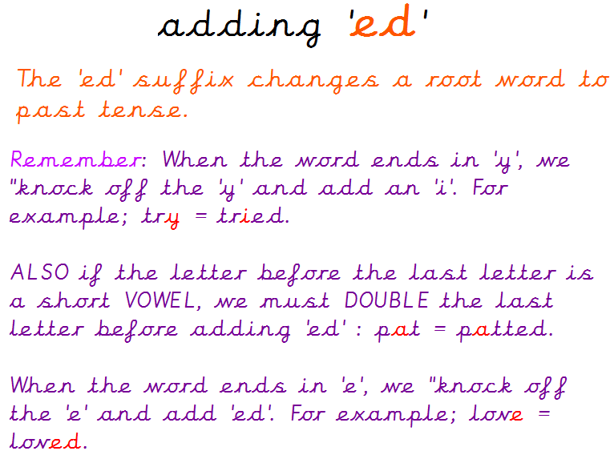
Box 3
Root word | Suffix ed
skip
try
smile
empty
love
chat
chase
carry
nod

Box 2
Root word | Suffix ed
cry | cried
pat | patted
dance | danced
trim | trimmed
marry | married
like | liked
copy | copied
force | forced
hop | hopped

Lesson 2 – “ed”
Using one of the words that has “ed” please write a sentence. The sentence must also contain the word “and”.
For example – The young, kind girl was extremely cheerful and she danced all night long at the entertaining party.
________________________________________________________________________________________________________________________________
________________________________________________________________________________________________________________________________
________________________________________________________________________________________________________________________________
Lesson 3 – “ing”
Box 1

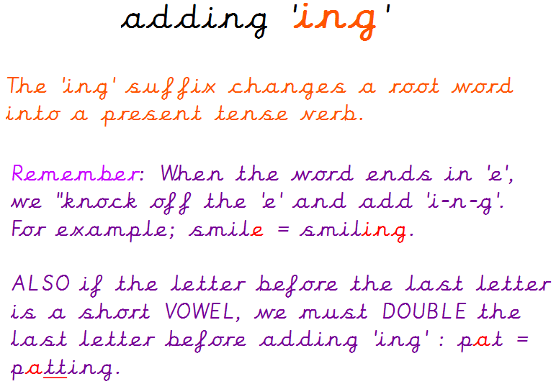
Box 3
Root word | Suffix ing
clap
write
win
bake
decide
shut

Box 2
Root word | Suffix ing
run | running
take | taking
knit | knitting
slip | slipping
come | coming
slide | sliding

Lesson 4 – “ing”
Using one of the words that has “ing” please write a sentence. The sentence must also contain the word “and”.
For example – Harry was taking his adorable dog for a walk in the mysterious woods and he ended up slipping over in some squelchy mud.
________________________________________________________________________________________________________________________________
________________________________________________________________________________________________________________________________
________________________________________________________________________________________________________________________________
Lesson 5 – “s” and “es”
Box 1

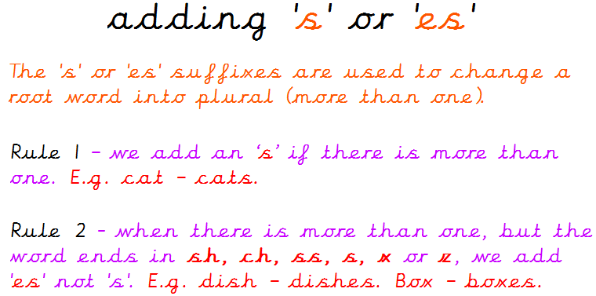
Box 3
Root word | Suffixes s, es
bush
jump
stop
watch
fox
game

Box 2
Root word | Suffixes s, es
dog | dogs
stranger | strangers
fizz | fizzes
animal | animals
stretch | stretches
crash | crashes

Lesson 6 – “s” and “es”
Using one of the words that has “s” or “es” please write a sentence. The sentence must also contain the word “and”.
For example – The stranger crashes into an abandoned field and they discover some friendly animals.
________________________________________________________________________________________________________________________________
________________________________________________________________________________________________________________________________
________________________________________________________________________________________________________________________________
Lesson 7 – “er”
Box 1

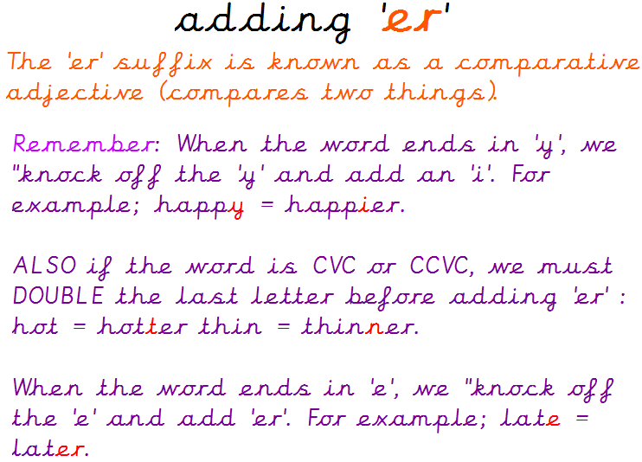
Box 3
Root word | Suffix er
cute
early
fit
late
friendly
glum
lucky
brave
thin

Box 2
Root word | Suffix er
happy | happier
grim | grimmer
nice | nicer
hot | hotter
scary | scarier
rude | ruder
lazy | lazier
mad | madder
simple | simpler

Lesson 8 – “er”
Using one of the words that has “er” please write a sentence. The sentence must also contain the word “and”.
For example – The shimmering sun is a lot hotter today and I am much happier that the weather is nicer.
________________________________________________________________________________________________________________________________
________________________________________________________________________________________________________________________________
________________________________________________________________________________________________________________________________
Lesson 9 – “est”
Box 1

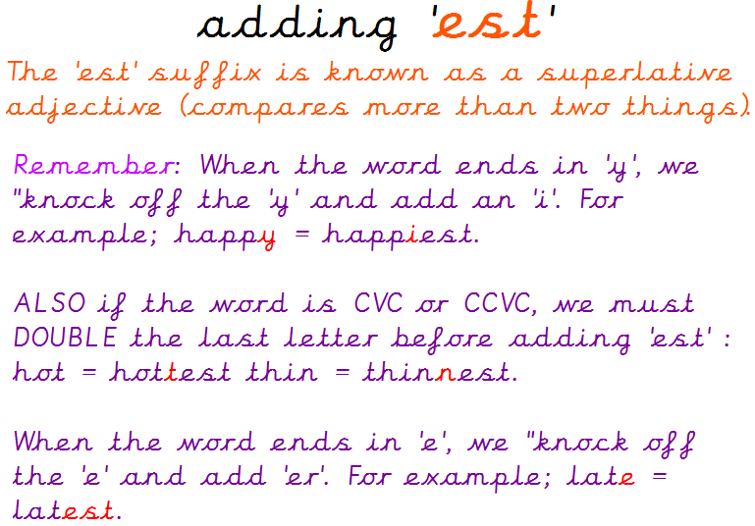
Box 3
Root word | Suffix est
easy
wide
big
fluffy
large
wet
noisy
sad
safe

Box 2
Root word | Suffix est
huge | hugest
fat | fattest
heavy | heaviest
dim | dimmest
tasty | tastiest
crude | crudest
red | reddest
fine | finest
windy | windiest

Lesson 10 – “est”
Using one of the words that has “est” please write a sentence. The sentence must also contain the word “and”.
For example – It was the windiest day outside and I was eating the tastiest scrumptious cake.
________________________________________________________________________________________________________________________________
________________________________________________________________________________________________________________________________
________________________________________________________________________________________________________________________________
Maths
In Year 1, we would be moving onto fractions at this point in the academic year.
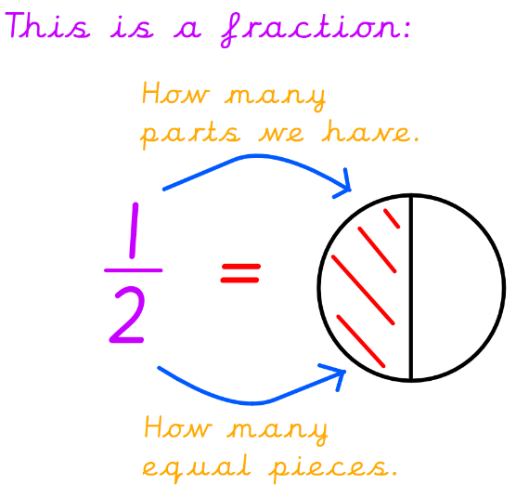
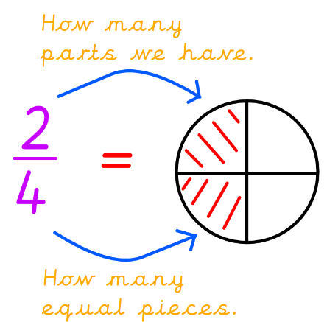
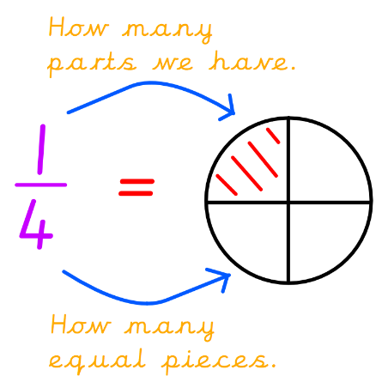

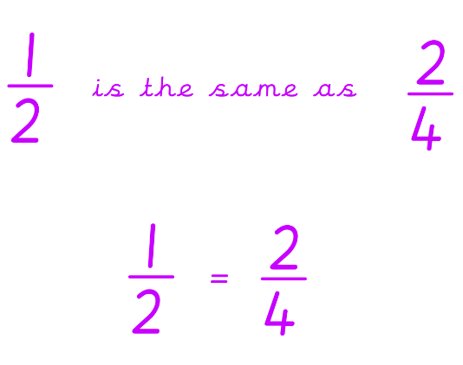
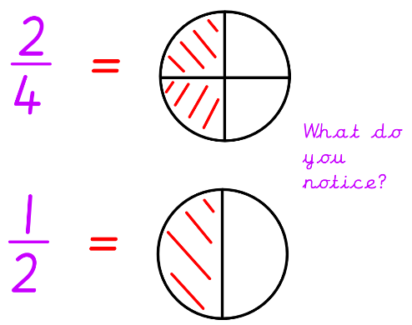

Please get your child to identify and write fractions.
Please complete the following worksheets. When finished, try drawing your own shapes and finding the fractions of them. You can also find a fraction of objects and amounts (teddies, toys etc).
Shade in the fractions of these shapes.
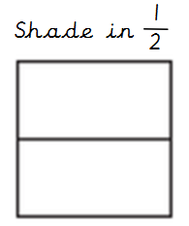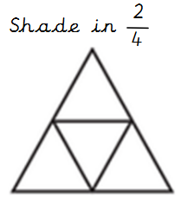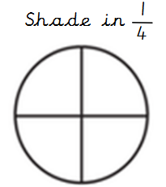

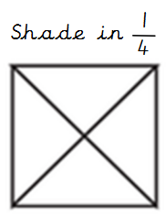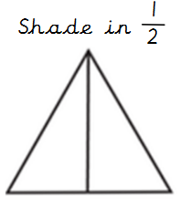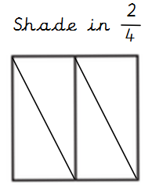

Write the fractions of these shapes.
_______ _______ _______

_______ _______ _______

Complete these word problems.
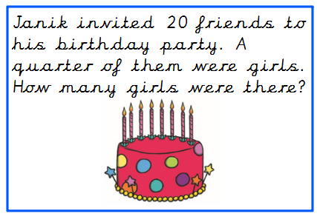
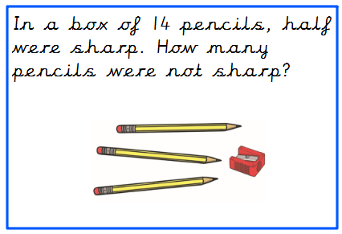
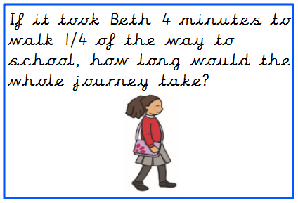
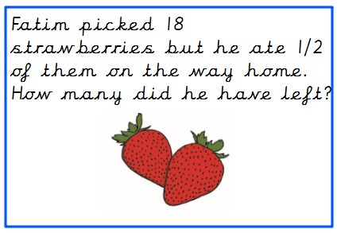

Daily learning expectations involve:
- Topic related tasks
- Reading 1 book per day
- Phonics speed sounds
- 1 suffix lesson per day
- Fractions (5 per day)
- Please repeat anything your child is not secure with.

For extra fun and engaging activities “Twinkl” have given all parents an incredible offer – all content on their website is FREE for one month! All you have to do is go to www.twinkl.co.uk/offer enter your email address and create a password and use the code: UKTWINKLHELPS
If you click on the KS1 section, there you will find a vast range of activities for your child to enjoy!

The expectation is that all parents and carers will follow this daily model so that when all children return back to school, they are all at the same point. We will be continuing with learning with the knowledge that they have been learning the above at home, so please ensure your child completes the short activities above.
This pack is for your child to begin week commencing Monday 11th May and is designed to last until Friday 22nd May. Please return this pack to your child’s class teacher on the day of return to Royd.

