Year 2 Parents and Carers:
Homework starting from Monday 11th May 2020 that will last for 2 weeks (end date Friday 22nd May 2020). Please note that w/C Monday 25th May 2020 is half term and therefore no homework will be set. Please follow the guidance in this pack and this will help your child to keep on track with the national curriculum for when they return to school.
Daily learning expectations involve:
- Topic related tasks
- Reading 1 book per day
- Phonics speed sounds
- 1 suffix lesson per day
- Money tasks
- Please repeat anything your child is not secure with.
Reading
Please read a book daily from the following website: https://www.oxfordowl.co.uk/for-home/find-a-book/library-page/?fbclid=IwAR08_sImZbWDzoo57OfcXsyZBBdBgboprOSRhpiDc6_MXL0OLl5vw6y2dlc
You will need to register and create a log in but all the eBooks are free.
Please go on the website provided and scroll down to find the following: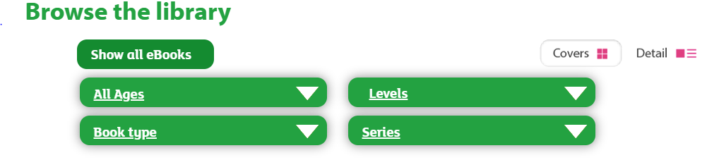
Select “levels” and then “book band” and select the required book band colour for your child. At this point in the academic year expected standard (at age related expectation) your child would be reading book band 10: white. However, if your child is greater depth standard (above age related expectation) they would be reading book band 11: lime. If your child is working towards standard in reading (working below age related expectations) please select a colour that is appropriate for your child’s ability. As part of parents’ evening, you received some coloured comprehension questions linked to the book bands. Please also ask your child these questions when they read to you.

Phonics
Phonics is an important part of year 2 curriculum and is taught daily. Please click on the following link:
https://www.ruthmiskin.com/en/find-out-more/help-during-school-closure/
Once you have clicked on the link above, click on YouTube Channel which you will find under the subheading RWI Phonics lessons at home. Your child will need to compete set 2 speed sounds at 10am and set 3 speed sounds at 10:30am.
Topic
This half term the Year 2 topic is The Enchanted Woodland. Below is a list of activities for your child to complete. Please choose one of the bullet points to focus on each day:

Maths
In Year 2, we would be moving on to money at this point in the academic year.
Below are some activities your child can complete:
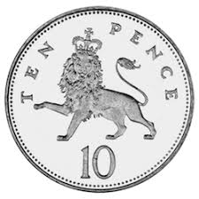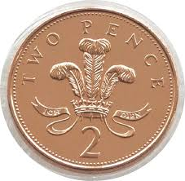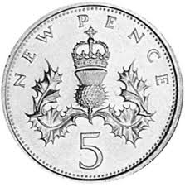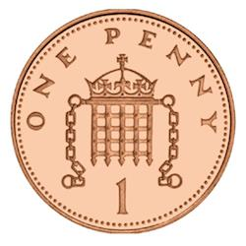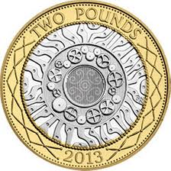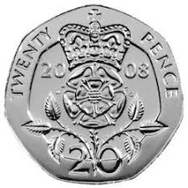

- Cut out the coins above and order them from the smallest value to the largest value.
- Use the coins again and order them from the largest value coin to the smallest value coin.

Counting coins:
How many 1p’s make 9p?
How many 2p’s make 12p?
How many 5p’s make 35p?
How many 10p’s make 30p?
How many 20p’s make 60p? – tip: just like counting in 2’s, but with a ‘0’ on the end (ten times bigger).
How many 50p’s make £1?
How many £1’s make £2?

Can you add together the coins in each purse to find out how much is inside:
Draw coins in each purse so they add together to make the value given:

Have a go at completing these word problems:
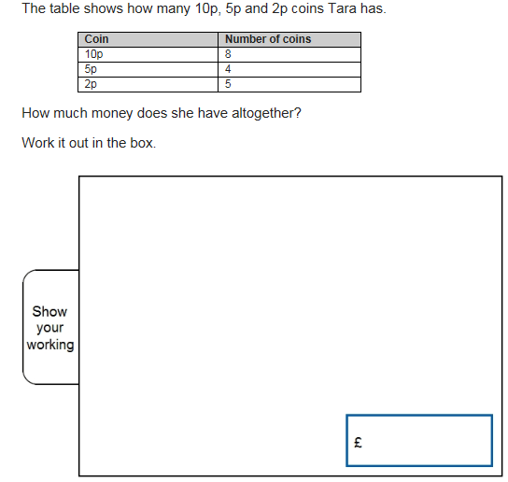
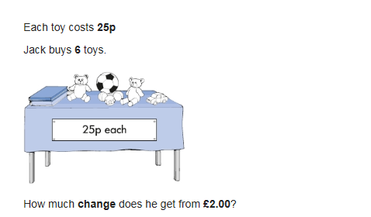

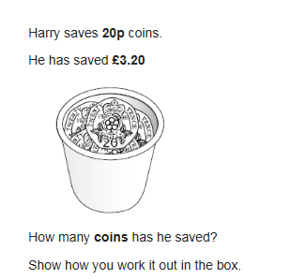

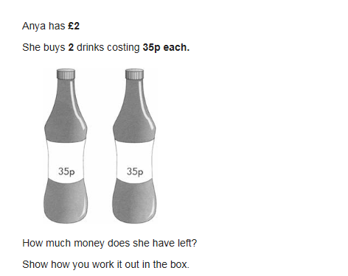

Writing
As part of the previous homework packs children were asked to complete 5 spellings per day from the spelling lists provided. School are aware that some children will still be working on these spellings in order to get them correct. Therefore, please continue to practise spelling the words from the previous homework.
In addition to this please complete the following activities linked to the suffixes. A suffix is a group of letters that go at the end of a root work to change its meaning. In Year 2 the suffixes that children are taught are as follows; -ed, -ful, -ly, -less, -ness, -ment, -ing, -er, -est, -s, -es and -ies. Box 1 is an explanation of spelling rules linked to the suffix. Box 2 is the teacher showing you how to apply the suffix to a root word using the spelling rules. Box 3 is what we would like your child to complete.
To provide further challenge, your child can apply their knowledge and use a word containing a suffix within a sentence e.g. The beautiful sun disappeared below the horizon and darkness filled the sky.

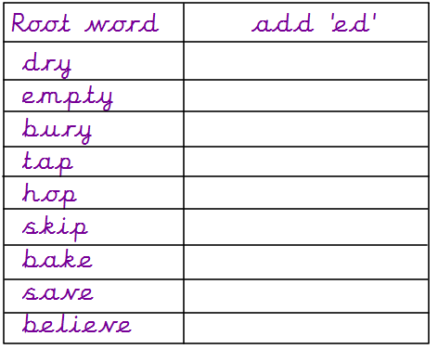
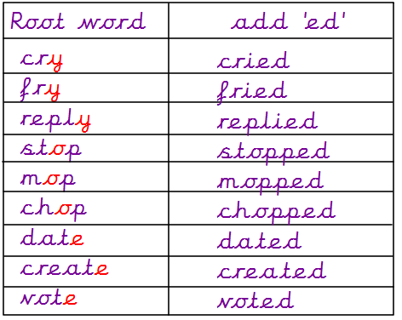
Lesson 1
3. Your turn:
2..
Lesson 2
3. Your turn:
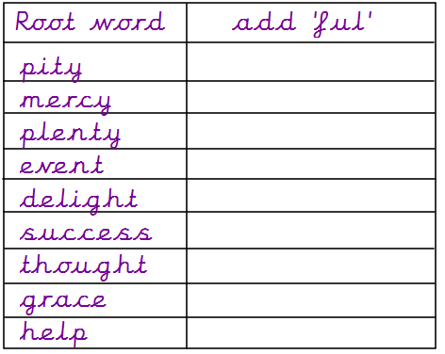

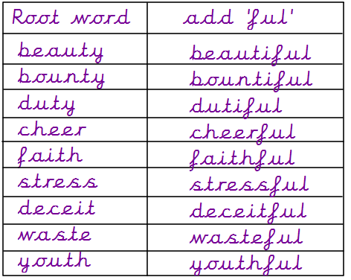

2..

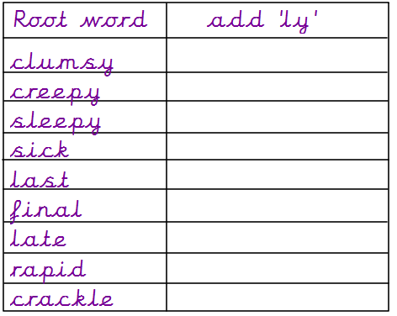
3. Your turn:
Lesson 3
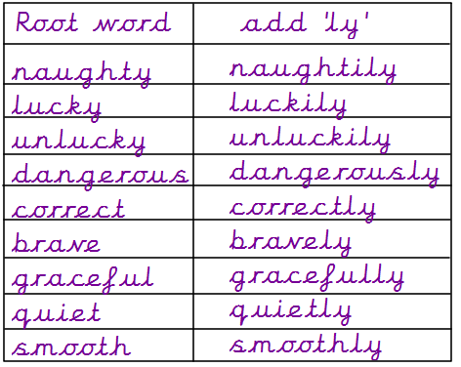
2.

3. Your turn:
Lesson 4
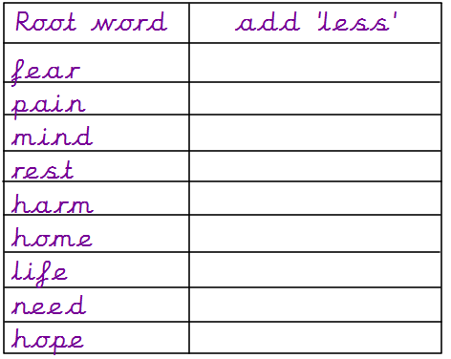

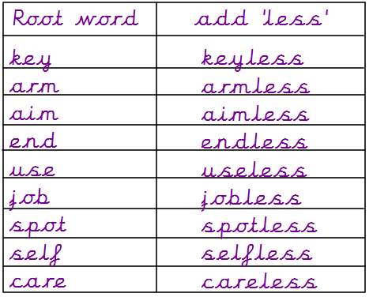
2.

3. Your turn:
Lesson 5

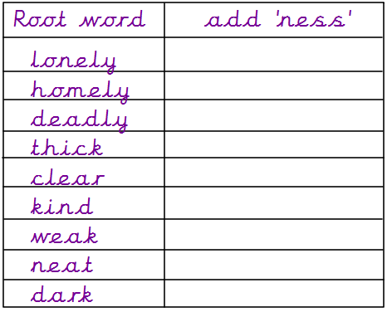

2.
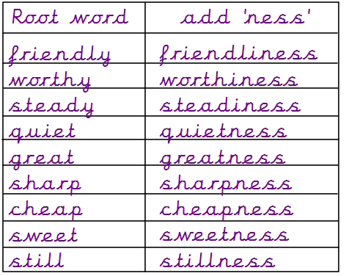

3. Your turn:
Lesson 6
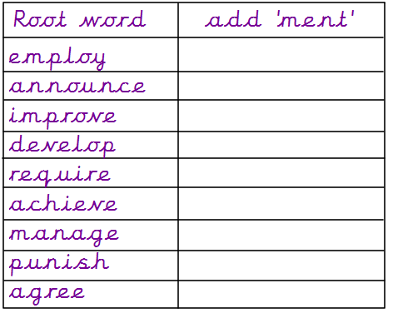

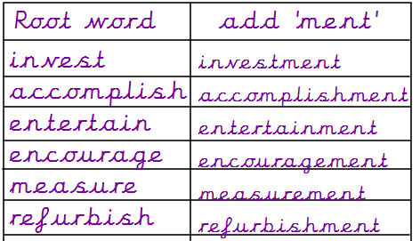
2.

3. Your turn:
Lesson 7
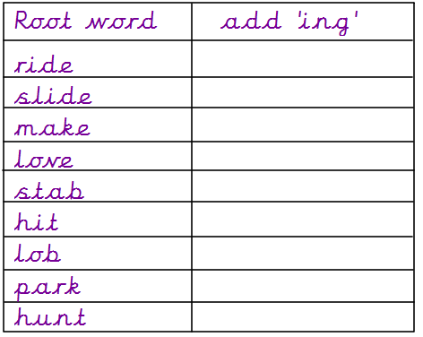

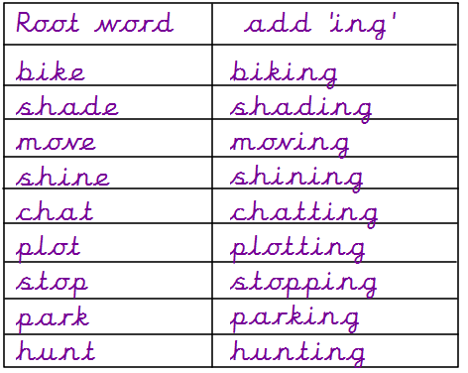
2.

3. Your turn:
Lesson 8
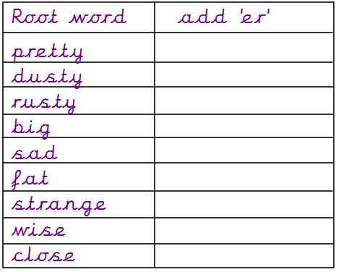

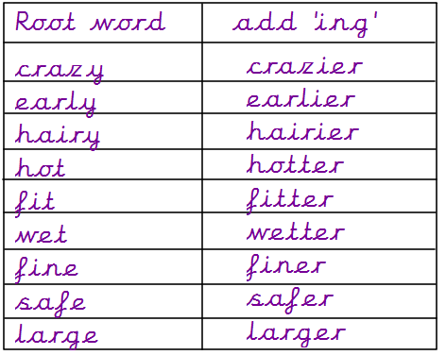
2.

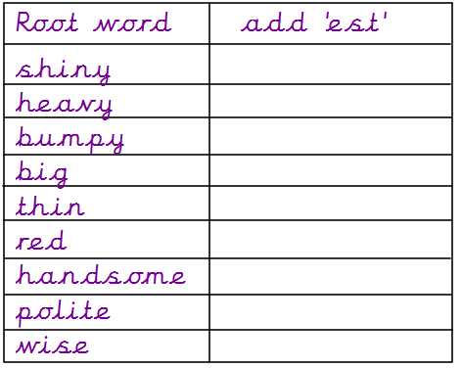
3. Your turn:
2.
Lesson 9
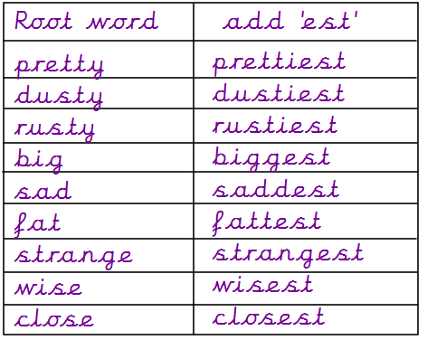

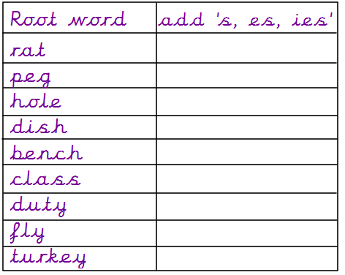
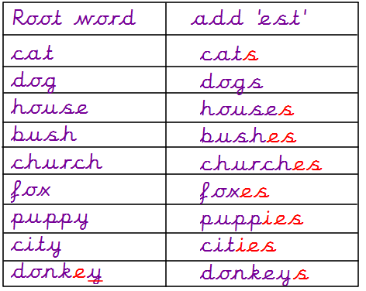
add ‘s, es, ies’
3. Your turn:
2.
Lesson 10

For extra fun and engaging activities “Twinkl” have given all parents an incredible offer – all content on their website is FREE for one month! All you have to do is go to www.twinkl.co.uk/offer enter your email address and create a password and use the code: UKTWINKLHELPS
If you click on the KS1 section, there you will find a vast range of activities for your child to enjoy!

The expectation is that all parents and carers will follow this daily model so that when all children return back to school, they are all at the same point. We will be continuing with learning with the knowledge that they have been learning the above at home, so please ensure your child completes the short activities above.
This pack is for your child to begin week commencing Monday 11th April and is designed to last until Friday 22nd May. Please return this pack to your child’s class teacher on the day of return to Royd.

