Year 1 Parents and carers:
Homework starting from Monday 25th May 2020 that will last for 3 weeks (end date Friday 12th June 2020). Please follow the guidance in this pack and this will help your child to keep on track with the national curriculum for when they return to school.
Daily learning expectations involve:
- Topic related tasks- complete an activity
- Reading- read 1 book per day
- Phonics- speed sounds videos
- Writing- complete 1 lesson per day
- Maths - complete several money questions per day
- Please repeat anything your child is not secure with.

Topic
This half term in Year 1, the children’s topic is Moon Zoom. Below is a list of activities for your child to complete. Please choose one of the bullet points to focus on each day.
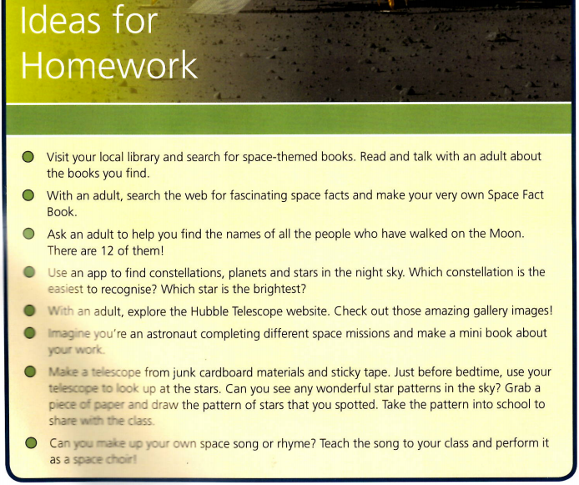
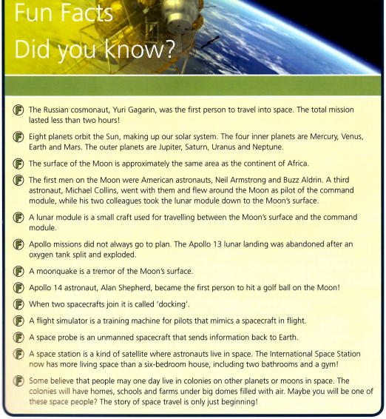
Reading
Please read a book daily from the following website: https://www.oxfordowl.co.uk/for-home/find-a-book/library-page/?fbclid=IwAR08_sImZbWDzoo57OfcXsyZBBdBgboprOSRhpiDc6_MXL0OLl5vw6y2dlc
You will need to register and create a log in but all the ebooks are free.
Please go on the website provided and scroll down to find the following: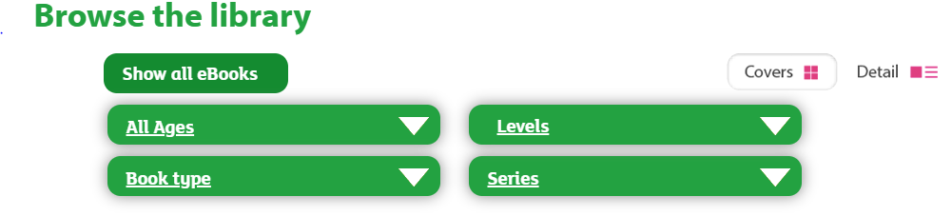
Select “levels” and then “book band” and select the required book band colour for your child. At this point in the academic year expected standard (at age related expectation) your child would be reading book band 6 orange. However if your child is greater depth standard (above age related expectation) they would be reading book band 7 turquoise. If your child is working towards standard (above age related expectation), please select the required book band level dependent on your child’s reading capability from the following options:
Book band 1 pink
Book band 2 red
Book band 3 yellow
Book band 4 blue
Book band 5 green
As part of parents’ evening, you received some coloured comprehension questions linked to the book bands. Please also ask your child these questions when they read to you.
Phonics
As part of Year 1, a key aspect of the curriculum is daily phonics. If your child is expected standard (at age related expectation) or greater depth standard (above age related expectation) in reading, please go to the following website: https://www.ruthmiskin.com/en/find-out-more/help-during-school-closure/
Please click on ‘YouTube channel’ (highlighted in blue at the end of the first line) and watch Set 2 speed sounds at 10am and Set 3 speed sounds at 10.30am. This will help to keep your child on track with their reading.
If your child is working towards standard (below age related expectation) your child will also need to watch Set 1 speed sounds at 9.30am.

Writing
As part of the previous homework packs your child was asked to complete 5 spellings a day from the spelling lists provided. School are aware that some children will still be working on these spellings in order to get them correct. Therefore, please continue to practise spelling the words from the previous homework. In addition to this, please complete the following activity linked to punctuation and grammar. A prefix is a group of letters that go at the beginning of a root word to change its meaning. In year 1 the prefix that children are taught is un-. A suffix is a group of letters that go at the end of a root word to change its meaning. In Year 1, the suffixes that children are taught are as follows: ed, ing, s, es, er, est.
Box 1 is an explanation of spelling rules linked to the suffix or prefix. Box 2 is the teacher showing you how to apply the suffix or prefix to a root word using the spelling rules. Box 3 is what we would like your child to complete.
Lessons 8-10, punctuation. Full stops, capital letters and exclamation marks. Read the explanations and apply the punctuation where appropriate.

Lesson 1 – “un-”
Box 1

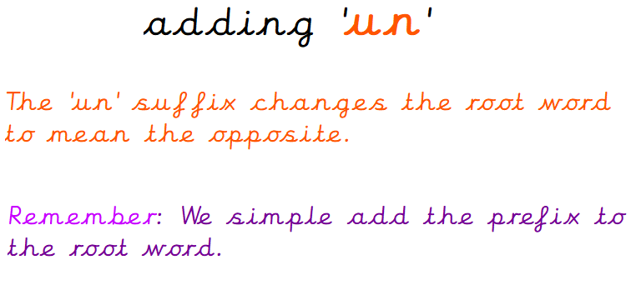
Box 3
Root word | Prefix un-
able
clean
real
safe
tidy
known
fair
cover
usual

Box 2
Root word | Prefix un-
happy | unhappy
kind | unkind
help | unhelp
tie | untie
zip | unzip
lock | unlock
like | unlike
lucky | unlucky
wind | unwind

Lesson 2 – “un”
Using one of the words that has “un” please write a sentence. The sentence must also contain the word “and”.
For example – The young child dropped her delicious chocolate ice-cream and this made her extremely unhappy.
________________________________________________________________________________________________________________________________
________________________________________________________________________________________________________________________________
________________________________________________________________________________________________________________________________

Lesson 3 – “ed” Has your child remembered the spelling rule for the suffix ‘ed’?
Box 1

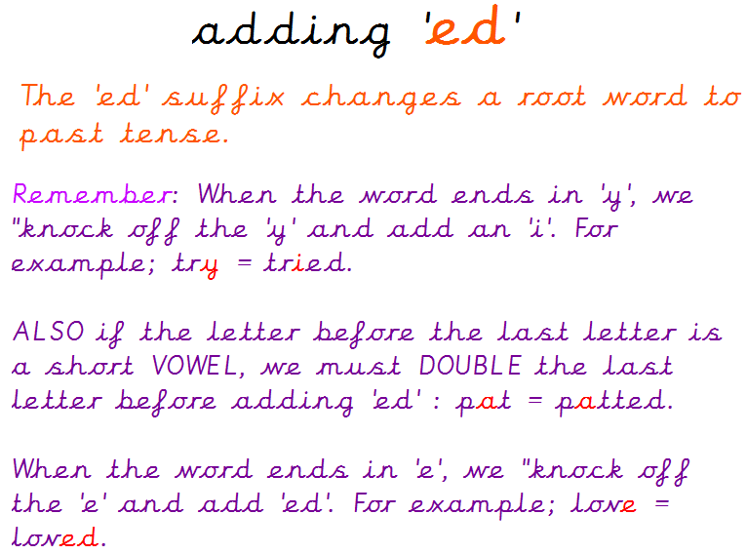
Box 3
Root word | Suffix ed
skip
try
smile
empty
love
chat
chase
carry
nod

Box 2
Root word | Suffix ed
cry | cried
pat | patted
dance | danced
trim | trimmed
marry | married
like | liked
copy | copied
force | forced
hop | hopped

Lesson 4 – “ing” Has your child remembered the spelling rule for the suffix ‘ing’?
Box 1

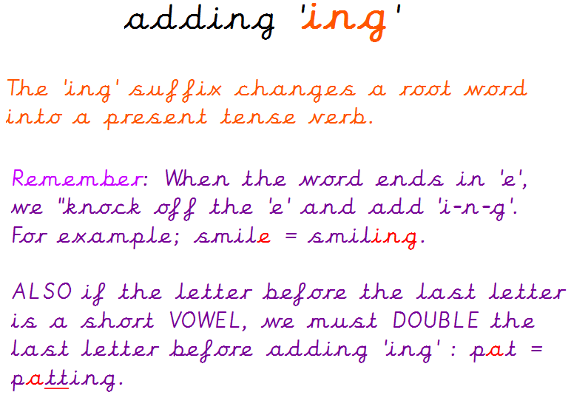
Box 3
Root word | Suffix ing
clap
write
win
bake
decide
shut

Box 2
Root word | Suffix ing
run | running
take | taking
knit | knitting
slip | slipping
come | coming
slide | sliding

Lesson 5 – “s” and “es” Has your child remembered the spelling rule for the suffix ‘s’ and ‘es’?
Box 1

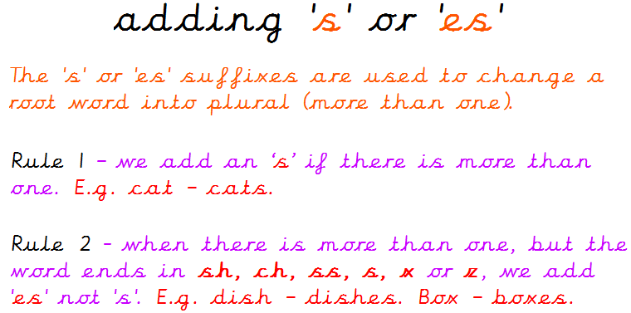
Box 3
Root word | Suffixes s, es
bush
jump
stop
watch
fox
game

Box 2
Root word | Suffixes s, es
dog | dogs
stranger | strangers
fizz | fizzes
animal | animals
stretch | stretches
crash | crashes

Lesson 6 – “er” Has your child remembered the spelling rule for the suffix ‘er’?
Box 1

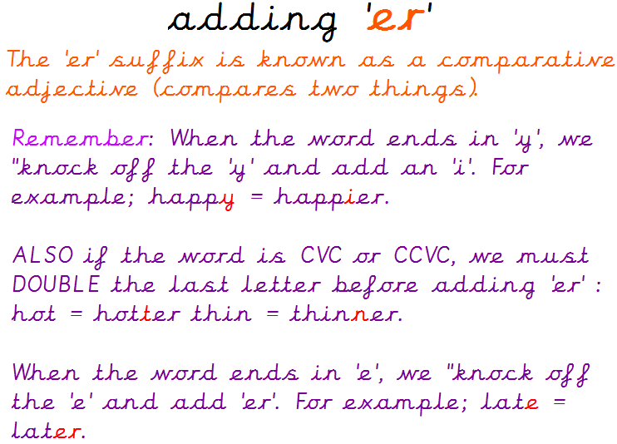
Box 3
Root word | Suffix er
cute
early
fit
late
friendly
glum
lucky
brave
thin

Box 2
Root word | Suffix er
happy | happier
grim | grimmer
nice | nicer
hot | hotter
scary | scarier
rude | ruder
lazy | lazier
mad | madder
simple | simpler

Lesson 7 – “est” Has your child remembered the spelling rule for the suffix ‘est’?
Box 1

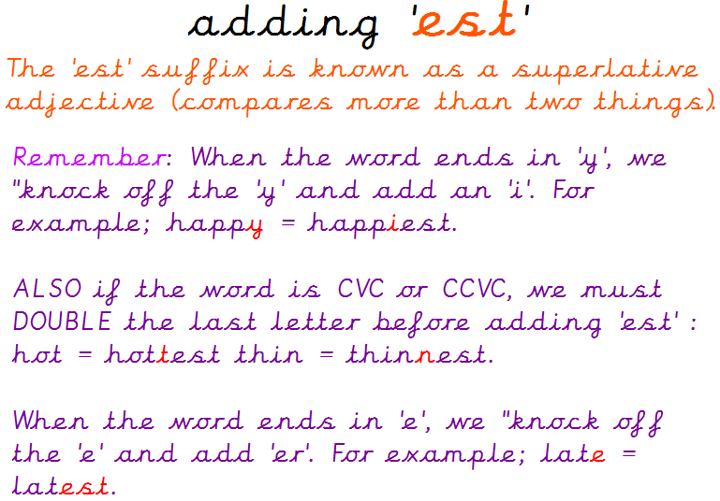
Box 3
Root word | Suffix est
easy
wide
big
fluffy
large
wet
noisy
sad
safe

Box 2
Root word | Suffix est
huge | hugest
fat | fattest
heavy | heaviest
dim | dimmest
tasty | tastiest
crude | crudest
red | reddest
fine | finest
windy | windiest

Lesson 8 – full stops and capital letters
A full stop (.) is used to denote the end of a sentence, Capital letters are used at the start of a sentence, for the personal pronoun I, for names of people and places like counties and cities e.g. England and London and for days of the week and months of the year.
Circle the mistakes in these sentences.

once upon a time there was a little girl called goldilocks who was extremely beautiful
she had gorgeous, blonde, curly hair and her eyes were bright blue like the atlantic sea.
one day goldilocks was slowly walking through sherwood forest where she came across a tiny house
she gently tiptoed towards the house and knocked on the door
Nobody answered so goldilocks crept in and tried daddy bear’s porridge.
“i don’t like this porridge and it is far too hot for me.”

Write your own sentence including the personal pronoun I. The sentence must also contain the word ‘and’ and a full stop.

________________________________________________________________________________________________________________________________
Write your own sentence including your name using a capital letter. The sentence must also contain the word ‘and’ and a full stop.
________________________________________________________________________________________________________________________________
________________________________________________________________________________________________________________________________

Lesson 9- Question marks
Question marks are used after someone as asked a question which requires an answer or response. e.g. Who does this coat belong to? Would you like to play outside? What is the time? These are some of the question words you can begin your question with (who, what, can, do, is, how, why, how, when, where)
Please add a full stop (.) or a question mark (?) to the following sentences.
Where would you like to go at the weekend
On Saturday I visited my Granny and she taught me how to knit
What is the weather like today
Do you want to build a snowman
I went to visit the enchanted woodlands and I collect the beautiful flowers
The tiny, fluffy mouse crept up to the cheese and he quickly took a gigantic bite

Now come up with two questions of your own.
________________________________________________________________________________________________________________________________
________________________________________________________________________________________________________________________________
________________________________________________________________________________________________________________________________
________________________________________________________________________________________________________________________________
________________________________________________________________________________________________________________________________

Lesson 10 – exclamation marks
Exclamation marks are used to denote strong feelings or emotions and a command. E.g. Sam was furious when his brother took his toy! (strong feeling or emotion) Matt bellowed “shut the door!” (command)
Please add a full stop (.) or an exclamation mark (!) to the following sentences.
The wolf had a cunning plan
Little Red Riding Hood skipped along the path on the way to Grannie’s house
She was extremely surprised to see the wolf in Grannie’s bed
The woodcutter heard a scream
Grannie crept out from under the bed and gave Little Red Riding Hood a huge hug
Little Red Riding Hood took a delicious, chocolate cake to her grannie
Now come up with two exclamations of your own.
________________________________________________________________________________________________________________________________
________________________________________________________________________________________________________________________________
________________________________________________________________________________________________________________________________
________________________________________________________________________________________________________________________________
________________________________________________________________________________________________________________________________

Maths
In Year 1, we would be moving onto money at this point in the academic year.
Please get your child to identify and write the amount of money.
Please complete the following worksheets. When finished, try drawing your own coins and finding the total amount of them.
Match the coins to the numicon amounts
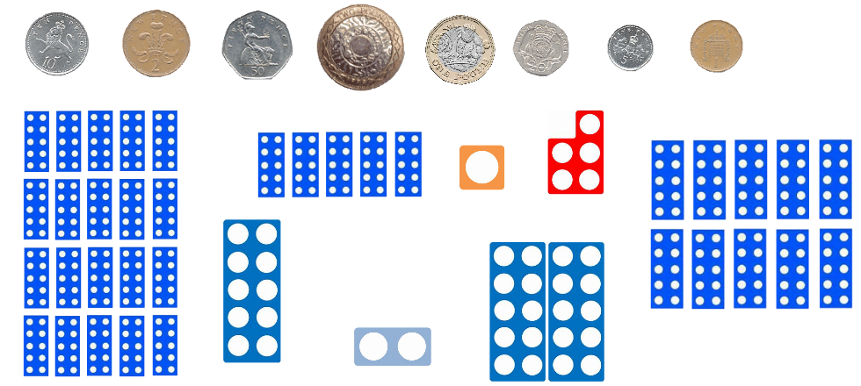
Order the coins from largest to smallest- draw them underneath on the line provided

Order the coins from smallest to largest- draw them underneath on the line provided

_______________________________________________________________________________________

Using the least amount of coins make these values.
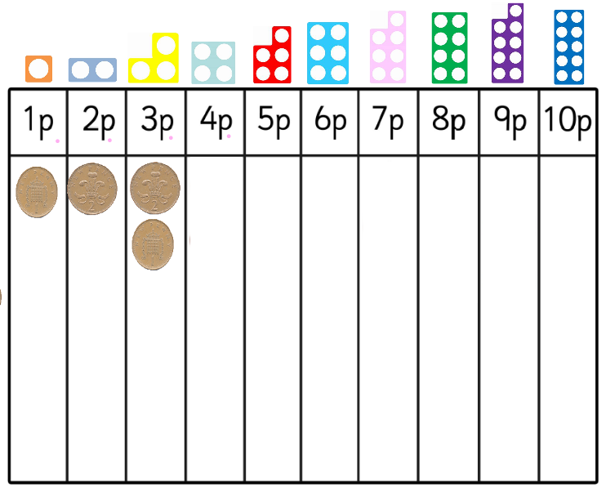
Using the least amount of coins make these values.
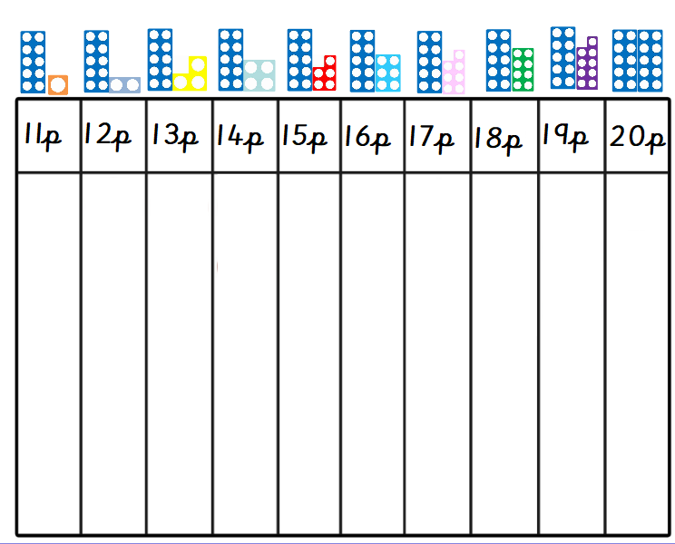
Show two ways of making the same amount
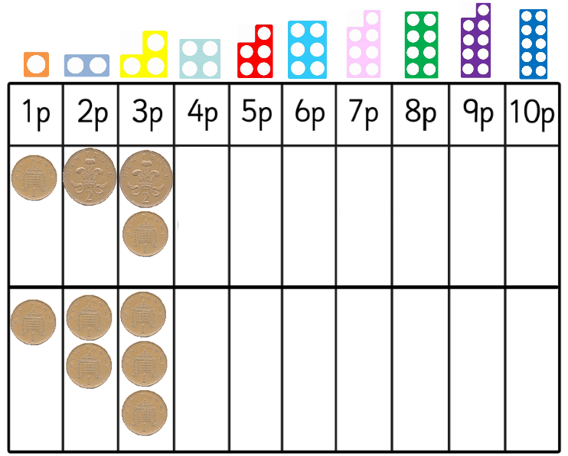
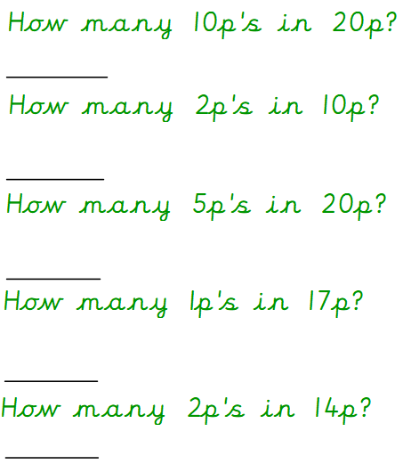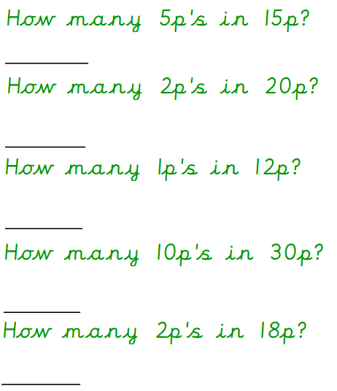
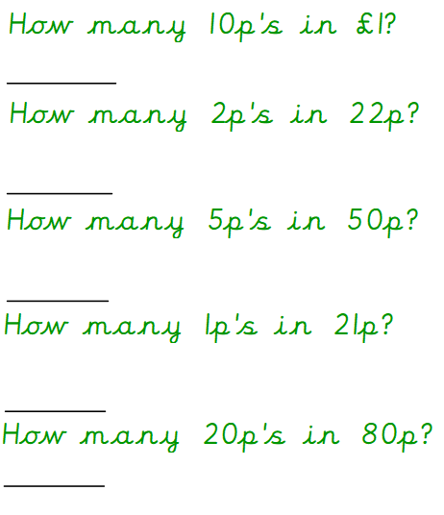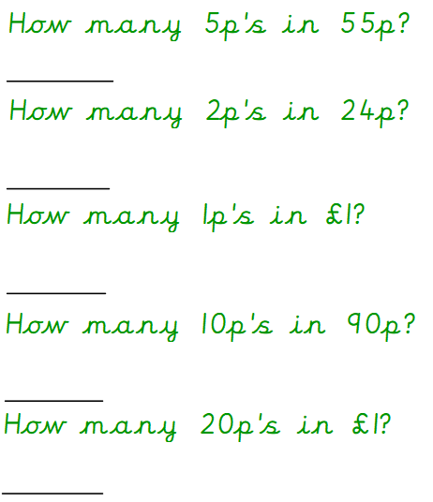
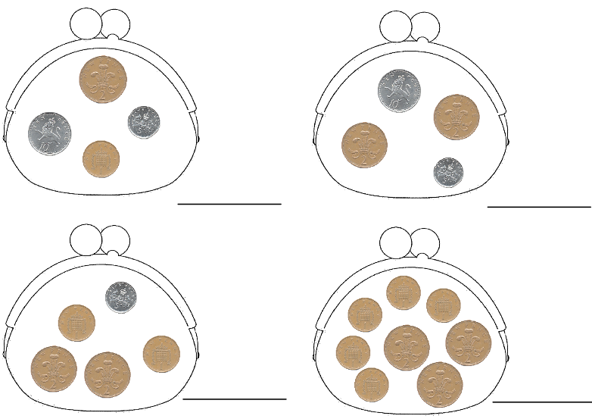

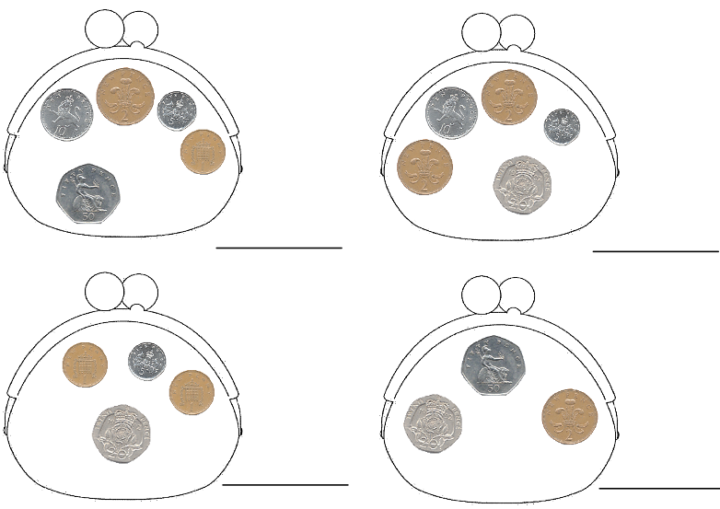

Solve these word problems:
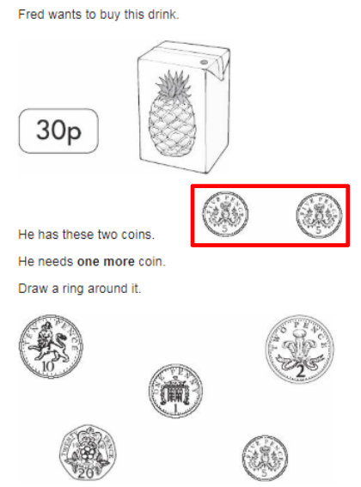
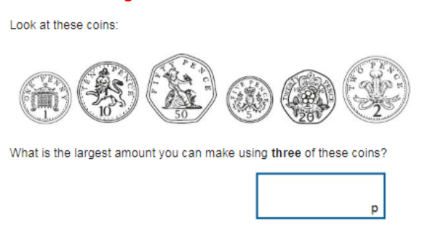
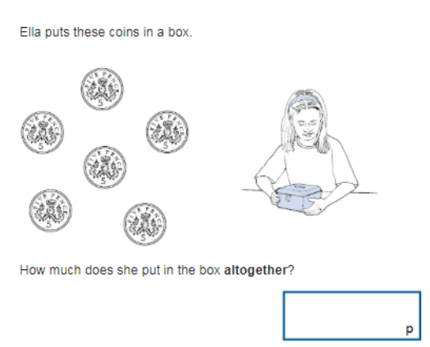
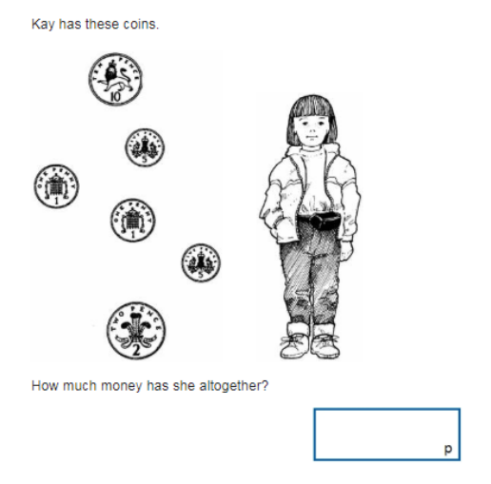

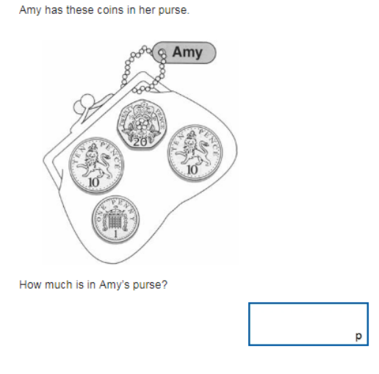
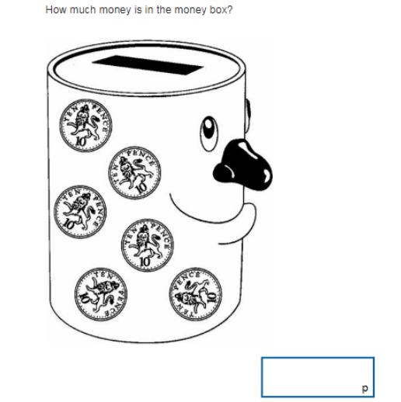

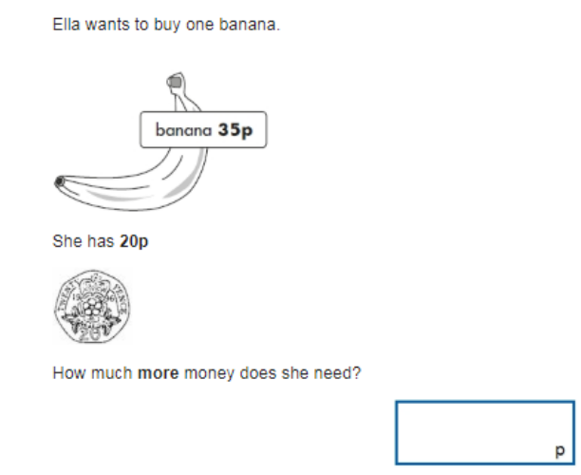
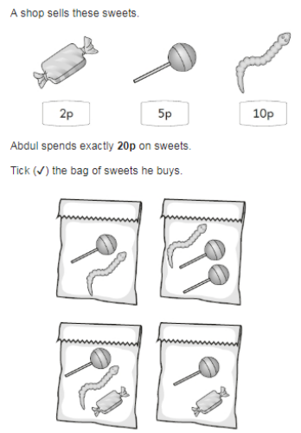

For extra fun and engaging activities “Twinkl” have given all parents an incredible offer – all content on their website is FREE for one month! All you have to do is go to www.twinkl.co.uk/offer enter your email address and create a password and use the code: UKTWINKLHELPS
If you click on the KS1 section, there you will find a vast range of activities for your child to enjoy!

The expectation is that all parents and carers will follow this daily model so that when all children return back to school, they are all at the same point. We will be continuing with learning with the knowledge that they have been learning the above at home, so please ensure your child completes the short activities above.
This pack is for your child to begin week commencing Monday 25th May and is designed to last until Friday 12th June. Please return this pack to your child’s class teacher on the day of return to Royd.

