11th February 2022
WORLD BOOK DAY 2022 – Thursday 3rd March
Dear Parents/Carers.
On Thursday 3rd March Reception pupils will be taking part in World Book Day 2022.
This is a worldwide celebration of reading, books, authors and illustrators. A key aim of World Book Day is to give every child in the UK and Ireland a book of their own to keep, by distributing World Book Day Tokens to children. Children can exchange this token for one of eight exclusive World Book Day Books at participating booksellers.
Reading is the biggest indicator to a child succeeding in the future.
‘Reading for pleasure is the single biggest indicator of a child's future success, more than family circumstances, parents’ educational backgrounds or income.’ – Organisation for Economic Co-Operation & Development.
The children in Reception will be reading the story “Elmer”. Throughout the day the children will be completing activities around this story. We are asking that they either dress up as a book character from “Elmer” or wear some comfy pyjamas for the day.

As part of our celebration of reading, we would also like to invite your child to take part in a whole school homework competition. Their task is to make something linked to their focus book “Elmer”. Children will need to bring in their homework on the day and prizes will be awarded.

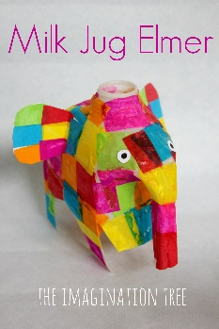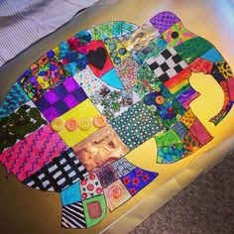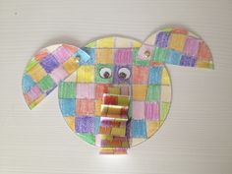

Yours sincerely,
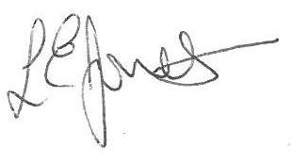
Louise Jones
Head Teacher

