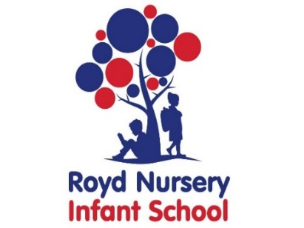
Royd Nursery Infant School
Carr Road, Deepcar
Sheffield, S36 2PR
Tel 0114 288 2594
Email enquiries@royd.sheffield.sch.uk
www.roydnurseryinfants.co.uk
Headteacher: Louise Jones

February 2022

Dear Parents/Carers of Ned Astley
At Little Messys we aim to develop children's confidence, social skills and football skills through highly engaging games and challenges. We promote teamwork and sportsmanship in our sessions which reflect on their school life too.
We are now taking bookings for the Spring 1 term. This programme is open to Y1 and Y2 girls and boys of any ability. The block of sessions will commence on Wednesday 23 and Thursday 24 February for 5 weeks (last sessions Wednesday 23 and 24 March). There are a maximum of 12 places for each session which will be allocated on a first come first served basis. We will be playing in the school hall so please bring appropriate clothing (+ shinpads, Tracksuit bottoms, jumper, trainers and a water bottle).
If you wish your child to participate please fill in the registration form below indicating which session/sessions are preferred, and return it to the School Office.
An upfront CASH payment of £17.50 (£3.50 x 5 sessions or £35 for both days) will secure your child’s place for this block of sessions. Payment must be with the consent slip for a place to be reserved.
For more information about Little Messys visit our website www.littlemessys.co.uk. Or check out our Facebook page Little Messys Sheffield .
Liam Ward, Little Messys. Sheffield@littlemessys.co.uk
IMPORTANT
Make sure whoever is picking up your child knows the PASSWORD you’ve set with school. Due to the schools safeguarding policy, we are not able to let children go until we get the password.
--------------------------------------------------------------------------------------------------------------------------
CHILD’S NAME: Ned Astley CLASS: 7
PARENT NAME:________________________SIGNED:________________________
CONTACT NUMBER:_________________ Photo Consent (tick box for permission) [ ]
Preference : Wednesday Thursday Both days

MEDICAL OR ANY OTHER NEEDS WE SHOULD BE AWARE OF

:______________________________________________________________________
PLEASE ENCLOSE THIS TERMS PAYMENT OF £17.50 CASH (£35 if child is doing both days) WITH THIS RETURN SLIP TO THE SCHOOL RECEPTION TO SECURE YOUR CHILD’S PLACE.

